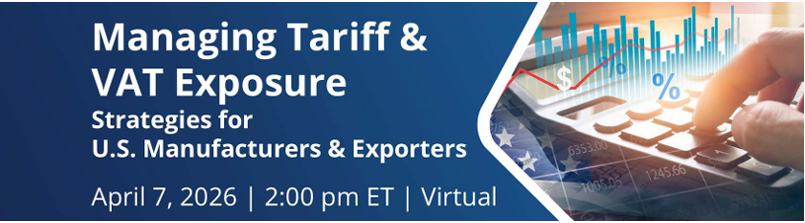

Overview: Join us to learn practical, often overlooked strategies to legally reduce tariffs and VAT through duty drawback, smarter transaction structuring, and valuation adjustments that improve margins and cash flow. We’ll break down real-world tactics you can implement immediately to lower costs, optimize pricing for international customers, and strengthen compliance without cutting corners.
Presenters: Sydnee Goodell, CITTA Brokerage, Robert Leach, ICPA Board Member and the District Export Council of North Dakota
What: Managing Tariff & VAT Exposure
When: April 7, 2026 – 2pm to 4pm EDT
Where: Online
Register: Managing Tariff & VAT Exposure Tickets - Tuesday, Apr 7, 2 pm - 4 pm EDT

