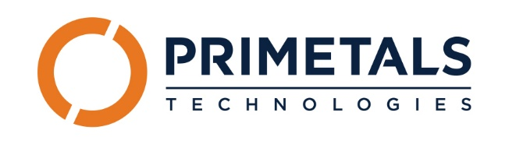
Primetals Technologies USA, LLC is a leading partner for engineering, plant construction and lifecycle services in the metal industry. We provide innovative and practical solutions to support our customers with long-term sustainability goals and their increased competitiveness. We believe the technical and economic know-how of our employees is the key success factor of our company.
At Primetals Technologies, you are encouraged to learn, grow, develop and contribute.
Come join the 7,000 employees worldwide—including 1,000 team members across 14 U.S. locations—at Primetals Technologies, a Group Company of Mitsubishi Heavy Industries.
Our Alpharetta, GA location is currently seeking to fill a Trade Compliance Officer position.
Applicants must pass a pre-employment physical exam and drug screen.
Classification and base pay will depend upon skillset and prior experience.
Duties of the Trade Compliance Officer will be performed in-house and on location at customer site.

Requirements –
- Active Licensed Customs Broker (LCB) Certificate
- Five (5) years of experience in trade compliance role in a global logistics company.
- Extensive hands-on experience with the ACE portal.
- Strong knowledge of Section 232 steel and aluminum tariffs.
- Experience managing Duty Drawback or similar programs.
- Strong understanding of U.S. import and export regulations.
- Excellent attention to detail and communication skills.
- High proficiency with Microsoft 365 (Outlook, Excel, Teams, PowerPoint, SharePoint).
- Absolute discretion and integrity in handling confidential information.
- Proven ability to work under pressure, manage competing deadlines, and adapt to fast-changing priorities.
- Bachelor’s in Business Administration, Supply Chain or related field.
ESSENTIAL DUTIES & RESPONSIBILITIES:
Import Compliance
- Oversee access to and proper use of the CBP Automated Commercial Environment (ACE) system
- Establish and maintain direct payment and refund processes with U.S. Customs and Border Protection (CBP)
- Ensure accurate and compliant customs clearance data including HTS classification, invoices, and country of origin
- Support Primetals Technologies entities with product classification and tariff optimization
- Prepare and manage Duty Drawback claims
- Conduct internal audits of import documentation and compliance processes
- Monitor regulatory changes and update internal procedures accordingly
- Forecast annual Duties, Taxes, and Fees (DTF) for customs bond planning
- Liaise with customs brokers and regulatory agencies

Export Compliance
- Determine and assign Export Control Classification Numbers (ECCNs)
- Ensure compliance with U.S. export control laws, sanctions, and embargoes
- Conduct audits of export documentation and compliance practices
- Provide export control training and guidance to employees

Primetals Technologies offers a full range of benefits, including paid time off, and
  - Insurance – Medical – including an HSA option, dental, vision, accident, hospital indemnity, critical illness, life & accidental death
  - Financial – 401(k), flexible spending accounts, education reimbursement, and employee referral bonuses.

At Primetals Technologies, we value difference for the benefit of our employees, our customers, and our Community. Primetals Technologies is committed to equal employment opportunity regardless of race, color, ancestry, religion, sex, national origin, sexual orientation, age, citizenship, marital status, disability, or gender identity.

