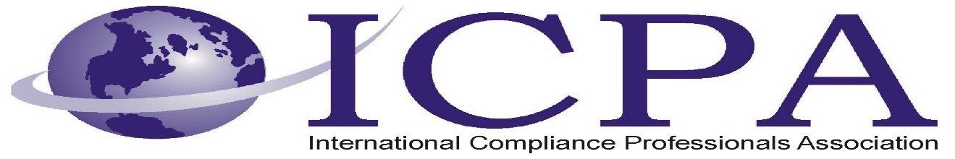

Job Opportunity

Company | Gateway Recruiting
Job Title | Director of Trade Compliance
Location | Cleveland, Ohio
Salary Range | $180,000 - $220,000 Annual Salary
Relocation Assistance | Relocation assistance available

Job Summary:
The Director of Trade Compliance, Investigations & Disclosures (I&D) is responsible for managing the investigation & disclosures process for the Company and its operating units. This role demands exceptional communication (verbal and written) skills. The Director of I&D leads internal investigations, reviews reported compliance issues, determines whether violations have occurred, and prepares disclosures to the appropriate governmental agencies. If no violation is identified, the Director ensures proper case closure with an internal memo documenting the findings. Additionally, the Director of I&D partners with Company Sites to identify root causes and implement corrective actions to eliminate compliance gaps.
As part of the Leadership Team, the Director of I&D is expected to engage with business operating units, conduct site visits, provide strategic guidance, and ensure regulatory alignment in global operations.

Job Duties & Responsibilities:
- Oversee investigations & disclosures process, ensuring compliance with trade regulations.
- Conduct internal investigations into compliance violations and prepare regulatory disclosures.
- Stay informed on changes in trade regulations, including export controls, import laws, and sanctions across the U.S. and international markets.
- Serve as the Corporate Point of Contact for operating unit Presidents and Site Leads across multiple Company operating units.
- Conduct regular site visits, provide tailored guidance and support for compliance-related matters.
- Function as a resource for operating units on various topics, including:
  - Export classification and jurisdiction determinations
  - Export permit and licensing applications and administration
  - Technology transfers / Deemed exports
  - Controlled Goods Program oversight
  - Shipment clearance
  - Denied party, proliferation and diversion screening
  - Import classification, valuation, country of origin analysis, assists reporting
  - Free Trade Agreement analysis and qualification
  - Management of Customs Brokers
  - Record-keeping and accurate documentation
  - Review and approval of visitor and travel requests

Job Qualifications:
- Significant experience (10+ years preferred) and expertise in domestic and international trade compliance – experience with trade compliance in manufacturing, specifically aerospace and defense, is preferred.
- Ability to interact effectively with other functions, including Engineering, Program Management, Supply Chain, and Logistics, as well as Operating Unit Trade Compliance staff and corporate leadership.
- Experience and working knowledge of U.S., Canadian, and other country export and import laws and regulations, including customs laws and controlled goods regulations (including ITAR, EAR, FTR, and OFAC).
- Exceptional written, verbal, and presentation skills, with the ability to clearly communicate compliance requirements and investigative findings to diverse audiences, including regulators and senior leadership.
- Strong critical thinking and project management skills, ability to exercise independent judgment and manage complexity and ambiguity.
- Ability to manage a high volume of work at a detailed level in a fast-paced environment, working with frequent interruptions and minimal day-to-day supervision.
- Able and willing to travel domestically and internationally at least 25%.
- Must be a U.S. Person (A U.S. Person is a U.S. citizen or person who is a lawful permanent resident as defined by 8 U.S.C. 1101(a)(20) or who is a protected individual as defined by 8 U.S.C. 1324b(a)(3)).

Contact Information to Apply

Whitney Forbes – wforbes@gatewayrecruiting.com

