I want to use an example to teach co-workers about COO determination and use something that they will remember. Therefore, I have chosen a Bloody Mary Jello mold to use as an example. Below are the ingredients that will be used to make it in the U.S.
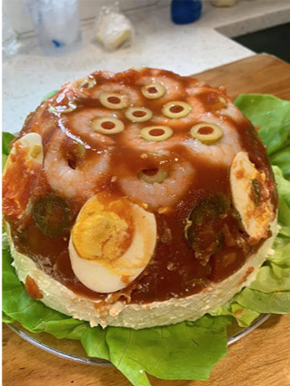
Amounts | Ingredients | HTS | COO
3 tsp | (3 envelopes) of unflavored gelatin powder | 2106.90.5890 | DE
3 Cups | Tomato juice | 2202.90.3600 | IT
1/2 Cup | Vodka | 2008.90.8000 | UA
1/2 Cup | Beer | 2206.00.9040 | DE
1 tsp | Minced garlic | 0703.20.0015 | US
2 tsp | Worcestershire sauce | 2103.90.8000 | UK
1 tsp | Lemon juice | 2202.90.3600 | IN
1/2 tsp | Salt | 2501.00.0000 | CN
1 tsp | Black pepper | 0904.11.0020 | VN
3 dash | Hot sauce (or more if you like it hot) | 2103.90.9051 | MX
1/2 cup | Sliced green pimento olives | 2005.70.2580 | MA
 | Gherkins to garnish | 2001.10.0000 | TR
8-12 | Raw shrimp | 0306.17.0042 | TH
3 | Eggs | 0407.21.0030 | CA
4 Cups | Spreadable liver sausage | 1602.20.4000 | HU
Bloody Mary Jello mold |  | 3503.00.5510

My questions:
- Would you say that this went through substantial transformation creating a U.S. product?
- If no, what would you say is the essential characteristic to determine the COO?
- What would you state the COO marking should be since it would not qualify for “Made in the U.S.A.” per FCC’s Made in the USA rules?
- If this were sold as a kit with the exact amounts of ingredients to make 1 mold, can this be classified as one item or would you need to classify everything separately?

