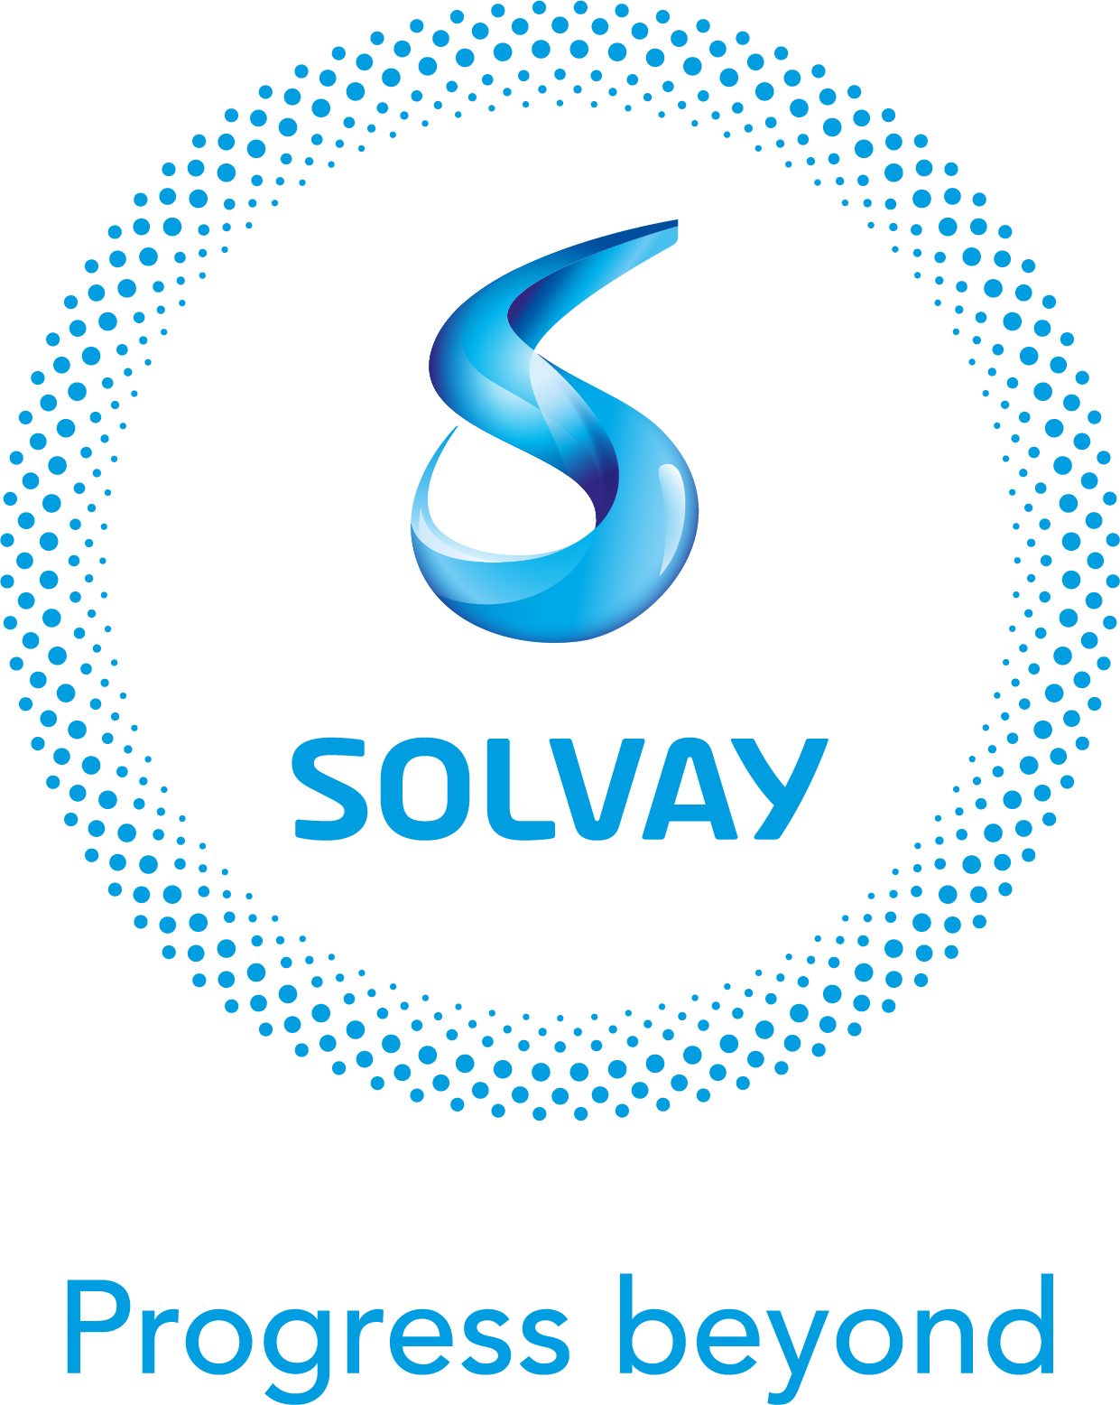

Global Trade NAM Expert

Job overview and responsibilities

Mission

The Global Trade NAM expert ensures the highest level of compliance with local customs and trade regulations through the deployment and enforcement of localized standard operating procedures. It contributes to generating value for our group by boosting our businesses’ trade lanes performance and cash by means of a robust operating model and a strong governance with other functions. He/she supports the deployment of our Global Trade strategy that allows for future-proof agility against external trade disruptions.

The Global Trade NAM expert is part of the Global Trade organization that sits under the responsibility of Solvay Chief Operations Officer. The function reports to the Global Trade NAM region manager.

Key responsibilities

Stay updated about own domain
- Stay updated about all relevant laws, rules and regulations affecting global trade activities, within own perimeter
- Anticipate any key changes in the regulatory environment of own perimeter
- Maintain solid knowledge about the GBU business within own perimeter
- Stay updated about trends and developments within the supply chain and global trade domain

Define, deploy and monitor strategies, policies and standards
- Support the deployment of the global and regional global trade strategies, policies and standard operating procedures within own perimeter
- Perform controls as instructed in internal control policies and plans, and standard operating procedures

Organize, coordinate, manage and/or improve global trade activities
- Maintain contact with suppliers to support resolution of operational issues
- Prepare external audits and assist GT NAM manager with audit defense, follow up and reporting.
- Support the GT NAM manager with the assistance around (1) technical processes (classification, origin determination, valuation, license application, etc.) requiring local/regional expertise and (2) the Implementation, maintenance and monitoring of customs related activities (special procedures, entry/exit procedures, free trade zones, etc ). Apply for and coordinate with governmental agencies any authorizations and certificates, handle financial instruments (customs credit, deferment accounts,etc.). All the aforementioned activities are performed with an eye on cost and process efficiencies
- Assist the GT country manager with the design, deployment and maintenance of duty saving and trusted trader programs (AEO, CTPAT)
- Track and report key global trade metrics within own perimeter

Manage and coordinate with external and internal partners
- Maintain regular contact with service providers (customs brokers) of own perimeter
- Coordinate global trade activities with all stakeholders (tax, procurement, controlling, industrial management, product stewards, legal, etc.) as per internal governance model and Solvay One principles

Education and experience

- Bachelor’s degree in economics, law, international trade, supply chain or similar
- Licensed Customs Broker is an asset
- Knowledge regarding duty drawback programs is an asset
- Chemistry background is a plus
- +5 years of relevant experience in Global Trade operations in NAM

Skills and behavioral competencies

- Strong analytical skills
- Hands-on and compliance-oriented
- Ability to work autonomously and with cross-border teams in a highly matrix organization
- Eagerness to embark on an ambitious global trade transformation journey

Language skills

English

What value will this role bring to the candidate?
This role offers a unique opportunity for the candidate to be part of a growing global trade family and participate in the ambitious transformation journey Solvay has launched in order to upscale our global trade capabilities.
It gives the candidate the ability to further grow his/her technical skills and embark on multiple transformative projects as part of our Global Trade Program.

Additional information

Travels to domestic sites (US,CA) and trade conferences

