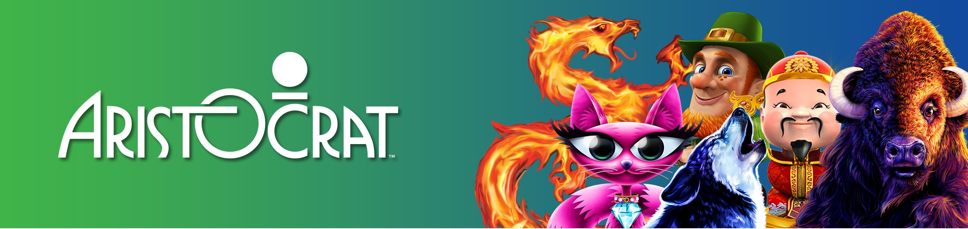

Title: North America (NA) Trade Compliance Specialist

Company Summary
We're pioneers in our field and relentless in our pursuit of excellence. Aristocrat is an ideas company at heart, which means innovation is embedded into every aspect of our business. Whether we're designing sleek new cabinets, premium game content or award-winning systems, we apply fresh thinking and creativity to deliver the world's greatest gaming experience, every day. With cool new titles, such as Game of Thrones TM, Sons of Anarchy and Lightning Link along with our award-winning app Heart of Vegas, we're continually pushing the bar of creativity.

Job Description Summary
Aristocrat Technology is looking to add an Analyst to their Global Trade Compliance team. The Global Trade Compliance team’s primary function is to provide center led leadership and direction for the development, administration and enforcement of policies and procedures related to Aristocrat’s global trade compliance program. The (NA) Trade Analyst's primary responsibility is to support and manage customs reporting activity, conduct audits/assessments of customs broker and Aristocrat's US and Canada operations to ensure compliance with relevant government and corporate policies/procedures; formulate recommendations for improvement in operating performance and controls, ensuring that proper and timely corrective actions are implemented; analyze import/export data and trends to identify and report areas of potential risk.

Job Requirements
- Support US, Canada and third-party brokers/freight forwarders to resolve day-to-day issues that result in import/export delays.
- Act as regional liaison for import and export activity to ensure compliance and timely delivery.

Provide guidance, as needed, on harmonized tariff classification, customs valuation, and country of origin determination and other governmental data points driving exemptions of products and purchases.

Manage US & CA customs brokers and customs reporting activities

Manage US & CA FTA qualification and preferential programs

Support Birtcher, Tulsa and all US warehouses w/ export shipping requirements & import receiving controls

Support Canada Exports and reporting requirements

Exercises independent judgment in methods, techniques and evaluation criteria for obtaining data and analyzing it.

Regularly interacts with senior management or executive levels on matters concerning several functional areas, divisions, and/or customers.

Broker Bill Review and submission for payment

US and Canada Export document creation and Electronic Export Filing (EEI) management & audit

Support US Quarterly customs payments

Remain abreast of current U.S. Customs programs, initiatives, and regulatory changes and analyze potential impact on Aristocrat.

Current and changing import and export laws and requirements that impact the daily operations

Support and govern Aristocrat import and export operations to ensure compliance with Aristocrat policy and local laws and regulations

Manage broker and freight forwarder KPIs to ensure compliance and mitigate risks

Interact with the global trade team regarding changing requirements, expectations, and policy and ensure practical regional application.

Strong skills to be able to influence to enable change management

Qualifications
- Bachelor’s degree in Finance, Mathematics, Business Administration or Supply Chain.
- Minimum of 4-5 years’ related experience (Trade Compliance, Audit, Finance/Accounting, Materials Management or other related field).
- Strong working knowledge of US and CA Customs laws, Harmonized Tariff Classification, Free Trade Agreement Analysis/Qualification, Process Auditing, and application of Import/Export trade regulations.
- Analysis/Qualification, Process Auditing, and application of Import/Export trade regulations.
- Strong project management and Global Trade systems experience (e.g. Global Trade Management (E2Open), D365, Internal – ERP; External – ACE, SQL).

Why Aristocrat?
- World Leader in Gaming Entertainment
- Robust benefits package
- Global career opportunities

Our Values

