ICPA Training Email – Ideas for Format Changes
- Add ICPA logo, put into a more newsletter type format with borders and ICPA colors
- Definitely recommend highlighting ICPA’s trainings first
- Move the social links to the top of the email and add logos
- For training from partners, suggest organizing either by webinar and seminar or by topic (import vs export)

Subject Line: ICPA Training Opportunities
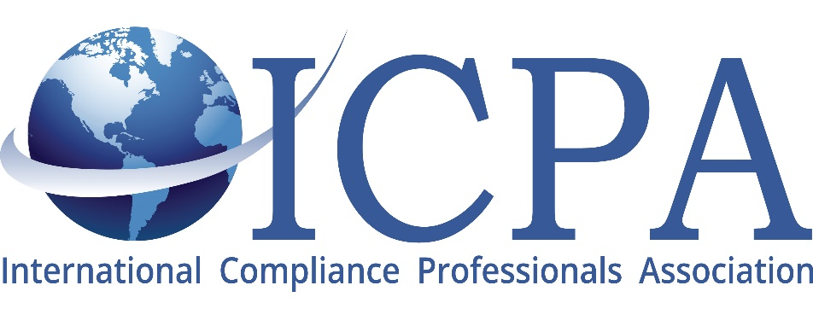
Check out the below training opportunities from ICPA and our partners


For more ICPA news follow us on LinkedIn, Facebook and Instagram!

ICPA Webinars
9/27/22 10:30CST - Uyghur Forced Labor Prevention Act – What You Need to Know: Adrienne Braumiller, with Braumiller Law Group and George Tuttle with Tuttle Law
ICPA Conferences
2022 ICPA China Conference at the Hyatt Regency Portland, OR September 19th-20th.
2022 ICPA Fall Conference at the Hilton DFW Lakes October 16th-18th.
2023 ICPA Annual Conference at the Swan and Dolphin Orlando, FL March 12th-15th.

Other training opportunities from our partners [webinar, seminar organization]
- Newsletter: Crowell & Moring: The Month in International Trade – August 2022
- Webinar: Internal Compliance Training
- Webinar: Flexport Webinar | Flexport Capital: Helping Brands Navigate a Cash Crunch (September 21)
- Webinar: Export Compliance Solutions & Consulting Presents: Overview of the Most Commonly Used ITAR Exemptions, Wed. November 9th, part of the ECS Webinar Series
- Webinar: Chemical and pharmaceutical classification training webinar
- Webinar: Exporting Procedures – Global Training Center (September 22)
- Webinar: Importing Procedures – Global Training Center (September 12)
- Webinar: Export Compliance Solutions & Consulting Presents: How to Submit a Voluntary Disclosure, Wed. December 14th, part of the ECS Webinar Series
- Seminar: International Trade Compliance (October) – Minneapolis, MN – GTC
- Seminar: FREE U.S. Sanctions Seminar and Networking Reception on Both Coasts! Washington DC and Santa Clara – Seats Filling Quickly!
- Seminar: Export Compliance Training Institute Presents: Impact of ITAR, EAR and OFAC Controls on Non-U.S. Companies Seminar in Tel Aviv, Israel – January 16-19, 2023
- Seminar: Export Compliance Training Institute (ECTI) Presents: ITAR, EAR and OFAC Export Controls Seminar in Washington, DC – October 10-13, 2022
- Seminar: Export Compliance Training Institute Presents: University Export Controls in Columbus, Ohio – September 27-29, 2022
- Seminar: CTPAT MASTERCLASS by SCSI * San Diego – Sept. 21st & 22nd
- Seminar: Export Compliance Solutions & Consulting Presents: 5th Annual ITAR/EAR Symposium, Mastering ITAR/EAR Challenges, Annapolis, MD, October 11-12, 2022
- Other: U.S. Export Compliance Certification Programs (Content Enablers, George Mason University, The Institute of Export and International Trade)
- Other: Discount for ICPA! Export, Import, and Sanctions Training – Advanced and Awareness Levels (Content Enablers)

Other training opportunities from our partners [topic organization]
Import
- Webinar: Chemical and pharmaceutical classification training webinar
- Webinar: Importing Procedures – Global Training Center (September 12)
- Seminar: CTPAT MASTERCLASS by SCSI * San Diego – Sept. 21st & 22nd
Export
- Webinar: Export Compliance Solutions & Consulting Presents: Overview of the Most Commonly Used ITAR Exemptions, Wed. November 9th, part of the ECS Webinar Series
- Webinar: Exporting Procedures – Global Training Center (September 22)
- Webinar: Export Compliance Solutions & Consulting Presents: How to Submit a Voluntary Disclosure, Wed. December 14th, part of the ECS Webinar Series
- Seminar: Export Compliance Training Institute Presents: Impact of ITAR, EAR and OFAC Controls on Non-U.S. Companies Seminar in Tel Aviv, Israel – January 16-19, 2023
- Seminar: Export Compliance Training Institute (ECTI) Presents: ITAR, EAR and OFAC Export Controls Seminar in Washington, DC – October 10-13, 2022
- Seminar: Export Compliance Training Institute Presents: University Export Controls in Columbus, Ohio – September 27-29, 2022
- Seminar: FREE U.S. Sanctions Seminar and Networking Reception on Both Coasts! Washington DC and Santa Clara – Seats Filling Quickly!
- Seminar: Export Compliance Solutions & Consulting Presents: 5th Annual ITAR/EAR Symposium, Mastering ITAR/EAR Challenges, Annapolis, MD, October 11-12, 2022
- Other: U.S. Export Compliance Certification Programs (Content Enablers, George Mason University, The Institute of Export and International Trade)
General
- Newsletter: Crowell & Moring: The Month in International Trade – August 2022
- Webinar: Internal Compliance Training
- Webinar: Flexport Webinar | Flexport Capital: Helping Brands Navigate a Cash Crunch (September 21)
- Seminar: International Trade Compliance (October) – Minneapolis, MN – GTC
- Other: Discount for ICPA! Export, Import, and Sanctions Training – Advanced and Awareness Levels (Content Enablers)

