Trade Compliance Coordinator
POSITION SUMMARY:
The Trade Compliance Coordinator will be responsible for maintaining day-to-day compliance with trade regulations for the Franklin Electric locations in the United States and Canada. The Trade Compliance Coordinator must have a working knowledge of and experience in trade compliance and customs duties.

KEY RESPONSIBILITIES
KEY RESPONSIBILITIES:
- Ensures compliance with the laws and regulations of US Customs and Border Protection and all other government agencies that impact trade compliance; especially in the areas of Tariff Classification, Origin Management, Customs Valuation, Free Trade Agreements, Anti-Dumping, Punitive Duties and Export Controls.
  - Serves as an internal consultant to provide necessary services concerning trade compliance affairs; reviewing and responding to all internal customer requests regarding import/export compliance.
  - Monitors status of containers for CBP or broker issues and assists the supply chain team with imported and exported shipments as needed.
  - Reviews and maintains all US and CA HTS classifications, free trade eligibility, countries of origin and maintains certificates and data accuracy of these items.
  - Supports risk assessments to identify compliance concerns and effectively collaborates with appropriate internal partners to achieve resolution.
- Conducts spending/ landed cost analysis as requested.
- Drives efficiency, standardization and strengthens compliance through active engagement in trade related projects and automation efforts.
- Proactively monitors the latest developments in relevant trade compliance legislation.

SKILLS KNOWLEDGE AND EXPERTISE
EDUCATION/EXPERIENCE:
- At least 2 years of relevant experience in trade, logistics, or customs compliance.
- Minimum of a Bachelor of Science in Supply Chain, Business or related program required.
QUALIFICATIONS:
- Requires a strong communicator, detail orientated, team focused and an ability to drive progress.
- Intermediate Microsoft Office Suite Experience preferred.
- Experience with CBP ACE, Customs Broker System Portals, SNAP-R, JD Edwards E-1 and similar systems preferred.
- Available for an estimated 15% travel time to corporate office or various FE locations.
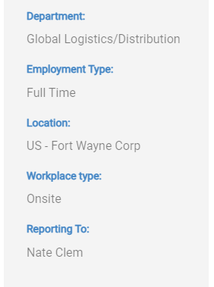

BENEFITS
Becoming a part of the Franklin Electric team not only provides outstanding benefits, it also opens doors to opportunities for future growth. Enjoy peace of mind with a world-class company. But more importantly, be satisfied in knowing you make a difference.

ABOUT FRANKLIN ELECTRIC
We are a global leader in the manufacturing and distribution of products and systems focused on the movement and management of water and fuel. We offer pumps, motors, drives, and controls for use in a wide variety of residential, commercial, agricultural, industrial, and municipal applications. Franklin Electric is proud to be named in Newsweek’s lists of America’s Most Responsible Companies and Most Trusted Companies for 2022.
Apply Now

