Job Title | Regulatory Compliance Analyst
Business Unit | ODCBU
Function/Region | Government Compliance/US
Location | Edison, NJ
Leader | Import/Export Supervisor
People Leadership | N/A
Job Level | 5
Role Purpose
Builds and maintains relationships that guides and reinforce compliance. Supports monthly internal assessments and audits to identify and mitigate risks. Ensure the seamless movement of imported and exported inventory to/from Edison in compliance with government regulations.

Accountabilities
- Complete timely filing of customs entries, ISF filings, payment of duties and fees for seamless import process
- Support the development of regulatory compliance policies, procedures and manuals
- Addresses inquiries related to Classification, Free Trade Agreement eligibility and Country of Origin
- Review and reconcile bonded inventory discrepancies between systems
- Provide departmental audit support for excise tax payments and other government fees
- Post entry audit for FDA, TTB and CBP compliance; conduct scheduled audits for TTB compliance for the Edison DSP
- Create and maintain a compliance resource database and support ongoing training
- Submit COLA applications, waivers, brand and state registrations
- Generate monthly reports for excise tax accruals , fees and CBMA savings
- Other duties and projects as assigned

Values
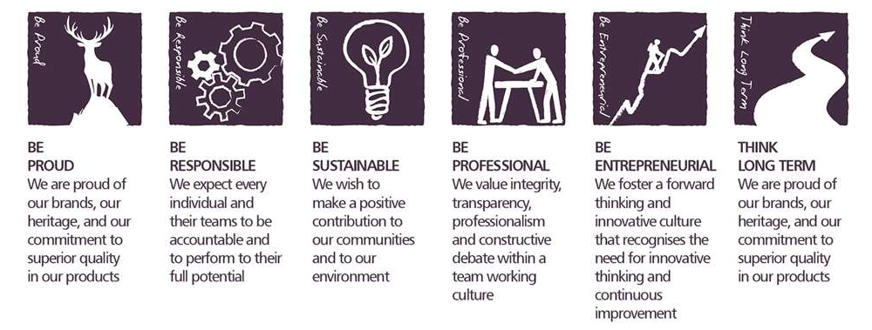
Core Competencies:
Analysing  - Analyses numerical data, verbal data and all other sources of information  - Breaks information into component parts, patterns and relationships  - Probes for further information or greater understanding of a problem  - Makes rational judgements from the available information and analysis | Adhering to Principles and Values  - Upholds ethics and values  - Demonstrates integrity  - Promotes and defends equal opportunities, builds diverse teams  - Encourages organisational and individual responsibility towards the community and the environment
Persuading & Influencing  - Makes a strong personal impression on others  - Gains clear agreement and commitment from others by persuading, convincing and negotiating  - Promotes ideas on behalf of self or others  - Makes effective use of political processes to influence and persuade others | Learning and Researching  - Rapidly learns new tasks and commits information to memory quickly  - Demonstrates a rapid understanding of newly presented information  - Gathers comprehensive information to support decision making  - Encourages an organisational learning approach (i.e. learns from successes and failures and seeks staff and customer feedback).  Manages knowledge (collects, classifies and disseminates knowledge of use to the organisation)
Applying Expertise & Technology  - Applies specialist and detailed technical expertise  - Develops job knowledge and expertise through continual professional development  - Shares expertise and knowledge with others  - Uses technology to achieve work objectives  - Demonstrates appropriate physical co-ordination and endurance, manual skill, spatial awareness and dexterity  - Demonstrates an understanding of different organisational departments and functions | Coping with Pressures & Setbacks  - Works productively in a pressurised environment  - Keeps emotions under control during difficult situations  - Balances the demands of a work life and a personal life  - Maintains a positive outlook at work  - Handles criticism well and learns from it

Skills and Qualifications:
Essential:
- Bachelor's degree in a related field ( Supply Chain, Business, Logistics), or equivalent work experience
- 1-2 years previous experience working in an audit, regulatory or compliance capacity
- Self-motivated and a team player, yet comfortable and capable of being independent and resourceful
- Excellent Analytical and organizational skills and great attention to detail
- Ability to demonstrate outstanding judgment and flexibility, identifying and reacting to critical issues in a timely manner

Desirable:
- Prior work experience with TTB, CBP and FDA or working within the alcohol beverage industry
- Interest in working for a global company and able to work effectively with individuals of diverse cultural backgrounds
- Ability to learn quickly

TO APPLY CLICK HERE:
https://careerssearch.williamgrant.com/jobs/job/Import-Export-Regulatory-Compliance-Analyst/543

