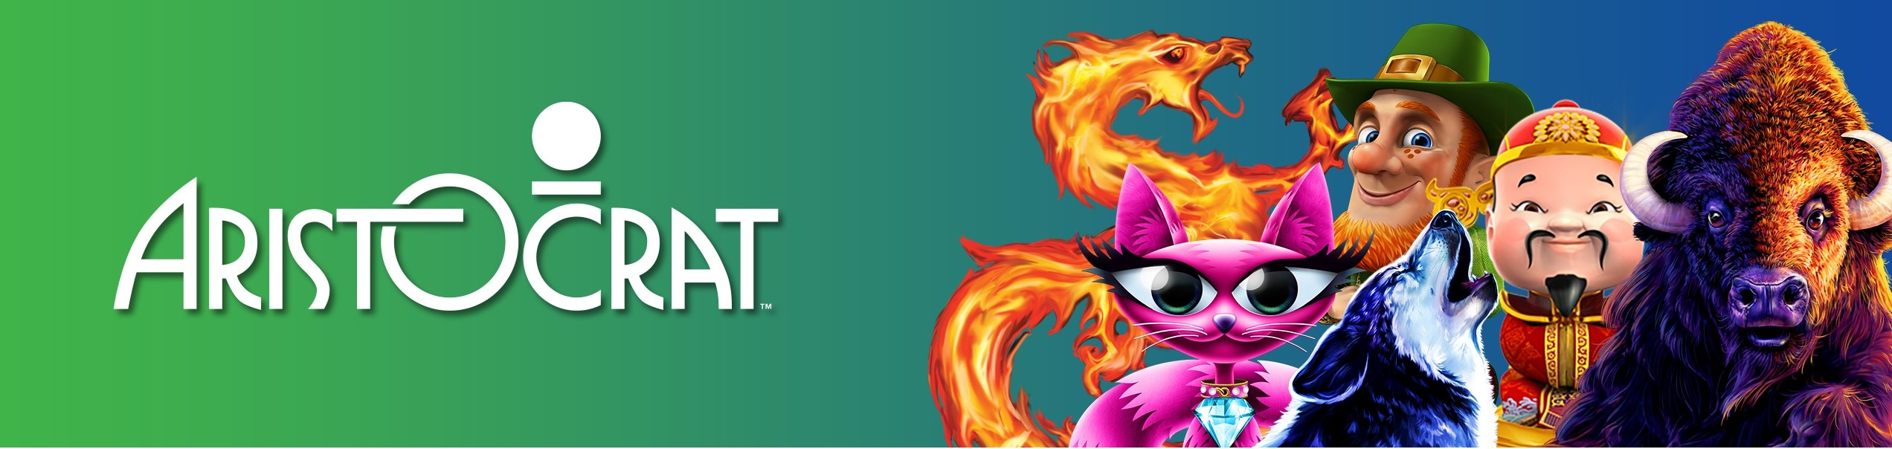

Title: Global Trade Compliance Manager

Company Summary
We're pioneers in our field and relentless in our pursuit of excellence. Aristocrat is an ideas company at heart, which means innovation is embedded into every aspect of our business. Whether we're designing sleek new cabinets, premium game content or award-winning systems, we apply fresh thinking and creativity to deliver the world's greatest gaming experience, every day. With cool new titles, such as Game of Thrones TM, Sons of Anarchy and Lightning Link along with our award-winning app Heart of Vegas, we're continually pushing the bar of creativity.

Job Description Summary
Hiring Manager - Please insert a paragraph that captures the essence of the role, which will attract the type of candidate you hope to hire.

The Global Trade Compliance Manager is a key role reporting directly to the Director, Global Trade Compliance. You will be responsible for implementing and executing Aristocrat’s Global Trade Compliance program in the Americas, EMEA, ANZ/APAC regions as part of a center led global logistics team in accordance with company objectives, policies, and procedures. The Global Trade Compliance Manager is accountable for ensuring that Aristocrat conducts import/export activities in support of our customers having the world’s best gaming experience.
As a leader in the global compliance team, you will be working closely with logistics and compliance organizations within other regions, as well as other functional areas within the company.

Job Requirements
Hiring Manager - Please insert 5- 8 critical requirements or objectives you have for this role. No more than 8 for will go on the website.

- As a Global Trade Compliance Manager, you will implement and manage all elements of the Global Trade Compliance Program and drive implementation of management systems and automated controls at a regional level.
- You will use your expertise to ensure that daily, weekly, monthly import/export functions, reporting and monitoring activities are performed, reported accurately and timely and ensure that preventative and detective controls are monitored and are being used in accordance with policy, rules and regulations.

- You will have a strong knowledge and understanding Global Trade Compliance Data including Trade Lane Valuation, Harmonized Classification, and Country of Origin.
- Working with regional teams, you will facilitate the import and export of Aristocrat products across borders, including support in obtaining any necessary permits and licenses, and enhancing export controls and screening processes across the region.
- Perform trade requirement assessments of enterprise-wide ITC performance and procedures and drive the identification and follow-up on all corrective action, acting as a subject matter expert for internal, external and government audits and report findings and recommendations for additional controls or corrective actions to business leaders.
- You will coordinate KPIs/metrics reporting relating to import and export transactions and maintain compliance with and proficiency of rules, regulations and policies enforced by government agencies involved in the regulation of imported or exported goods in the regions.
- You will stay up to date on Customs Compliance Alert reports from Aristocrat’s different regions and review amendments to international trade and customs related legislation, research, report on the impact of such amendments, and communicate needed action as appropriate.
- Lead the ongoing development of trade compliance training plans/programs throughout the regions, as well as general awareness updates and training for broader Aristocrat Technologies.

Qualifications
Hiring Manager - Please insert 3-5 critical qualifications you have for this role. No more than 5 will go on the website

- Bachelor Degree in Trade Law preferred, Business Administration or related field acceptable.

- Minimum 5-8 years of experience in a trade compliance role supporting regulated business, dealing with international and US trade compliance laws, Trade Data, Trade Lane Value Classification, and COO.

- Experience using Global Trade Compliance technology

- Ability to work cross functionally with the legal, sales, operations, and finance personnel in all regions to ensure international trade compliance laws are followed.

- Process-driven, detail oriented, self-motivated, and analytical with good problem-solving skills and a customer service focus. Must be effective in oral and written communication.

Why Aristocrat?
- World Leader in Gaming Entertainment
- Robust benefits package
- Global career opportunities

Our Values

