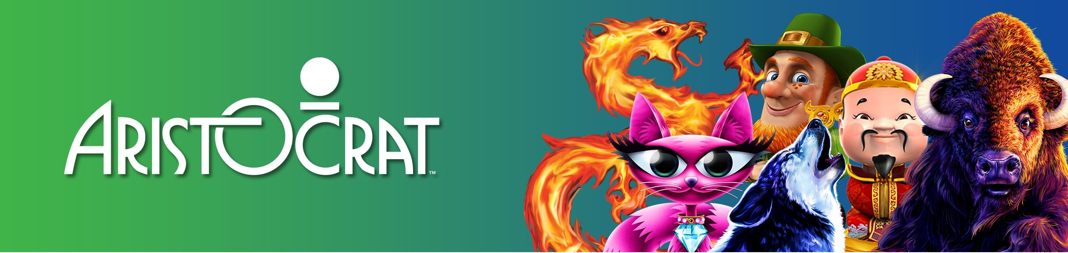

Title: Director, Global Trade Compliance

Company Summary
We're pioneers in our field and relentless in our pursuit of excellence. Aristocrat is an ideas company at heart, which means innovation is embedded into every aspect of our business. Whether we're designing sleek new cabinets, premium game content or award-winning systems, we apply fresh thinking and creativity to deliver the world's greatest gaming experience, every day. With cool new titles, such as Game of Thrones TM, Sons of Anarchy and Lightning Link along with our award-winning app Heart of Vegas, we're continually pushing the bar of creativity.

Job Description Summary
Hiring Manager - Please insert a paragraph that captures the essence of the role, which will attract the type of candidate you hope to hire.
Aristocrat Technology is looking for a Global Trade Compliance Director to stand up and lead a global trade compliance team. The Director, Global Trade Compliance leads the overall trade compliance function at the enterprise level with a focus on policies, systems, and enterprise reporting. You will help develop the strategy for and implement a best in class International Trade Compliance (ITC) model which manages all non-legal ITC activities worldwide including the development, resourcing, and implementation of effective policies and procedures; advocacy on behalf of the organization with various government organizations; oversight of ITC applications; training and business support across the organization; as well as the definition, staffing, and ongoing evolution of a global trade compliance organizational structure responsible for execution of tactical trade activities to support the business units.

Job Requirements
Hiring Manager - Please insert 5- 8 critical requirements or objectives you have for this role. No more than 8 for will go on the website.
- Responsibility to mature the structure and strategy for the global trade compliance organization while developing, implementing, and overseeing the maintenance of controls to ensure compliance with trade requirements in support of Aristocrat’s businesses.
- Responsible for establishment, implementation, administration, and maintenance of the written Aristocrat’s trade compliance policies, standards, and procedures including oversight to ensure the successful implementation and local training of the associated site level policies and procedures. Lead the teams responsible for regional and local product business unit trade compliance activities to ensure global compliance.

- Define the strategy and ensure the roll out and administration of trade compliance technology / systems strategy to streamline the trade compliance processes.
- Evaluate the global ITC team to ensure the team has proper staffing, clarity of responsibility, appropriate skill sets, ongoing training, and a strong network to be effective in their roles. Ensure development and delivery of global training programs to all staff engaged in ITC related activity.
- Advise the business on significant legal and regulatory changes and trade compliance trends, support impact assessment of required changes, and counsel the businesses on appropriate adjustments required.
- Develop and implement processes to ensure submission of all required semi-annual and annual reports to the appropriate government agencies. Analyze the reports and metrics pertaining to various elements of the trade requirements process, and report out to senior management on trends, areas of concern and improvement opportunities.
- Establish, implement, and support an internal compliance review program that includes periodic audits and assessments across the regional business unit network. Support Aristocrat’s audit team with internal investigations ensuring proper access to required information.
- Lead the ongoing development of the training plans / program for the trade compliance staff as well as general awareness updates and training for broader Aristocrat Technologies.

Qualifications
Hiring Manager - Please insert 3-5 critical qualifications you have for this role. No more than 5 will go on the website
- Bachelor’s degree required, MBA or associated graduate degree preferred.
- 15 years of international and US regulatory import/export trade experience with at least 5 years in a senior management role with a multi-national corporation.
- Broad experience developing and implementing trade programs, policies and procedures, and trade compliance technology within a multi-national organization. Licensed Customs Broker preferred.
- Strong, action oriented interpersonal and team building skills with ability to convey a clear strategic vision and influence effectively across functions.
- Must be able to work well in a matrix organization and possess the leadership acumen to build successful cross-functional relationships to build consensus with all stake holders to drive change to successfully deliver broad programs across all levels of the organization and across functional boundaries.

Why Aristocrat?
- World Leader in Gaming Entertainment
- Robust benefits package
- Global career opportunities

Our Values

