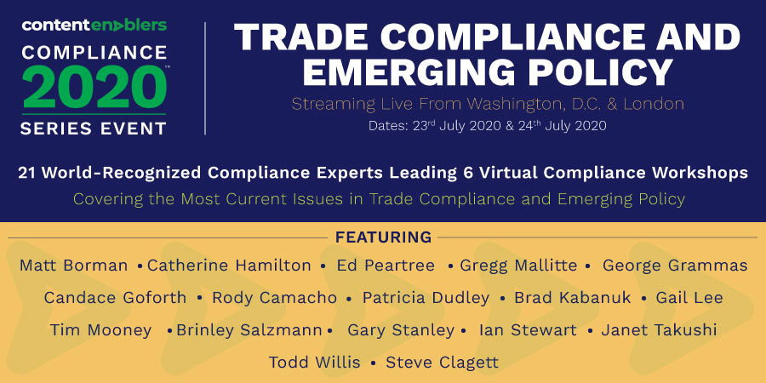

Title for List in ICPA Email: CONTENT ENABLERS PRESENTS: 2-Day Virtual Conference on “TRADE COMPLIANCE AND EMERGING POLICY” - 21 world-recognized speakers/6 virtual workshops
TRADE COMPLIANCE AND EMERGING POLICY
2-Day Virtual Conference – The Trade Compliance Event of the Year!
No event this year gives you more focused insight on the evolving issues facing trade compliance practitioners.
Learn More Now!
July 23-24, 2020
Join a virtual online conference consisting of six compliance workshops led by 21 world-recognized compliance leaders! Topics to be covered include:
- Evolving Regulations and Policies
- Developments in Defense Trade (to include UK Panel Discussion)
- Auditable Export Controls and Sanctions Compliance Panel Discussion
- Adapting Training to Reflect Post-COVID-19 Requirements Panel Discussion
- USMCA: Understanding the Changes in North American Trade
- Developments in Nuclear Exports
- USML Categories I-III: Firearms and Related Items – Transitioned to the EAR
View the detailed agenda here: DETAILED AGENDA & SPEAKERS
To Attend, Subscribe Now! Benefits of subscribing include:
- The opportunity to attend the July 23-24 COMPLIANCE 2020 Event, “TRADE COMPLIANCE AND EMERGING POLICY,” a virtual two-day event featuring Matt Borman and an array of world-recognized compliance experts.
- Access to 12 months of continuous learning – As a subscriber, you’ll have access to a full year of online and in-person COMPLIANCE 2020 events featuring analysis and insider perspectives from top government and industry experts on important and developing compliance issues. You’ll also have access to all of the recordings of previous COMPLIANCE 2020 events.
- Comprehensive, Practical, and Engaging Training from the Trade Compliance Practitioner Training Series that you can view and review for 12 months. No more worrying that you will miss a vital regulation update! As a subscriber, you will receive notifications by email when regulations change.
- Choose from the following 12-month subscriptions to the Trade Compliance Practitioner Training Series:
  - Foundations of U.S. Export Compliance $29/month Course Details
  - U.S. Export Classification $39/month Course Details
  - U.S. Export Authorizations $39/month Course Details
  - U.S. Export Clearance $39/month Course Details
- A Certificate of Completion from the Schar School of Policy and Government at George Mason University for each completed course
BEST VALUE! Get all four courses above and access to all COMPLIANCE 2020 events listed below (12+ months of continuous learning) for $125/month! SUBSCRIBE NOW
COMPLIANCE 2020 Events (November 2019 through July 2020…more to come this year!)
- Trade Compliance and Emerging Policy – 21 world-recognized compliance leaders present six virtual workshops (July 23-24, 2020)
- Export Controls for Cyber Security and Digital Transformation presented by Louverture Jones, Deloitte & Touche LLP; Sean Ryan, Deloitte Tax LLP (Recorded June 2020)
- The Future of US/UK Trade – Who Will Come Out a Winner? A roundtable with Frank Samolis, Matthew Kirk, and George Grammas (moderator) of Squire Patton Boggs (Recorded May 2020)
- Update on New Rules Regarding Exports to China presented by Kevin Wolf of Akin Gump (Recorded April 2020)
- Emerging and Foundational Technologies and CFIUS for Export Compliance Professionals presented by George Grammas, Squire Patton Boggs (Recorded February 2020)
- The Law, Policy, and Practice of the EAR’s Unverified List, Entity List, and Denied Persons List presented by Kevin Wolf of Akin Gump (Recorded January 2020)
- Globalization of Export Compliance & Sanctions; Emerging & Foundational Technologies; Refinement of Export Control Reform Principles (Recorded November 2019)

