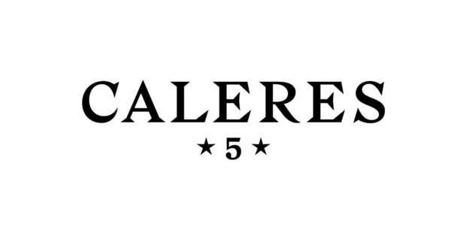

Manager, Foreign Trade Zone

We seek someone passionate about implementing strategic processes, reporting and metrics to ensure regulatory compliance and drive cost savings to join our Distribution Center team in Ontario, California.

We are Caleres, a global footwear company with brands that fit people’s lives. We are ferocious about fit and living our mission of inspiring people to feel good…feet first.

We seek people who:
- Oversee company compliance with Foreign Trade Zone program, ensuring importation and exportation requirements are met, and minimizing customs fines & duty liabilities
- Develop strong partnerships with Operations and Inventory Control teams to effectively audit and reconcile company inventory
- Take ownership and establish processes and metrics for Foreign Trade Zone operations, sharing knowledge and best practices
- Proactively inform business partners of new and upcoming laws and regulations

We seek people with these qualifications:
- Bachelor’s degree in Business Administration, Logistics, Finance or related field
- 5+ years experience in customs or distribution center environment preferred
- Foreign Trade Zone experience required
- Demonstrated experience effectively managing or supervising teams
- Strong analytical, problem solving and organizational skills
- Proficient in Microsoft Excel
- Working knowledge of SAP & PkMS or other warehouse management system preferred

But most of all, we seek people who share our values and our ferocity for fit.

People passionate about their work. People who hold themselves and others accountable. People who think a $2.6 billion company should be as creative as a start-up. People driven by an insatiable curiosity. People who care about being the best, among the best.

Please click HERE to be directed to the application site for Caleres!

EOE/M/F/Vet/Disabled

