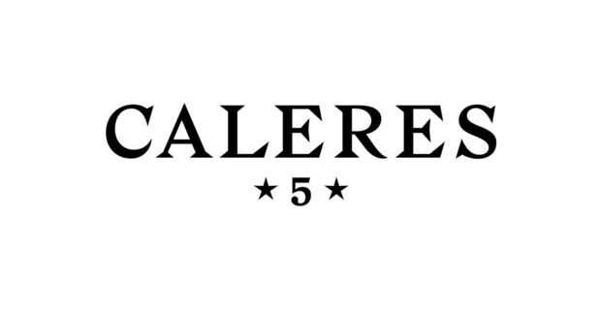

Administrator, Foreign Trade Zone

We seek someone passionate about process and providing strong attention to detail to ensure regulatory compliance to join our Distribution Center team in Ontario, California.

We are Caleres, a global footwear company with brands that fit people’s lives. We are ferocious about fit and living our mission of inspiring people to feel good…feet first.

We seek people who:
- Oversee company compliance with Foreign Trade Zone program, ensuring importation and exportation requirements are met, and minimizing customs penalties and fines
- Develop strong partnerships with Operations and Inventory Control teams to effectively audit and reconcile company inventory
- Account for all Foreign Trade Zone merchandise, both foreign and domestic, admitted to the facility through inventory control system
- Ensure reporting and auditing timelines are consistently met

We seek people with these qualifications:
- Bachelor’s degree in Business Administration, Logistics, Finance or related field
- 3+ years experience in customs or distribution center environment preferred
- Foreign Trade Zone experience preferred
- Auditing experience preferred
- Knowledge of import & export systems preferred
- Highly analytical, detail-oriented and process-driven
- Proficient in Microsoft Excel

But most of all, we seek people who share our values and our ferocity for fit.

People passionate about their work. People who hold themselves and others accountable. People who think a $2.6 billion company should be as creative as a start-up. People driven by an insatiable curiosity. People who care about being the best, among the best.

EOE/M/F/Vet/Disabled

