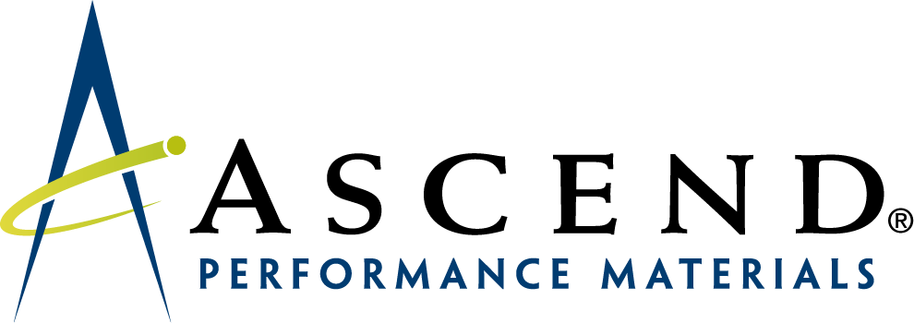

Import/Export Operations Clerk
-- Entry Level Position –
-- Full Time --

Company | Ascend Performance Materials
Location | Houston (downtown), Texas
Salary Range | Competitive compensation  (commensurate with skills and experience)
Relocation Assistance | No

Position overview:

Ascend Performance Materials’ Office of International Trade Compliance (ITC) is seeking a person to assist with import and export operations. This is an entry level, full-time position requiring 0-3 years of experience. Initially the successful candidate will learn and perform essential routine activities, then take on more complex tasks with successive levels of responsibility. This role is an ideal position for the career-minded individual interested in learning the technical aspects of importing, exporting, and international business in general from the ground up. You will have the opportunity to expand your knowledge of international trade with seasoned professionals and an in-house licensed customs broker as you apply Ascend’s established business controls to help ensure regulatory compliance.

Responsibilities

- Maintain orderly records of import, export, free trade agreement, and duty drawback activities (to meet statutory recordkeeping requirements)
- Perform the daily review of the restricted party screening results, flagging medium and high-risk parties and routing to the Sr. ITC Specialist for review and further instructions
- Assist with the process to verify a product’s eligibility for NAFTA
- Perform preparatory steps to set up file reviews of individual import and export transactions
- Prepare documentation for American goods returning from Canada to enable duty free treatment
- Perform Internet research on specific compliance issues as instructed
- Support other functions of ITC operations as business circumstances require

Required skills and behaviors

- Strong organizational and notetaking skills
- Strong with MS Word and Excel
- Desire to learn, and the ability to apply what is learned
- Unwavering commitment to accuracy and quality results
- Detail-oriented
- Comfortable asking questions as appropriate, and the judgement to know when to escalate
- Demonstrated ability to communicate clearly and effectively, both orally and in writing
- Ability to work independently to focus on a single task that demands a high attention to detail for an extended period of time
- Intrinsically motivated with a results-oriented work ethic
- Proven ability to work in a team environment
- Maintain professionalism at all times

Skills not required but considered a plus

- Knowledge of U.S. import and/or export regulations
- Familiarity with customs brokers and/or freight forwarders
- NAFTA or other free-trade agreements
- HTS classification
- Logistics
- Supply chain
- Incoterms
- SAP

Education

Bachelor degree required– preferably in international business, supply chain/logistics, business administration, economics, finance, or comparable degree

Why work at Ascend?

If you are looking for a career with one of the plastics industry’s most enlightened employers, Ascend Performance Materials offers an opportunity to develop a true sense of fulfillment and pride in your achievements.

Ascend provides an exciting platform from which you, your family and your community will benefit. You’ll become a trusted member of an interdependent and safe working environment where your opinions and ideas will be encouraged and respected, regardless of your position. Working alongside a diverse range of renowned technical experts on a continuous stream of industry-leading products and technologies, you’ll find a wide variety of opportunities within our growing business for both learning and career development.

Our culture is built on a strong set of core values that foster innovation and collaboration across every level of the organization. It is a culture grounded in open relationships between every member of the Ascend team. All of this is driven by an inspirational leadership team, intently focused on maximizing the new investment in the business.
The essence of our organization is embodied in the words “inspiring everyday,” and we have built a strong and confident business with performance at its core. It will be challenging but holistically rewarding and will enable you to achieve your personal and professional aspirations.

Ascend is an organization that genuinely seeks to inspire our people to inspire others. We believe this gives Ascend a higher purpose, making it a unique work environment for you to consider when choosing career options. More at https://www.ascendmaterials.com/.

Contact Information to Apply

Send resume to: jeremy.merritt@ascendmaterials.com

Include your phone number and best time to call.

