Customs Compliance Leader
Employment Duration: Full-time
Working Location: Corte Madera, California
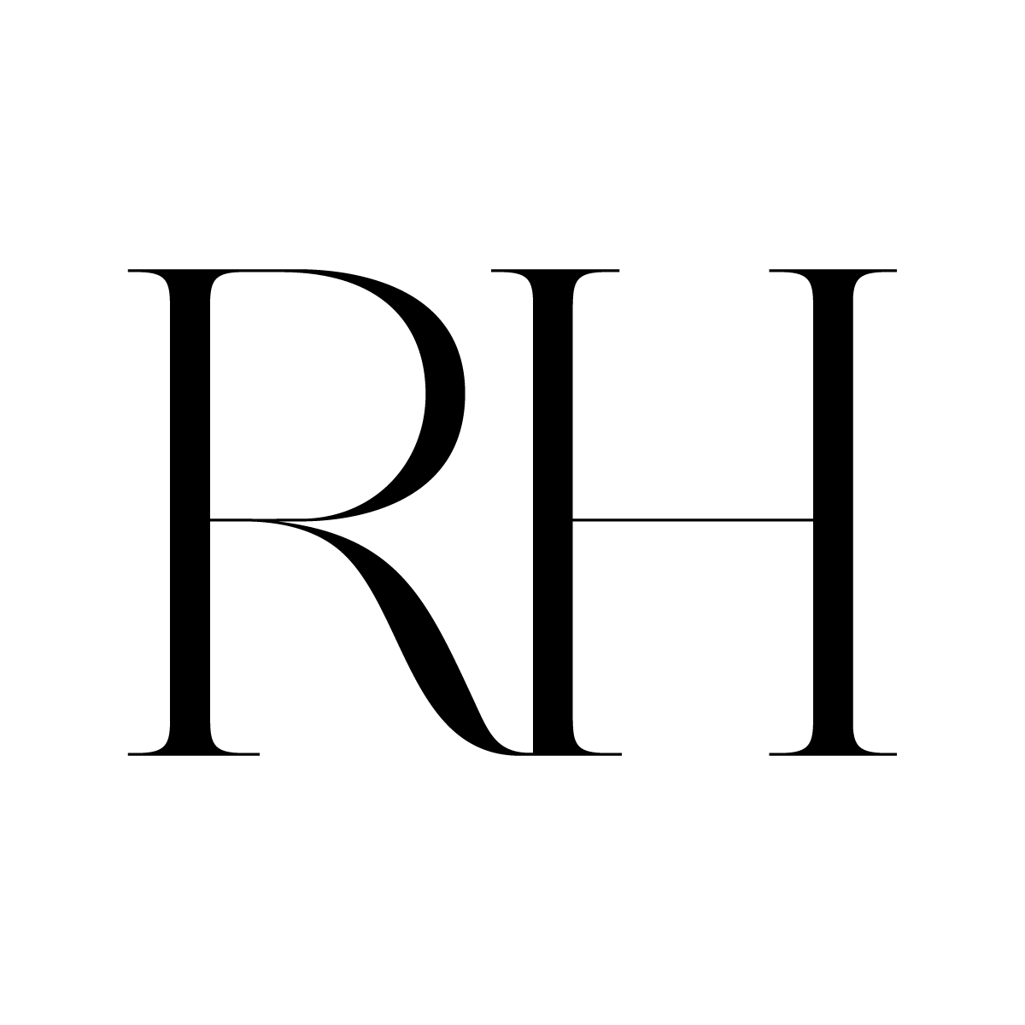

We believe the “right” people are our greatest asset. We seek out those who contribute new ideas, take risks and challenge convention, and embrace individuals who are innovative, have a point of view, and won’t take no for answer. Leveraging the creative spirit of all our Associates, at all levels of our organization, our environment is like no other — uniquely focused on empowering Associates to deliver first-class client experiences.

Restoration Hardware is looking for a Customs Compliance Leader for our International Transportation Logistics team, reporting to Sr. Director, International Logistics, Import/Export Compliance. This is a hands-on role that engages with RH Supply Chain, Planning, Merchandising, Sourcing, Product Development and many various RH service provider partners to support and improve best in class networks that allow RH to be the best Home Merchants. We are looking for someone who wants to make a difference and who enjoys a fast-paced environment where new challenges are the norm.

RESPONSIBILITIES

- Apply strategic and tactical leadership to Restoration Hardware’s international supply chain and our Customs compliance program
- Engage with various customs brokers as well as associated freight forwarders, carriers and parcel courier on daily basis
- Customs brokerage process owner serve as primary contact for customs brokers
- Accountable for inbound vendor-to-US and outbound to client customer supply chain performance measured against key performance metrics in the areas of cost, cycle time, service, and quality of delivery
- Serve as a subject matter expert resource for internal cross-functional partners
- Communicate and partner with overseas agents/vendor suppliers
- Ensure customs brokerage process and performance supports high volume network, sea container shipments as well as land border, air forwarder and courier parcels on a daily basis
- Monitor daily / weekly / monthly status and performance reports; address problem areas and deficiencies as required
- Effectively use shipment data and documentation for managing exceptions
- Participate in and support business reviews on a quarterly basis (or more frequently as required) with service providers; drive corrective actions as warranted based on performance
- Post entry audit program
- ACE account and ACH duty payment
- Assign HTS codes to all RH products
- Maintain HTS/parts item database
- Use research tools to study regulations and binding rulings applicable to RH
- Engage in dialog as necessary with CBP personnel & related agencies on behalf of RH
- Lead RH’s duty drawback program
- Implement operational strategies in support of key sourcing and supply chain initiatives
- Coordinate and facilitate face-to-face and teleconference meetings between vendors, service providers, and cross-functional partners as required to ensure open, accurate, and timely communication flow between all parties
- Collaborative and effective working relationships with all cross functional business partners

REQUIREMENTS

- At least 4 years relevant business experience with roles focused in Customs Compliance
- In-depth understanding of customs brokerage roles and corporate customs compliance programs/procedures, proven expertise
- Basic understanding of freight forwarder, carrier, air, sea and road logistics
- Must possess strong computer skills, MS Office at minimum
- Solid familiarity of the Customs Regulations Title 19 CFR
- HTS (Harmonized Tariff Schedule) expertise
- ACE (Customs Automated Customs Environment)
- Fundamental understanding of inventory and accounting principles
- Customs broker license preferred but not mandatory
- Familiarity with GT NEXUS a plus
- Prior Retail experience helpful
- Work involvement with transportation logistics service providers a plus
- Understanding and exposure to C-TPAT programs a plus

For immediate consideration, please submit your resume via our Careers Page.
https://chm.tbe.taleo.net/chm04/ats/careers/v2/viewRequisition?org=RESTORATIONHARDWARE&cws=37&rid=17613

RH is one of the most innovative and fastest-growing luxury brands in the home furnishings marketplace. The careful integration of people, products, ideas and inspiration creates our own unique point of view, where the whole becomes more valuable than the sum of its parts.

RH is an equal opportunity employer and does not discriminate against any applicant on the basis of race, color, religion, national origin, gender, marital status, age, disability, sexual orientation, military/veteran status, or any other status protected by federal or state law or local ordinance.

