Dress For Less
R0SS

POSITION DESCRIPTION

TITLE: DEPARTMENT: REPORTSTO (TITLE):
Sr. Specialist, Import Compliance & Classification Transportation - 9640
Manager, Import Customs Compliance
JOB CODE: GRADE: EXEMPT/ NON-EXEMPT:

LOCATION:
5486
67E
Exempt
SEDC

GENERAL PURPOSE:
To develop and coordinate International Customs Compliance and correctly assign classification information for multiple product types imported to the Ross distribution centers.
Responsibilities include; pre-classification of imported products, monitor, audit, report and improve import compliance related activities for Ross and all supporting third parties, and to develop, validate, and improve processes and procedures to ensure Ross is compliant of all custom regulations.

ESSENTIAL FUNCTIONS: % OF TIME

- Provide Product Development, Buying Offices and vendors/agents with HTS and duty rate as it relates to their costing calculations (ELC)
- Work with import broker to resolve questions and provide information as needed for timely Customs clearance
- Support in preparing Post-Entry Adjustments and binding ruling requests for submission to customs or customs broker
- Support procedures to coordinate between dedicated service providers, Ross transportation, and Ross distribution centers and. International Ross merchant group/vendors.
- Provide analytical and product management support to Operations and other business areas as needed.
- Perform all projects requested by the Manager, Customs Compliance
30%

30%

20%

10%

5%
5%

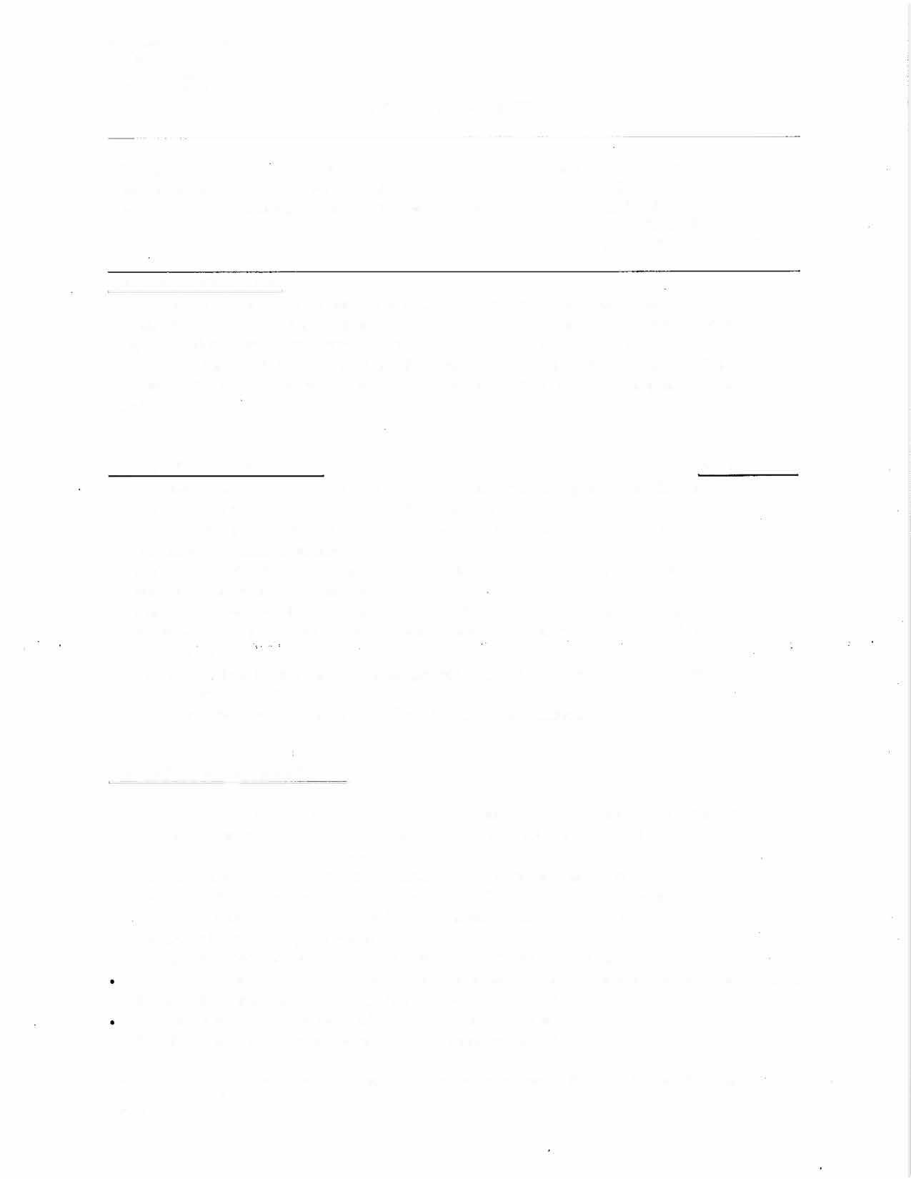

MINIMUM REQUIREMENTS:
- 5-6 years’ experience with broad customs classification experience using the Harmonized Tariff Schedule in an international transportation or customs brokerage atmosphere
- 2-5 year’s customer service experience
- Extensive knowledge of Customs Compliance, Reasonable Care requirements, Recordkeeping requirements, GSP requirements, ISF process, Documentation requirements, FDA requirements, OGA and overall understanding of import entry process
- Bachelor’s Degree or equivalent in work experience
- Strong self-motivation and the ability to work aggressively to complete projects
- Must possess strong written and oral communication skills and be able to communicate with all levels and departments both within and outside the company
- High level working knowledge of Microsoft Word, Excel and Access
- Excellent analytical, organizational and communication skills


PREFERRED REQUIREMENTS:
- Licensed U S Customs Broker
- Customs Compliance background specifically associated with the retail industry
- College degree in Transportation or Logistics or equivalent work experience
- 7-8 years of international transportation operations\staff experience
- 4-6 years of customer service experience
- Experience with Transportation and Compliance systems
- Experience with hands-on utilization of current supply-chain software applications and systems
- Foreign Trade Zone experience
SUPERVISORY RESPONSIBILITIES:
None

