
Import Specialist
Customs Compliance
Customs Compliance Manager
6/22/17

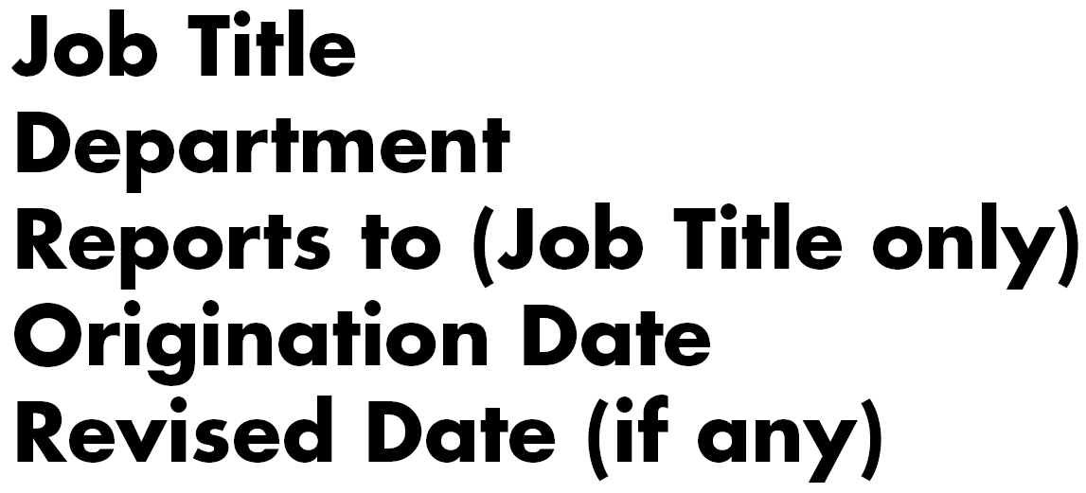
The primary role of this position is to assist the Customs Compliance Manager(s) in tasks that support the day-to-day import operations of the business and to implement processes to achieve import compliance. The Import Specialist works with business units and functions to ensure trade compliance requirements are incorporated into local work instructions.

- Daily monitoring, inquiry, resolution and communication with internal and external parties to facilitate timely movement of import shipments to US.

- Work with shippers, freight forwarders, import brokers to ensure all information and documentation is complete and accurate for import declarations and processes.

- Review and verify import broker entries. Provide direction to brokers to make corrections when errors are found.

- Act as point of contact and resolve discrepancies or inaccuracies related to invoicing from import brokers, freight forwarders, and carriers to ensure timely payment.

- Maintain recordkeeping database for import and export documentation.

- Special projects and duties as assigned

Education
- Bachelors of Science/Administration Degree in related area preferred.
- Licensed Customs Broker or interest in becoming licensed in the future
Experience
- 2 to 4 years import compliance experience required either in the Customs Brokerage field or supply chain environment.
Key Skills
- Working knowledge of global trade regulations: Customs Regulations, Harmonized Tariff Schedule of the United States (HTSUS).
- High ethical standards, demonstrated success in applying independent judgment, strong project development and management skills.
- Organization, prioritization and time management skills.
- Excellent communication skills, both verbal and written.
- Analytical and math skills

