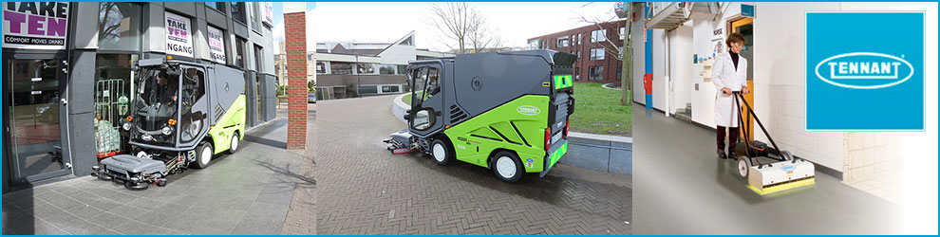
Tennant employees work to create a cleaner, safer, healthier world. Recognized leader in designing, manufacturing and marketing floor cleaning equipment and solutions, Tennant is a company that cares about what it's doing, and the sustainability of its products, and works every day to develop new solutions that clean exceptionally well, but don't damage the environment.

Job Description / Export Compliance Analyst I

Ensure Tennant Company’s adherence to U.S. and international export laws and regulations as it relates to the importation/exportation of Tennant goods and technology. Responsible for daily North American import/export operations (US, Canada & Mexico). Resolution of any issues impacting the movement of Tennant goods across international borders.

General Responsibilities

List only key activities describing major tasks/duties, essential responsibilities, accountabilities, work relationships, and key activities associated with the role.
- Administer the embargoed country, restricted party screening and export controlled shipment processes
- Resolve daily inquiries from Intl Customer Service regarding US export shipments
- Monitor daily operations of Mexican importations with designated customs brokers and resolve border issues
- Monitor daily operations of Canadian importations (non-resident importer of record program)
- Assign country of origin for US, China, Australia & Japan Tennant manufactured items (i.e. machines, parts, etc.)
- Support International Customer Service with non-SAP export transactions
- Review the administration of ACE system used for US export clearances
- Create US free trade agreement certificates of origin for international customers.
- Act as a resource for International Customer Service on compliance issues.
- Support accuracy and integrity of global compliance data within SAP and with 3rd Party global product databases (e.g. customs brokers)
- Maintain written policies and procedures related to import/export operation procedures
- Export / import documentation preparation
- Provide support with customs compliance projects as needed

REQUIRED EXPERIENCE & EDUCATION:
- 4 Year college degree, preferably in business, logistics, transportation operations
- One to Two years’ experience with international import/export operations
- Ability to interact with various functional groups within Tennant
- Strong analytical, organization and communication skills
- Ability to work independently and as a team member
- Knowledge of MS Word & Excel

Preferred
- Knowledge of Free Trade Agreements
- Knowledge of international transportation
- Knowledge of SAP ERP system a plus

REQUIRED INTERPERSONAL & BEHAVIORAL SKILLS: In addition to the General Responsibilities, the following are requisite interpersonal and behavior skills of the position as well as:
- Ability to problem-solve.
- Ability to concentrate on tasks, make decisions and work calmly and effectively in a high-pressure, deadline oriented environment.
- Willingness to be flexible with time and adjust to a changing work environment.
- Ability to build and maintain positive relationships, both internally and externally, while maintaining a client service orientation.
- Consistent attendance either onsite or remotely as needed by the business.
- Demonstrated ability to work independently, organize and accurately prioritize work, be detail-oriented, understand when urgency is required and use good judgment in varied situations.
Tennant Company
Tennant Company is a recognized leader in designing, manufacturing and marketing solutions that help create a cleaner, safer, healthier world. With a vision to become a global leader in sustainable cleaning innovation that empowers our customers to create a cleaner, safer and healthier world, Tennant creates solutions that are changing the way the world cleans. Tennant products include equipment used to maintain indoor and outdoor surfaces, as well as TennantTrue® financing solutions, equipment parts, service, and maintenance to help ensure superior cleaning performance from your Tennant machines. Products are marketed under the Tennant®, Nobles®, Green Machines®, Orbio® and Alfa brands.

Contact Information
Recruiter Name: Michael J Burns
Recruiter Email Address Michael.Burns@tennantco.com
Equal Opportunity Employer
Tennant Company is committed to being an equal opportunity employer. Employment decisions are made on the basis of individual skill, ability, reliability, productivity, and other factors important to performance. We do not discriminate on the basis of race, color, creed, religion, sex, national origin, physical or mental disability, age, veteran status, pregnancy, sexual orientation, genetic information, gender identity, or any other basis protected by state or federal law or local ordinance.
Employees of Tennant Company work with a spirit of Stewardship. Very simply, Stewardship is a filter for our actions and decisions, as we strive to leave things in better condition than when we found them.
