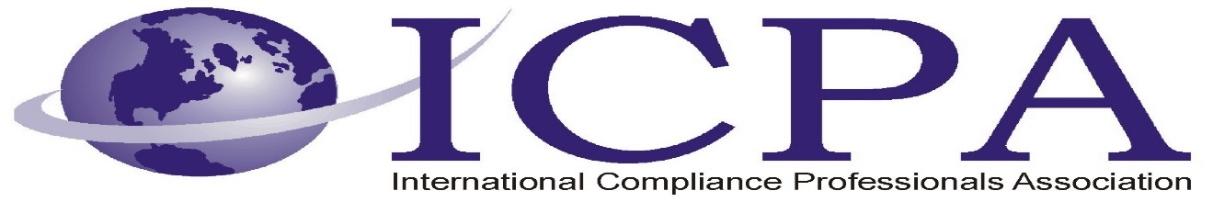

Job Opportunity

Company | The Boeing Company
Job Title | Global Trade Control Manager
Location | Australia, Singapore, Japan, Korea
Salary Range
Relocation Assistance | No

Job Description / Responsibilities / Requirements

Description

The Global Trade Controls (GTC) – International Manager will be responsible for the management of Global Trade Control Specialists located in Japan, China, Singapore and Australia and reports to the Global Trade Controls Senior Manager located in the United States.

The individual selected will be responsible for delivering compliant and efficient global trade solutions through strategic engagement with key business leaders and government regulators.

Must be able to travel up to 25% of the time. Security Clearance may be required.

Primary Responsibilities include, but are not limited to:
- Coach, guide, mentor and provide developmental opportunities and to enhance employee performance and engagement.
- Resolution of trade control issues throughout Boeing International regions; providing expert guidance to Boeing business stakeholders and supervisory oversight to Trade Control Specialist.
- Engagement at various levels with government trade control authorities throughout all Boeing International regions in East Asia to facilitate trade control matters for Boeing business activities.
- Collaboration with Boeing International regional offices and Boeing businesses to integrate activities into the broader GTC mission and provide support to stakeholders.
- Ensure the establishment and implementation of Export/Import Compliance Plans throughout Boeing Non-US entities in East Asia.
- Develop and maintain relationships and partnerships with businesses and functions at Boeing U.S. and non-U.S. locations.
- Provide support to GTCs Global Compliance and Requirements (GC&R) organization for audits and assessments and coordinate with Boeing Global Law Affairs on sensitive matters as required or directed.

Qualifications
- Extensive global trade control experience in an MNC environment
- Possession of a relevant degree or a combination of educational qualifications and experience
- Excellent communications and inter-personal skills
- Ability to manage teams

Contact Information to Apply

Apply online at www.boeing.com/careers. Refer to requisition number 1700006067.

