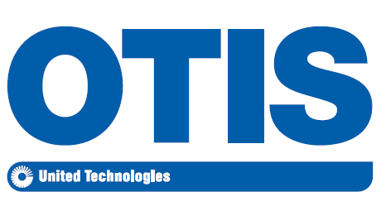
Otis, a United Technologies company, is the world leader in reliable, efficient and technologically advanced elevators, escalators and people-moving systems. Our revolutionary Gen2® elevators, energy-saving ReGen™ drives and NCE “green” escalator have clearly set the industry standard for innovation, safety and performance. More than 2.4 million Otis elevators and escalators are currently in operation throughout 200 different countries. We are proud to have a global team that continues to rise to the challenges of a fast-moving company. Together, the people of Otis are creating new ideas and opportunities by collaborating across time zones, geographies and cultures. So just imagine where we can take you!
Job: International Trade Compliance Specialist
Business Unit: Otis Elevator Company
Location: Florence, South Carolina USA

Education / Certifications
BA/BS degree
Job Description:
- The ITC Specialist will be responsible for verifying import business activities are compliant with U.S Import regulations & corporate policies.
- Execute and establishing new and existing international trade import policies and processes.
- Provide advice and guidance to Otis ITC Team on importing functions
- Manage Customs Brokers and day to day importer operations.
- Maintain applicable trade compliance records in accordance with U.S. regulations and corporate policy
- This position will be based in Florence, South Carolina.
Experience / Qualifications

- Individual should have a strong understanding of Customs regulations with a minimum of 5 years of experience.
- Has in depth knowledge of the U.S. importer discipline and role
- Knowledge and execution of U.S. classification (HTS) & Canadian classification
- Knowledge of Customs valuation processes Customs country of origin processes & PGA.
- Logistics experience
- Experience with JDE preferred
- Knowledge of some export regulations preferred
- Contributes to their team, department and or business unit by applying their knowledge.
- Ability to analyze and apply regulations to various import business processes and functions
- Proficiency using Windows/Microsoft Office Suite (i.e., Word, Excel, PowerPoint, Visio).
- This role requires strong inter-personal attributes including: high ethical standards, strong organizational and communication skills, leadership skills, highly self-motivated & a team player.
- Fully developed professional able to work with minimum supervision

*EEO/AAP Statement
United Technologies Corporation is An Equal Opportunity/Affirmative Action Employer. All qualified applicants will receive consideration for employment without regard to race, color, religion, sex, sexual orientation, gender identity, national origin, disability or veteran status, age or any other federally protected class.

