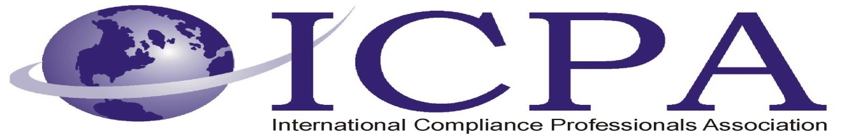

Job Opportunity

Company | Alcoa
Job Title | Export Compliance Manager
Location | Torrance, CA
Salary Range | DOE
Relocation Assistance | Negotiable

Job Description / Responsibilities / Requirements
Alcoa Fastening Systems & RIngs (AFSR) has an exciting opportunity for an Export Compliance Manager to work with Operations to ensure all manufacturing finished products and raw materials are effectively managed and meet all US and foreign government export laws and regulations. Supports compliance goals and drives toward leading edge compliance program. This position is located in Torrance, CA.
AFSR serves the global aerospace, automotive, and commercial transportation markets with the most specialized engineering, highest quality, and the greatest breadth and depth of fastening system solutions and seamless rolled rings in our industry. Headquartered in Torrance, CA; AFSR employs over 8,700 people in 13 countries at 39 locations. AFSR is a business unit of Alcoa, Inc. (NYSE:AA)

Key Responsibilities:
- Responsible for the implementation and administration of import and export compliance programs for ITAR/EAR controlled goods and technologies to ensure polices and procedures comply with both US Government regulations, corporate and BU policies and procedures and are consistent with industry best practices.
- Will also be responsible to ensure that the company's exports are compliant with the regulations of the EAR (Export Administration Regulations) or the ITAR (International Traffic in Arms Regulations) by assuring the goods have the correct ECCN (Export Commodity Classification Number), or ITAR munitions list classificaiton by working wtih Engineering.
- Maintain and ensure compliance with required Export records are required by Corporate policy, U.S. Customs Regulations, DoC Export Administration Regulations and DoS International Traffic in Arms Regulations for acurate and proper retention.
- Ensures timely reponses/guideance and completes export projects on schedule.
- Contributes to development of a system to manage the documentation required by export operations.
- Will assist the Director of Global Trade Compliance, Transportation and Cargo Security to establish a compliance program and will become responsible for supporting acquisition IMEX program on a going-forward basis once internal processes have become stabilized.
- Maintain associated data logs and department metrics. Perform process audits periodically to ensure compliance to all export related internal procedures and applicable laws and regulations.
- Primary point of contact for request to draft and submit licenses, agreements, product classification request and general correspondence, allowing adequate time for review.

Basic Qualifications:
- Bachelor's degree
- 8 years of experience in international trade, export operations, and export compliance
- U.S citizenship
Preferred Qualifications:
- Complete working knowledge of all US Compliance Rules and Regulations. Knowledge of BIS, DTC, OFAC and all other related trade legislation, rules, and regulations.
- Experience in implementing compliance processes in a manufacturing environment.
- Experience with Export Management System process controls
- Working knowledge of Anti-Boycott Compliance.
- Experience in interacting with senior level management and all levels of employees.

Contact Information to Apply
For consideration, please apply via the Alcoa Careers Page: https://sjobs.brassring.com/1033/ASP/TG/cim_jobdetail.asp?partnerid=16&siteid=56&AReq=16023BR
Or visit www.AlcoaCareers.com and search for job #16023

