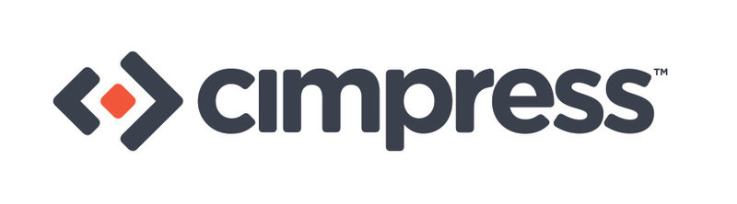
Title: North American Trade Compliance Analyst

Cimpress N.V. is the global leader in mass customization. We are a technology and manufacturing-driven company that aggregates, via the Internet, large volumes of small, individually customized orders for a broad spectrum of print, signage, apparel and similar products. We have production facilities in The Netherlands, Canada, Austria, Australia, France, Italy, Norway and India. As part of our Mass Customization Platform (MCP), we have invested in a strategic supply chain management capability that is tightly integrated with our other manufacturing teams. The North American Trade Compliance Analyst will play a key role supporting MCP by managing world class programs for the efficient cross-border movement of goods throughout North America, with the potential for additional global opportunities.

As a member the Cimpress Legal Group and reporting directly to Director of Trade Compliance in the U.S., you will be part of a team providing both strategic and tactical support to our expanding businesses and will help maintain the highest level of service to our customers.

You will be responsible for a full range of Trade Compliance activities and be expected to help identify potential issues as Cimpress’ manufacturing and supply chain functions continue to grow and evolve. Primary responsibilities for this role include:

- Customs transactional issue management:
- Respond to inquiries from Customs Brokers and internal customers and
resolve any issues impacting shipments including raw materials, plant equipment,
consumables and spares

- Harmonized Tariff System (HTS) Classification:
- Review and apply US, Canadian and other regional HTS codes to the product catalog
using the Customs Tariff, precedent Rulings and Explanatory Notes
- Create clear product descriptions as required under the Customs Regulations
- Review and update the existing Trade Compliance database

- Trade Compliance auditing:
- Review shipment documentation for the consistent and correct usage of HTS Codes,
valuation, Country of Origin and preferential trade programs
- Identify shipments requiring post-entry amendments

- Customs Recordkeeping program:
- Ensure that all Customs Entry files have been received and contain
all required documentation

- Customs Broker Reviews:
- Use service provider and Customs’ reports to evaluate performance
- Prepare a comprehensive metrics review of Key Performance Indicators
- Identify areas requiring improvement and develop solutions

Requirements:
- Bachelor’s degree, preferably in a business discipline
- Licensed Customs Broker / Certified Customs Specialist a plus
- Minimum two years’ experience in international trade (importing / exporting)
- Significant experience with classification under the Harmonized Tariff System (HTS)
- Strong work ethic with a high level of personal integrity
- Demonstrated analysis and problem solving skills
- Able to work independently as well as collaborate with other teams
- Hands on proficiency with Microsoft Office applications (Excel, Word, Power Point, Outlook)
- Exceptional oral and written communication skills
- Travel < 10 %
https://careers-cimpress.icims.com/jobs/15276/job

