Enriching Southwest Florida’s culture, conducting research that breaks new ground by using the region as our living laboratory and ensuring student success in the classroom and beyond. That’s the FGCU effect. See what effect we will have on you. We are currently seeking a…
Director of Compliance and Risk Management
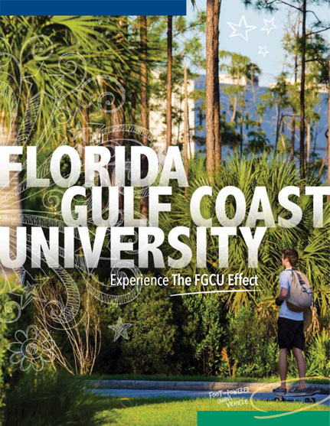

Florida Gulf Coast University is seeking an experienced compliance professional to apply for the position of Director of Compliance and Risk Management. This new position will report directly to the University President and will be responsible for decisions regarding the University’s compliance and ethics program. This position will work independently as well as with the University President and Cabinet, overseeing University-wide compliance efforts, ensuring institutional compliance with federal and state regulations, as well as industry standards.
As a member of the University’s senior management team establishing a new function, you will provide leadership, innovation, governance, and management necessary to identify, mitigate, and manage operational and strategic risk. You will develop compliance tools, practices, and policies to assist in managing risk. You will develop and establish an effective university-wide compliance and ethics program designed to prevent, monitor, and respond to non-compliance and recommend corrective actions to meet regulatory requirements, including training to promote compliance awareness.
The successful candidate must possess a bachelor’s degree from an accredited college or university in Business Administration, Finance, Accounting, or closely related field and have a minimum of seven (7) years of progressive experience in compliance, enterprise risk management, auditing, project management, or related field.
The ideal candidate would possess a master’s degree or juris doctorate and have ten years of directly related compliance and risk management experience with at least three (3) years of that experience in a leadership role. Professional certification such as Certified Compliance and Ethics Professional (CCEP), Associate in Risk Management (ARM), Certified Public Accountant (CPA), Certified Internal Auditor (CIA) is a plus.

Learn more about what FGCU has to offer you!
FGCU is a growing, comprehensive public institution offering a broad array of undergraduate and graduate programs in arts and sciences, business, engineering, environmental science, computer science, education, nursing/allied health, resort & hospitality management, public administration and social services. The University, with its innovative programs, technology friendly campus, and outstanding faculty/staff, is one of the most exciting educational environments in America.
Enjoy nearby wonderful recreational activities - beaches, bike trails, parks and water, as well as, theatre, arts and music. To learn a little bit more about us, please visit http://youtu.be/4zrbKt_nFSU.
In addition to an exciting work environment, FGCU offers exceptional benefits packages including thirteen (13) paid holidays per year, tuition vouchers for employees and/or dependents, and generous leave accrual. For more information, click here: http://www.fgcu.edu/HR/fcapbenefits.html
If you are a performance driven, innovative and progressive person, looking for a new challenge in your career, then FGCU has the opportunity you are looking for.
For additional information about this exciting opportunity and to submit your application, please visit us at https://jobs.fgcu.edu.
Review of materials will continue until the position is filled.
FGCU is an EOE AA M/F/Vet/Disability Employer

