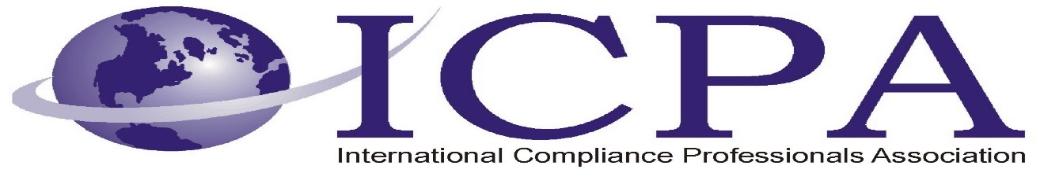

Job Opportunity

Company | DynCorp International LLC
Job Title | Senior Manager – Ethics & Compliance Operations  (Future Opportunity)
Location | Dubai, UAE and TBD, Nigeria
Salary Range | Open
Relocation Assistance | Open

Job Description / Responsibilities / Requirements

Job Summary

This job positing is for a future opportunity - Primary responsibility for the operational execution of ethics/compliance and Trade Compliance related initiatives and activities in support of the Ethics and Compliance department. The individual will work closely with the Chief Ethics & Compliance Officer as part of this role. Ensures implementation of DI policies, CEO initiatives and directives; and support the Nigeria program in creating and sustaining a regulatory compliant culture across all Nigerian operations.

Principle Accountabilities

JOB DUTIES & RESPONSIBILITIES

- Assist VP and Chief Ethics & Compliance Officer with the creation of organizational strategy for Nigerian operations.
- Create and implement short and long-term objectives, goals, and project plans for the Ethics & Compliance department.
- Serves as an Empowered Official pursuant to the ITAR, for the day-to-day operational compliance with all Export and Import laws and regulations, and certifies compliance to the Chief Compliance Officer
- Develops strategic initiatives to ensure DI maintains its standing, and avoids fines (administrative and criminal), debarment and/or suspension.
- Serves as DI’s expert in Import compliance, ensuring that all Customs transactions are handled with reasonable care, regarding the classification, valuation, admissibility, and marking of merchandise entered, and the payment of Customs duties and fees.
- Promote contract-wide adherence to DI’s Code of Ethics and Business Conduct
- Assist in the development of program specific ethics and trade compliance training, communication, and awareness risks
- Engage in the regular and systematic identification and assessment of risks and implement actions to mitigate and eliminate
- Assist the Nigerian organization in support of contract-wide compliance risks, including but not limited to:
  - FCPA Compliance
  - UK Bribery Act Compliance
  - International Traffic in Arms Regulations
  - Export Administration Regulations
  - Nigerian and UAE corruption regulations
  - Contract Risk Assessment Follow-up
  - Facilitation of inter-departmental communication on compliance issues
- Conduct routine and complex investigations to isolate allegations, ascertain facts, findings, and present recommendations to the appropriate level of management.
- Prepare concise, factual, comprehensive written reports and update investigation database (Ethicspoint) with current activity in a timely manner
- Interact with all PEO and Corporate business partners and provide constructive, timely, effective written and verbal feedback to minimize risks to the company
- Provide advice and counsel to leadership and employees on ethics/compliance related issues
- Assist Ethics & Compliance investigators with tasks and/or investigations as required
- Be an ethical role model for the organization

OTHER or ADDITIONAL RESPONSIBILITIES
- Other duties as required
- Remain abreast of evolving regulations, trends, risks, and best practices in the Ethics/Compliance fields

Reporting Relationships

Direct Report(s): No Direct Reports

Reports To: VP and Chief Compliance Officer

Internal/External Contacts

This position will regularly interface with Executive leadership, Legal, HR, Security, Program/PEO leads and other organizations on an ongoing basis.

Knowledge & Skills
- Ability to consistently exercise sound judgment and discretion in addressing issues and elevate significant concerns to the appropriate level of executive management
- Must have a demonstrated pattern of exceptional personal conduct
- Excellent interpersonal and communication skills with the ability to effectively interface with all levels of the organization and drive towards execution
- Experience performing investigations of sensitive nature as required
- Self starter with the ability to effectively prioritize workload with minimal supervision
- Ability to identify trends and assist in developing training and communication to mitigate future issues and risk
- Proven experience with Microsoft and web based programs for report writing

Experience & Education
- 8 + years of experience working in a corporate Ethics/Compliance function or similar organization
- Bachelor’s degree in a preferred. Years of experience may be substituted for degree.
- Experience conducting investigations at all levels
- Expertise in communicating with multiple levels of an organization
- Experience with the International Trade Regulations required - Experience as an Empowered Official a plus
- Experience with International Anti-Corruption regulations with specific focus on Foreign Corrupt Powers Act (FCPA), UK Bribery Act, and regional and local regulations required
- Experience with Human Trafficking in Persons regulations and conventions

Physical Requirements/Working Environment
- Primarily works in an office environment. Primary work location will be located in Nigeria and with Temporary Duty in Dubai, UAE

Travel

Travel will be a requirement of the position, on an as-needed basis to meet organizational objectives.

Location Specific Considerations

Will require travel to UAE and/or Nigeria, or other international locations.

Disclaimer

The above information on this description has been designed to indicate the general nature and level of work performed by employees within this classification. It is not designed to contain or be interpreted as a comprehensive inventory of all duties, responsibilities, and qualifications required of employees assigned to this job.

Contact Information to Apply

Please send your resume to joseph.veiga@dyn-intl.com

