
THE INTERNATIONAL TRADE CLUB OF CHICAGO
IMPORT/EXPORT WORKSHOP SERIES
Presents
Customs Compliance Case Studies: Common Predicaments and Pitfalls
Tuesday, September 29, 2015
9:00 a.m. to 12:00 p.m.

This workshop will cover a wide variety of the most common compliance legal challenges and predicaments faced by in-house compliance personnel. Particularly difficult and yet common factual situations will be identified and described in detail and a framework will be discussed and developed with the input of attendees for dealing with each factual scenario. Common problems encountered on the route to solving the problems faced will also be discussed.

- The profit-destroying classification error
- The massive undiscovered antidumping and/or countervailing duty liability
- Repeated CF-28s and Detentions
- The unsupportable NAFTA claim

- Related party sales where transaction value does not apply
- Classification and valuation of prototypes
- The notice of investigation for undeclared assists
- The un-announced visit by CBP

Location: DePaul University, O’Hare Campus, 8770 W. Bryn Mawr Ave. Chicago, IL
Speakers: Brian F. Walsh, Barnes, Richardson & Colburn LLP, Chicago, IL
David G. Forgue, Barnes, Richardson & Colburn LLP, Chicago, IL
Program Chair: Brian F. Walsh, Barnes, Richardson & Colburn, LLP

A fee of $60 will be charged for ITCC members and $95 for non-members. The DePaul O’Hare campus facility is located at the intersection of East River Road and West Bryn Mawr Avenue; directions to the facility are attached to this email. The International Trade Club of Chicago (ITCC) is a not-for-profit organization and all proceeds are used solely to cover the cost of ITCC activities. The ITCC appreciates the efforts of the volunteer speakers.

*NEW - This seminar is also available via LIVE WEBINAR. A fee of $125 will be charged for webinar participation.* Click http://www.itcc.org/eventshow.asp?event_id=636& to sign up for the webinar.
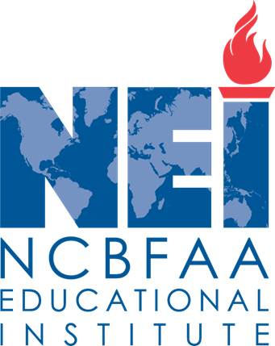
CONTINUING EDUCATION CREDIT
ATTENTION CERTIFIED CUSTOMS SPECIALISTS and ATTORNEYS: This program is approved by the NCBFAA for 3 CCS continuing education points. Please inform us of your NEI ID number at the time of registration. In addition, the Import Workshop Series is designated as a CLE provider by the Minimum Continuing Legal Education Board of the Supreme Court of Illinois. This program will provide three hours of credit. The ITCC will seek CLE approval for its programs from other states upon request. A $50 supplement will be charged attorneys to cover costs, including Supreme Court fees. Please indicate if a certificate of attendance is desired when you make your reservation.

NOW REGISTER AND PAY ONLINE at http://www.itcc.org and select appropriate date/workshop or webinar on homepage. Paypal accepted OR RESPOND VIA E-MAIL TO itcc@brc-chi.com OR FAX THIS FORM TO (312) 565-1782 OR RETURN THIS FORM WITH CHECK, PAYABLE TO INTERNATIONAL TRADE CLUB OF CHICAGO c/o 303 E. Wacker Drive, #1020, CHICAGO, IL 60601.
- - - - - - - - - - - - - - - - - - - - - - - - - - - - - - - - - - - - - - - - - - - - - - - - - - - - - - - - - - - - - - - - - - - - - - - - - - - - - - - - - - - - - - - - - - - - - - - - - - -

Attendance Certificate

CCS Credit

CLE Certificate

Payment Enclosed

Is Being Mailed

Will Pay at Door
TO ADD OTHERS TO OUR MAILING LIST, PLEASE SEND AN E-MAIL TO: itcc@brc-chi.com
Please make _____ reservation(s) for the September 29, 2015 Import/Export Workshop.

NAME: ________________________________________________________________________

E-MAIL ADDRESS: _____________________________________________________________

COMPANY: ___________________________________________________________________

ADDRESS: ____________________________________________________________________
PHONE: _____________________________________________________________________

For further information, please contact Brian F. Walsh, ITCC Workshop Series chair at (312) 565-2000.

