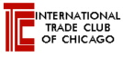
THE INTERNATIONAL TRADE CLUB OF CHICAGO
IMPORT/EXPORT WORKSHOP SERIES
Presents
BIS Briefing: The New Regulatory Definitions and Export Enforcement
Thursday, September 29, 2016
9:00 a.m. to 12:00 p.m.

Attention All Exporters. Hillary Hess, who is the Director of the BIS Regulatory Policy Division in Washington, D.C., will be joining us to discuss the important final rule which went into effect on September 1st as part of the Export Control Reform Initiative containing new definitions for many terms of fundamental significance including, among others: “technology,” “foreign person,” “release,” “export,” “reexport,” and “transfer.” The new rule also addresses the application of controls to electronically transmitted and stored technology and software. Richard Greene, who is the Special Agent in the Office of Export Enforcement, will also be discussing the implementation of best practices for complying with the EAR and investigations and penalties.

- Understanding the new Definitions Rule
- Activities considered to be exports
- Impact of the Definitions Rule on Cloud-Based Computing
- Reviewing exports of technology and technical data under the new rule
- Best practices for complying with export control regulations
- Understanding export investigations and penalties

Location: DePaul University, O’Hare Campus, 8770 W. Bryn Mawr Ave. Chicago, IL
Speakers: Hillary Hess, Director, Regulatory Policy Division, Bureau of Industry and Security
Richard Greene, Special Agent, Office of Export Enforcement, Bureau of Industry
and Security
Program Chair: Brian F. Walsh, Barnes, Richardson & Colburn, LLP, Chicago, IL

A fee of $60 will be charged for ITCC members and $95 for non-members. The DePaul O’Hare campus facility is located at the intersection of East River Road and West Bryn Mawr Avenue; directions to the facility are attached to this email. The International Trade Club of Chicago (ITCC) is a not-for-profit organization and all proceeds are used solely to cover the cost of ITCC activities. The ITCC appreciates the efforts of the volunteer speakers.

*NEW - This seminar is also available via LIVE WEBINAR. A fee of $125 will be charged for webinar participation.* Click http://www.itcc.org/eventshow.asp?event_id=636& to sign up for the webinar.
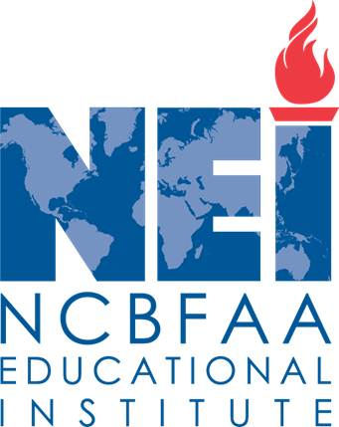
CONTINUING EDUCATION CREDIT
ATTENTION CERTIFIED CUSTOMS SPECIALISTS and ATTORNEYS: This program is approved by the NCBFAA for 3 CCS continuing education points. Please inform us of your NEI ID number at the time of registration. Please indicate if a certificate of attendance is desired when you make your reservation.

NOW REGISTER AND PAY ONLINE at http://www.itcc.org and select appropriate date/workshop or webinar on homepage. Paypal accepted OR RESPOND VIA E-MAIL TO itcc@brc-chi.com OR FAX THIS FORM TO (312) 565-1782 OR RETURN THIS FORM WITH CHECK, PAYABLE TO INTERNATIONAL TRADE CLUB OF CHICAGO c/o 303 E. Wacker Drive, #1020, CHICAGO, IL 60601.
- - - - - - - - - - - - - - - - - - - - - - - - - - - - - - - - - - - - - - - - - - - - - - - - - - - - - - - - - - - - - - - - - - - - - - - - - - - - - - - - - - - - - - - - - - - - - - - - - - -

Attendance Certificate

CCS Credit

Payment Enclosed

Is Being Mailed

Will Pay at Door
TO ADD OTHERS TO OUR MAILING LIST, PLEASE SEND AN E-MAIL TO: itcc@brc-chi.com
Please make _____ reservation(s) for the September 29, 2016 Import/Export Workshop.

NAME: ________________________________________________________________________

E-MAIL ADDRESS: _____________________________________________________________

COMPANY: ___________________________________________________________________

ADDRESS: ____________________________________________________________________
PHONE: _____________________________________________________________________

For further information, please contact Brian F. Walsh, ITCC Workshop Series chair at (312) 565-2000.

