Log into the ACE portal and go to Accounts>Importer>Mode of Communication
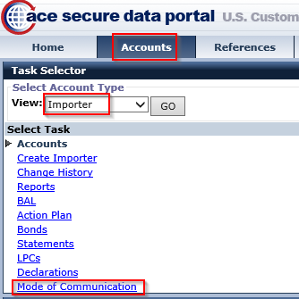
Select “Edit” and check the “Mail” option then “Save”
