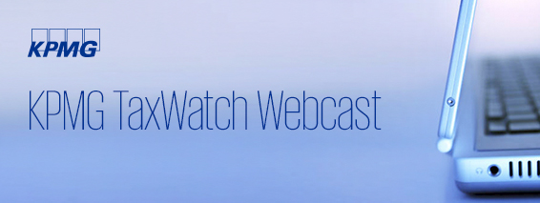

Managing CBP’s new approach to Audits
Date:  Monday, December 5, 2016 | Time:  2:00 p.m. – 3:00 p.m. (U.S EST)


A significant number of U.S. importers have recently been put on notice of their standing obligations to be compliant with customs laws. These companies received letters from U.S. Customs and Border Protection (CBP) Regulatory Audit encouraging them to review their recent trade data and available Informed Compliance Publications. These letters explained to the recipient the potential enforcement actions in the event of non-compliance.
The issuance of this notice has raised concerns and questions among the importing community.
KPMG LLP (KPMG) is pleased to invite you to a 60-minute Webcast to explore CBP’s intent, audit methodologies and current areas of audit emphasis. Professionals from KPMG’s Trade and Customs Practice as well as guest speakers from CBP Office of Trade’s Regulatory Audit will provide background and insight into these recent developments and will also discuss the potential impact on US importers.
Specifically, the Webcast will cover:
⎯ Rationale and importance of the informed compliance letters
issued by Regulatory Audit
⎯ Differences between audits, surveys and focused assessments
⎯ What this all means for importers and how to ensure you are
compliant
Please join us for what promises to be an insightful and informative Webcast.
After registering, you will receive details on how to log in to the Webcast or dial in for audio-only participation. Continuing professional education (CPE) credit is available to U.S. participants who meet the eligibility requirements.
Presenters
Douglas Zuvich
Partner, Trade & Customs, KPMG LLP
Andrew Siciliano
Partner, Trade & Customs, KPMG LLP

Guest Speakers from CBP Office of Trade’s Regulatory Audit including:
James T. Madden
CBP Office of Trade’s Regulatory Audit, Field Director, New York, NY
Teresa Halpin
CBP Office of Trade’s Regulatory Audit, Assistant Field Director, New York, NY
Joan Colby
CBP Office of Trade’s Regulatory Audit, Assistant Field Director, New York, NY

  KPMG is registered with the National Association of State Boards of Accountancy (NASBA) as a sponsor of continuing professional education on the National Registry of CPE Sponsors. State boards of accountancy have final authority on the acceptance of individual courses for CPE credit. Complaints regarding registered sponsors may be addressed to the National Registry of CPE Sponsors, 150 Fourth Avenue North, Suite 700, Nashville, TN 37219-2417. Web site: www.nasba.org.
  KPMG provides reasonable accommodations to employees who request such accommodations to participate in training. Individuals requesting such an accommodation(s) should contact their local HR professional at least two weeks prior to the start date of the program.
  Privacy | Legal
  You have received this message from KPMG LLP. If you wish to unsubscribe from TaxWatch webcast, please click here. If you wish to unsubscribe from all KPMG communications, please click here.
  KPMG LLP, 3 Chestnut Ridge Road Montvale, NJ 07645
  © 2016 KPMG LLP, a Delaware limited liability partnership and the U.S. member firm of the KPMG network of independent member firms affiliated with KPMG International Cooperative (“KPMG International”), a Swiss entity. All rights reserved.
  The KPMG name and logo are registered trademarks or trademarks of KPMG International.
  kpmg.com/socialmedia

