
THE INTERNATIONAL TRADE CLUB OF CHICAGO
IMPORT/EXPORT WORKSHOP SERIES
Presents
Prior Disclosures, Penalties, Redelivery Notices & Liquidated Damages
Friday, January 29, 2016
9:00 a.m. to 12:00 p.m.

Attention All Importers, Customs Brokers, In-House Lawyers and other interested persons, understanding the regulations involved in importing goods into the United States can often be difficult and violations can occur no matter how effective your compliance may be. Prior disclosures are interesting in that they are often the first line of defense when an importer discovers that some violation has occurred. But, making and perfecting a prior disclosure is sometimes not a simple task. In addition, some violations cannot be disclosed and often to lead to notices for redelivery and the assessment of liquidated damages. This program will address the many complex issues surrounding prior disclosures, notices for redelivery and claims for liquidated damages.

- Legal effects of Prior Disclosure
- When and how to disclose
- Penalties assessed by CBP
- The concept of Reasonable Care

- When are Notices of Redelivery issued?
- Effects of Redelivery Notices
- Types of liquidated damages cases
- Cancellation or mitigation of liquidated damages

Location: DePaul University, O’Hare Campus, 8770 W. Bryn Mawr Ave. Chicago, IL
Speakers: Brian F. Walsh, Barnes, Richardson & Colburn LLP, Chicago, IL
Shama Patari, Barnes, Richardson & Colburn, LLP, Chicago, IL
Program Chair: Brian F. Walsh, Barnes, Richardson & Colburn, LLP, Chicago, IL

A fee of $60 will be charged for ITCC members and $95 for non-members. The DePaul O’Hare campus facility is located at the intersection of East River Road and West Bryn Mawr Avenue; directions to the facility are attached to this email. The International Trade Club of Chicago (ITCC) is a not-for-profit organization and all proceeds are used solely to cover the cost of ITCC activities. The ITCC appreciates the efforts of the volunteer speakers.

*NEW - This seminar is also available via LIVE WEBINAR. A fee of $125 will be charged for webinar participation.* Click http://www.itcc.org/eventshow.asp?event_id=636& to sign up for the webinar.
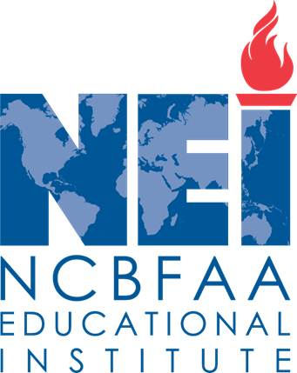
CONTINUING EDUCATION CREDIT
ATTENTION CERTIFIED CUSTOMS SPECIALISTS and ATTORNEYS: This program is approved by the NCBFAA for 3 CCS continuing education points. Please inform us of your NEI ID number at the time of registration. In addition, the Import Workshop Series is designated as a CLE provider by the Minimum Continuing Legal Education Board of the Supreme Court of Illinois. This program will provide three hours of credit. The ITCC will seek CLE approval for its programs from other states upon request. A $50 supplement will be charged attorneys to cover costs, including Supreme Court fees. Please indicate if a certificate of attendance is desired when you make your reservation.

NOW REGISTER AND PAY ONLINE at http://www.itcc.org and select appropriate date/workshop or webinar on homepage. Paypal accepted OR RESPOND VIA E-MAIL TO itcc@brc-chi.com OR FAX THIS FORM TO (312) 565-1782 OR RETURN THIS FORM WITH CHECK, PAYABLE TO INTERNATIONAL TRADE CLUB OF CHICAGO c/o 303 E. Wacker Drive, #1020, CHICAGO, IL 60601.
- - - - - - - - - - - - - - - - - - - - - - - - - - - - - - - - - - - - - - - - - - - - - - - - - - - - - - - - - - - - - - - - - - - - - - - - - - - - - - - - - - - - - - - - - - - - - - - - - - -

Attendance Certificate

CCS Credit

CLE Certificate

Payment Enclosed

Is Being Mailed

Will Pay at Door
TO ADD OTHERS TO OUR MAILING LIST, PLEASE SEND AN E-MAIL TO: itcc@brc-chi.com
Please make _____ reservation(s) for the January 29, 2016 Import/Export Workshop.

NAME: ________________________________________________________________________

E-MAIL ADDRESS: _____________________________________________________________

COMPANY: ___________________________________________________________________

ADDRESS: ____________________________________________________________________
PHONE: _____________________________________________________________________

For further information, please contact Brian F. Walsh, ITCC Workshop Series chair at (312) 565-2000.

