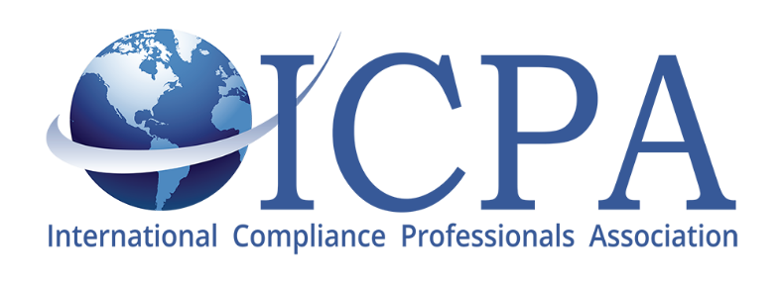
Proud to Offer a FREE Webinar Presentation:
Mitigating the Impact & Disruption to the Global Supply Chain: Covid-19
Thursday April 16, 2020 - 12:30 PM to 1:30 PM EST
Presented by:
Thomas Cook, Managing Director, Blue Tiger International, New York
ICPA is pleased to offer a webinar presentation regarding the Coronavirus, ways to mitigate as it is currently impacting all ICPA members their business’s and most recently affected ICPA itself.
The webinar content will focus on an up-to-date overview of the Covid-19 pandemic and the impact it is having on global supply chains.
Global logistics, import, export and supply chain issues will all be underscored and current challenges will be a focus of discussion.
The presentation will include recommendations, strategies and action-steps companies can utilize to mitigate the impact of the Coronavirus in their business models. Long-term management considerations for preventive measures and risk avoidance will also be included.
This 60-minute webinar will allow participant interface for comments and questions.
Agenda:
- Introductions
- Overview of the Coronavirus
- Impact on Global Trade
- Impact on Global Supply Chains
- USA, China and Europe
- Logistics and Transportation Infrastructures
- Trade Compliance in a “Covid-19” Supply Chain
- Procurement Management and Export Sales Development in the Face of the Pandemic
- Short-term Mitigation Strategies
- Long-term Management Strategies
- Summary & Questions
Cost: Free Registration to Close April 15, 2020 Click here to register
This webinar is being offered by the National Institute for World Trade.

