- Start by clciking on AES 202 USPPI Transaction Reports
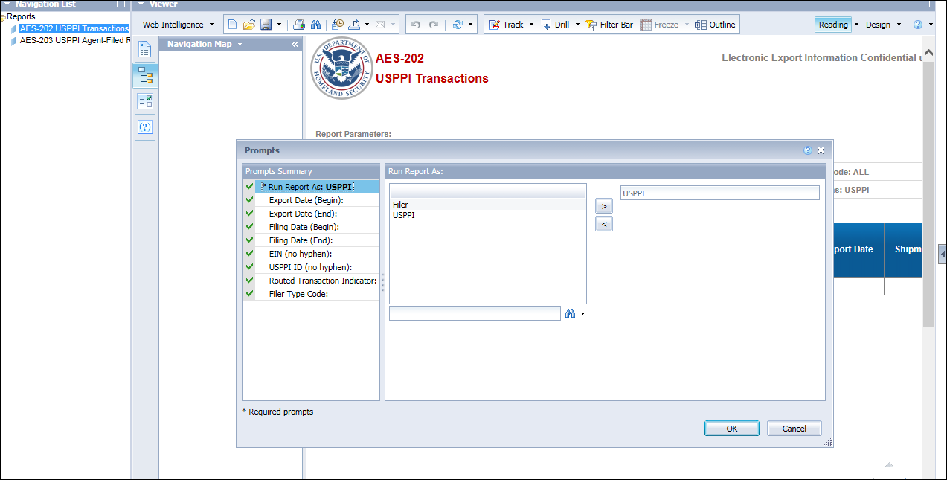
- Don’t enter any information, just click “Cancel”

- Click “Design”
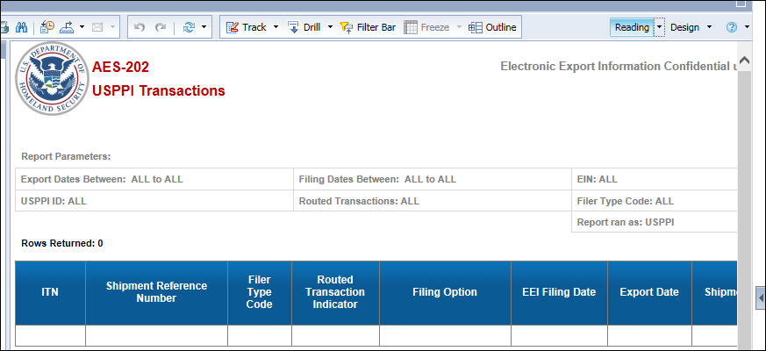

- Click “Data Access” then “Edit”
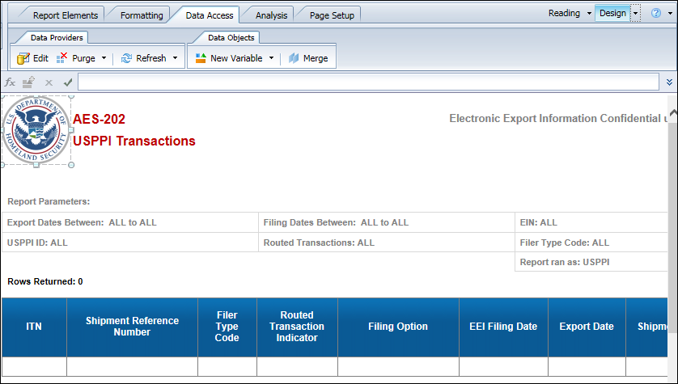

- Click “EEI” then scroll down to “Commodity Line” (a yellow folder)
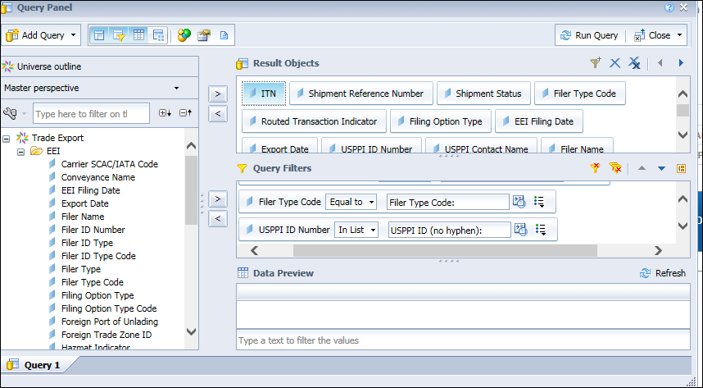

- See “Commodity Line”, then look for “Export Control Classification Number” (“ECCN”). Double click to add it to the Result Objects
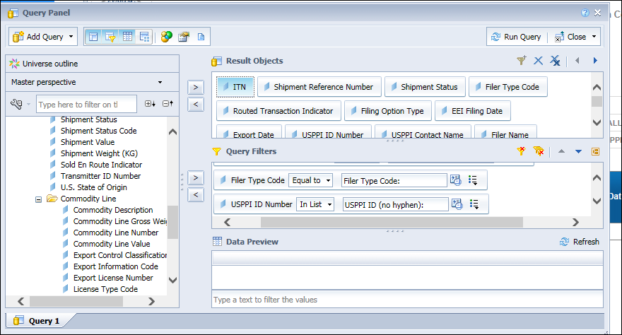
Click “Run Query” and include your dates of export or filing as necessary.
- Your results are ready but you must “pull” the ECCN info over. Click on the symbol circled.
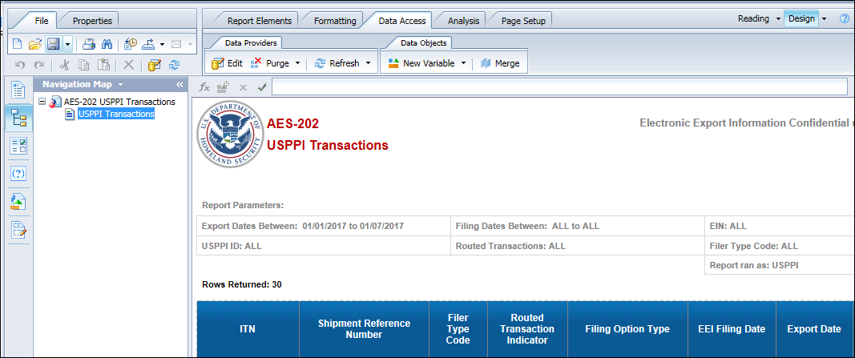

- You will see “Export Control Classification Number” is now available as a data element.
- Drag it to the report to the right, inserting it BETWEEN any column.

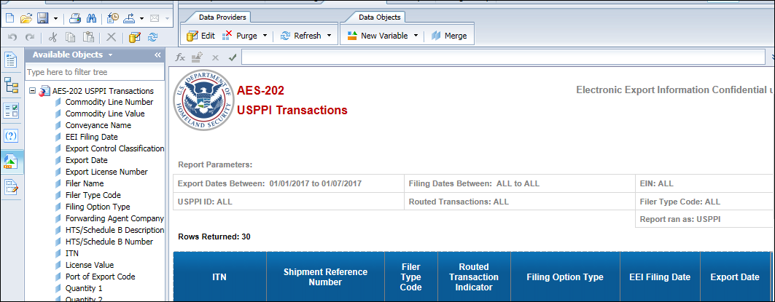
- Now you can export your report to Excel so you can view and sort as needed.

