

Presidential Documents

Proclamation 9693 of January 23, 2018
To Facilitate Positive Adjustment to Competition From Im- ports of Certain Crystalline Silicon Photovoltaic Cells (Whether or Not Partially or Fully Assembled Into Other Products) and for Other Purposes

By the President of the United States of America A Proclamation
- On November 13, 2017, the United States International Trade Commission (ITC) transmitted to the President a report (the ‘‘ITC Report’’) on its investiga- tion under section 202 of the Trade Act of 1974, as amended (the ‘‘Trade Act’’) (19 U.S.C. 2252), with respect to imports of certain crystalline silicon photovoltaic (CSPV) cells, whether or not partially or fully assembled into other products (including, but not limited to, modules, laminates, panels, and building-integrated materials) (‘‘CSPV products’’). These products ex- clude certain products described in the ITC Notice of Institution, 82 FR 25331 (June 1, 2017), and listed in subdivision (c)(ii) of Note 18 in Annex I to this proclamation.
- The ITC reached an affirmative determination under section 202(b) of the Trade Act (19 U.S.C. 2252(b)) that CSPV products are being imported into the United States in such increased quantities as to be a substantial cause of serious injury, or threat of serious injury, to the domestic industry producing a like or directly competitive article.
- Pursuant to section 311(a) of the North American Free Trade Agreement Implementation Act (the ‘‘NAFTA Implementation Act’’) (19 U.S.C. 3371(a)), the ITC made findings as to whether imports from Mexico and Canada, considered individually, account for a substantial share of total imports and contribute importantly to the serious injury, or threat thereof, caused by imports. The ITC made affirmative findings of contribution to injury with respect to imports of CSPV products from Mexico but made negative findings with respect to imports of CSPV products from Canada.
- On November 27, 2017, the United States Trade Representative (USTR) requested additional information from the ITC under section 203(a)(5) of the Trade Act (19 U.S.C. 2253(a)(5)). On December 27, 2017, the ITC provided a response that identified unforeseen developments that led to the importa- tion of CSPV products into the United States in such increased quantities as to be a substantial cause of serious injury (the ‘‘supplemental report’’).
- The ITC commissioners transmitted to the President their individual recommendations with respect to the actions that each of them considered would address the serious injury, or threat of serious injury, to the domestic industry and be most effective in facilitating the efforts of the industry to make a positive adjustment to import competition. The ITC did not recommend an action within the meaning of section 202(e) of the Trade Act (19 U.S.C. 2252(e)).
- Pursuant to section 203 of the Trade Act (19 U.S.C. 2253), and after taking into account the considerations specified in section 203(a)(2) of the Trade Act (19 U.S.C. 2253(a)(2)), the ITC Report, and the supplemental report, I have determined to implement action of a type described in section 203(a)(3) of the Trade Act (19 U.S.C. 2252(a)(3)) (a ‘‘safeguard measure’’), with regard to the following CSPV products:

  - solar cells, whether or not assembled into modules or made up into panels provided for in subheading 8541.40.60 in Annex I to this proclama- tion;
  - parts or subassemblies of solar cells provided for in subheadings 8501.31.80, 8501.61.00, and 8507.20.80 in Annex I to this proclamation;
  - inverters or batteries with CSPV cells attached provided for in sub- headings 8501.61.00 and 8507.20.80 in Annex I to this proclamation; and
  - DC generators with CSPV cells attached provided for in subheading 8501.31.80 in Annex I to this proclamation.
- Pursuant to section 312(a) of the NAFTA Implementation Act (19 U.S.C. 3372(a)), I have determined after considering the ITC Report that imports of CSPV products from each of Mexico and Canada, considered individually, account for a substantial share of total imports and contribute importantly to the serious injury or threat of serious injury found by the ITC.
- Pursuant to section 203 of the Trade Act, the action I have determined to take shall be a safeguard measure in the form of:
  - a tariff-rate quota on imports of solar cells not partially or fully assem- bled into other products as described in paragraph 6 of this proclamation, imposed for a period of 4 years, with unchanging within-quota quantities and annual reductions in the rates of duty applicable to goods entered in excess of those quantities in the second, third, and fourth years, as provided in Annex I to this proclamation; and
  - an increase in duties on imports of modules, imposed for a period of 4 years, with annual reductions in the rates of duty in the second, third, and fourth years, as provided in Annex I to this proclamation.
I have determined to exclude from this action the products listed in subdivi- sion (c)(ii) and (c)(iii) of Note 18 in Annex I to this proclamation.
- This safeguard measure shall apply to imports from all countries, except as provided in paragraph 10 of this proclamation.
- This safeguard measure shall not apply to imports of any product de- scribed in paragraph 6 of this proclamation of a developing country that is a Member of the World Trade Organization (WTO), as listed in subdivision
(b) of Note 18 in Annex I to this proclamation, as long as such a country’s share of total imports of the product, based on imports during a recent representative period, does not exceed 3 percent, provided that imports that are the product of all such countries with less than 3 percent import share collectively account for not more than 9 percent of total imports of the product. If I determine that a surge in imports of a product described in paragraph 6 of this proclamation of a developing country that is a WTO Member results in imports of that product from that developing country exceeding either of the thresholds described in this paragraph, the safeguard measure shall be modified to apply to such product from such country.
- The in-quota quantity in each year under the tariff-rate quota described in paragraph 8 of this proclamation shall be allocated among all countries except those countries the products of which are excluded from such tariff- rate quota pursuant to paragraph 10 of this proclamation.
- Pursuant to section 203(a)(1)(A) of the Trade Act (19 U.S.C. 2253(a)(1)(A)), I have determined that this safeguard measure will facilitate efforts by the domestic industry to make a positive adjustment to import competition and provide greater economic and social benefits than costs. If I determine that further action is appropriate and feasible to facilitate efforts by the domestic industry to make a positive adjustment to import competition and to provide greater economic and social benefits than costs, or if I determine that the conditions under section 204(b)(1) of the Trade Act (19 U.S.C. 2254(b)(1)) are met, I shall reduce, modify, or terminate the action established in this proclamation accordingly. In addition, if I determine within 30 days of the date of this proclamation, as a result of consultations between the United States and other WTO Members pursuant to Article

12.3 of the WTO Agreement on Safeguards, that it is necessary to reduce, modify, or terminate the safeguard measure, I shall proclaim the cor- responding reduction, modification, or termination of the safeguard measure within 40 days.
- Section 502 of the Trade Act (19 U.S.C. 2462) authorizes the President to designate countries as beneficiary developing countries for purposes of the Generalized System of Preferences (GSP).
- Proclamation 9687 of December 22, 2017, ended the suspension of Argen- tina’s designation as a GSP beneficiary developing country. That proclamation made corresponding modifications to the Harmonized Tariff Schedule of the United States (HTS). Those modifications included technical errors, and I have determined that modifications to the HTS are necessary to correct them.
- Section 604 of the Trade Act (19 U.S.C. 2483), authorizes the President to embody in the HTS the substance of the relevant provisions of that Act, and of other acts affecting import treatment, and actions thereunder, including the removal, modification, continuance, or imposition of any rate of duty or other import restriction.
NOW, THEREFORE, I, DONALD J. TRUMP, President of the United States of America, acting under the authority vested in me by the Constitution and the laws of the United States, including but not limited to sections 203, 502, and 604 of the Trade Act, and section 301 of title 3, United States Code, do proclaim that:
- In order to establish increases in duty and a tariff-rate quota on imports of the CSPV products described in paragraph 6 of this proclamation (other than excluded products), subchapter III of chapter 99 of the HTS is modi- fied as provided in Annex I to this proclamation. Any merchandise subject to the safeguard measure that is admitted into U.S. foreign trade zones on or after 12:01 a.m. eastern standard time on February 7, 2018, must be admitted as ‘‘privileged foreign status’’ as defined in 19 CFR 146.41, and will be subject upon entry for consumption to any quantitative restric- tions or tariffs related to the classification under the applicable HTS subheading.
- Except as provided in clause (3) below, imports of CSPV products of WTO Member developing countries, as listed in subdivision (b) of Note 18 in Annex I to this proclamation, shall be excluded from the safeguard measure established in this proclamation. Imports of solar cells of those countries that are not partially or fully assembled into other products shall not be counted toward the tariff-rate quota limits that trigger the over-quota rates of duties.
- If, after the safeguard measure established in this proclamation takes effect, the USTR determines that:
- the share of total imports of the product of a country listed in subdivi- sion (b) of Note 18 in Annex I to this proclamation exceeds 3 percent,
- imports of the product from all listed countries with less than 3 percent import share collectively account for more than 9 percent of total imports of the product, or
- a country listed in subdivision (b) of Note 18 in Annex I to this proclamation is no longer a developing country for purposes of this proclama- tion;
the USTR is authorized, upon publication of a notice in the Federal Register, to revise subdivision (b) of Note 18 in Annex I to this proclamation to remove the relevant country from the list or suspend operation of that subdivision, as appropriate.
- Within 30 days after the date of this proclamation, the USTR shall publish in the Federal Register procedures for requests for exclusion of a particular product from the safeguard measure established in this procla- mation. If the USTR determines, after consultation with the Secretaries

Billing code 3295–F8–P
of Commerce and Energy, that a particular product should be excluded, the USTR is authorized, upon publishing a notice of such determination in the Federal Register, to modify the HTS provisions created by Annex I to this proclamation to exclude such particular product from the safeguard measure described in paragraph 8 of this proclamation.
- In order to make technical corrections necessary to reflect the end of the suspension of Argentina’s designation as a GSP beneficiary devel- oping country, the HTS is modified as set forth in Annex II to this proclamation.
- Any provision of previous proclamations and Executive Orders that is inconsistent with the actions taken in this proclamation is superseded to the extent of such inconsistency.
- Except as provided for in clause (8) of this proclamation, the modifica- tions to the HTS made by this proclamation, including Annex I, shall be effective with respect to goods entered, or withdrawn from warehouse for consumption, on or after 12:01 a.m. eastern standard time on February 7, 2018, and shall continue in effect as provided in Annex I to this proclamation, unless such actions are earlier expressly reduced, modified, or terminated. Any modifications to the HTS made pursuant to clause
(3) or (4) of this proclamation shall take effect as indicated in a Federal Register notice published in accordance with those clauses. One year from the termination of the safeguard measure established in this proclama- tion, the U.S. note and tariff provisions established in Annex I to this proclamation shall be deleted from the HTS.
(8) The modifications to the HTS set forth in Annex II to this proclamation shall be effective with respect to the articles entered, or withdrawn from warehouse for consumption, on or after the dates set forth in the relevant sections of Annex II.
IN WITNESS WHEREOF, I have hereunto set my hand this twenty-third day of January, in the year of our Lord two thousand eighteen, and of the Independence of the United States of America the two hundred and forty-second.
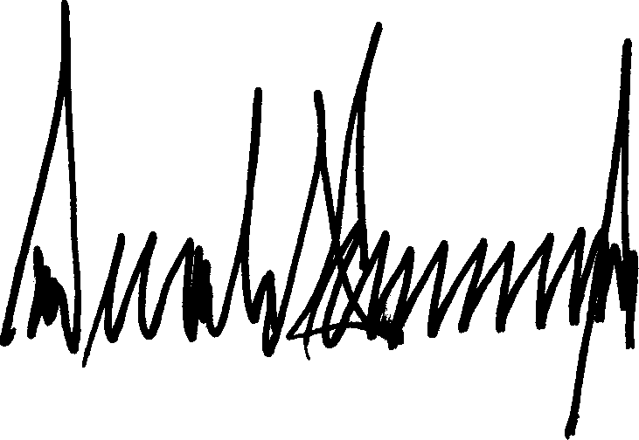

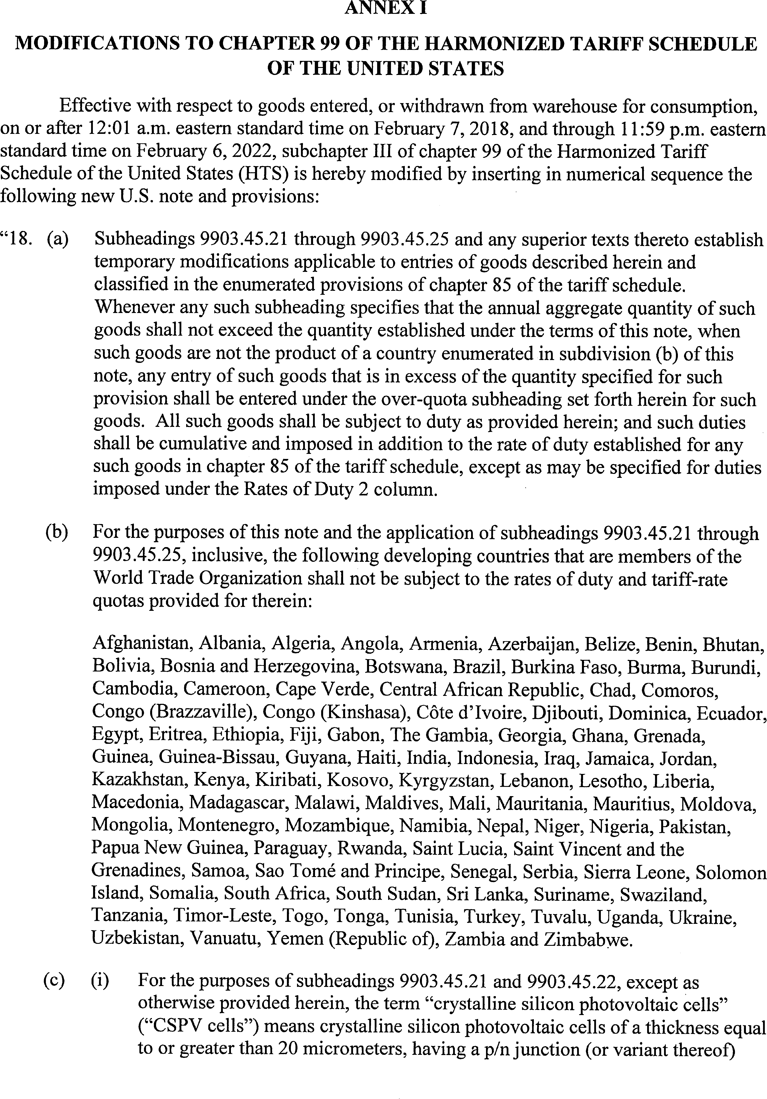

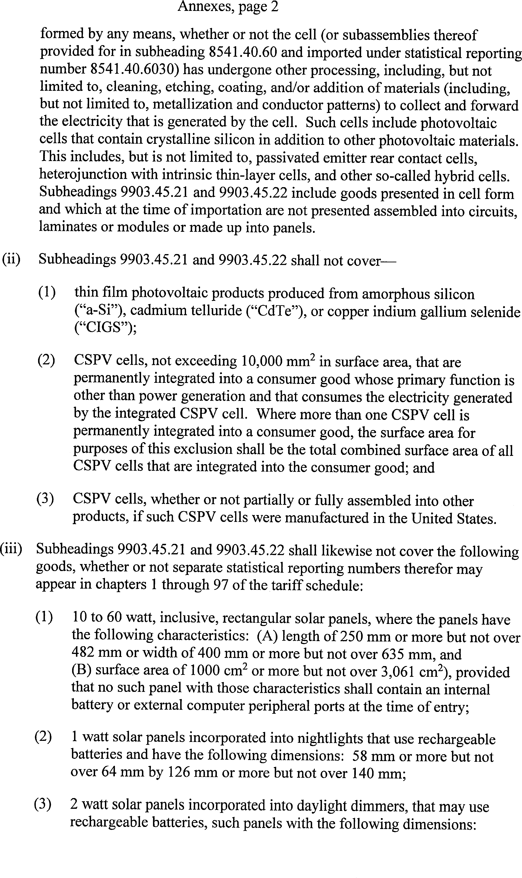

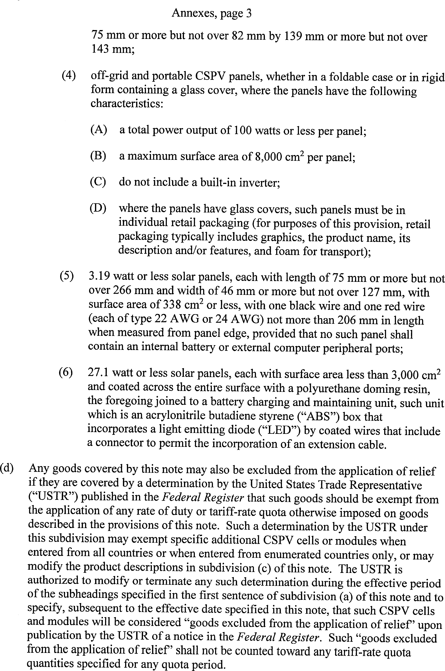

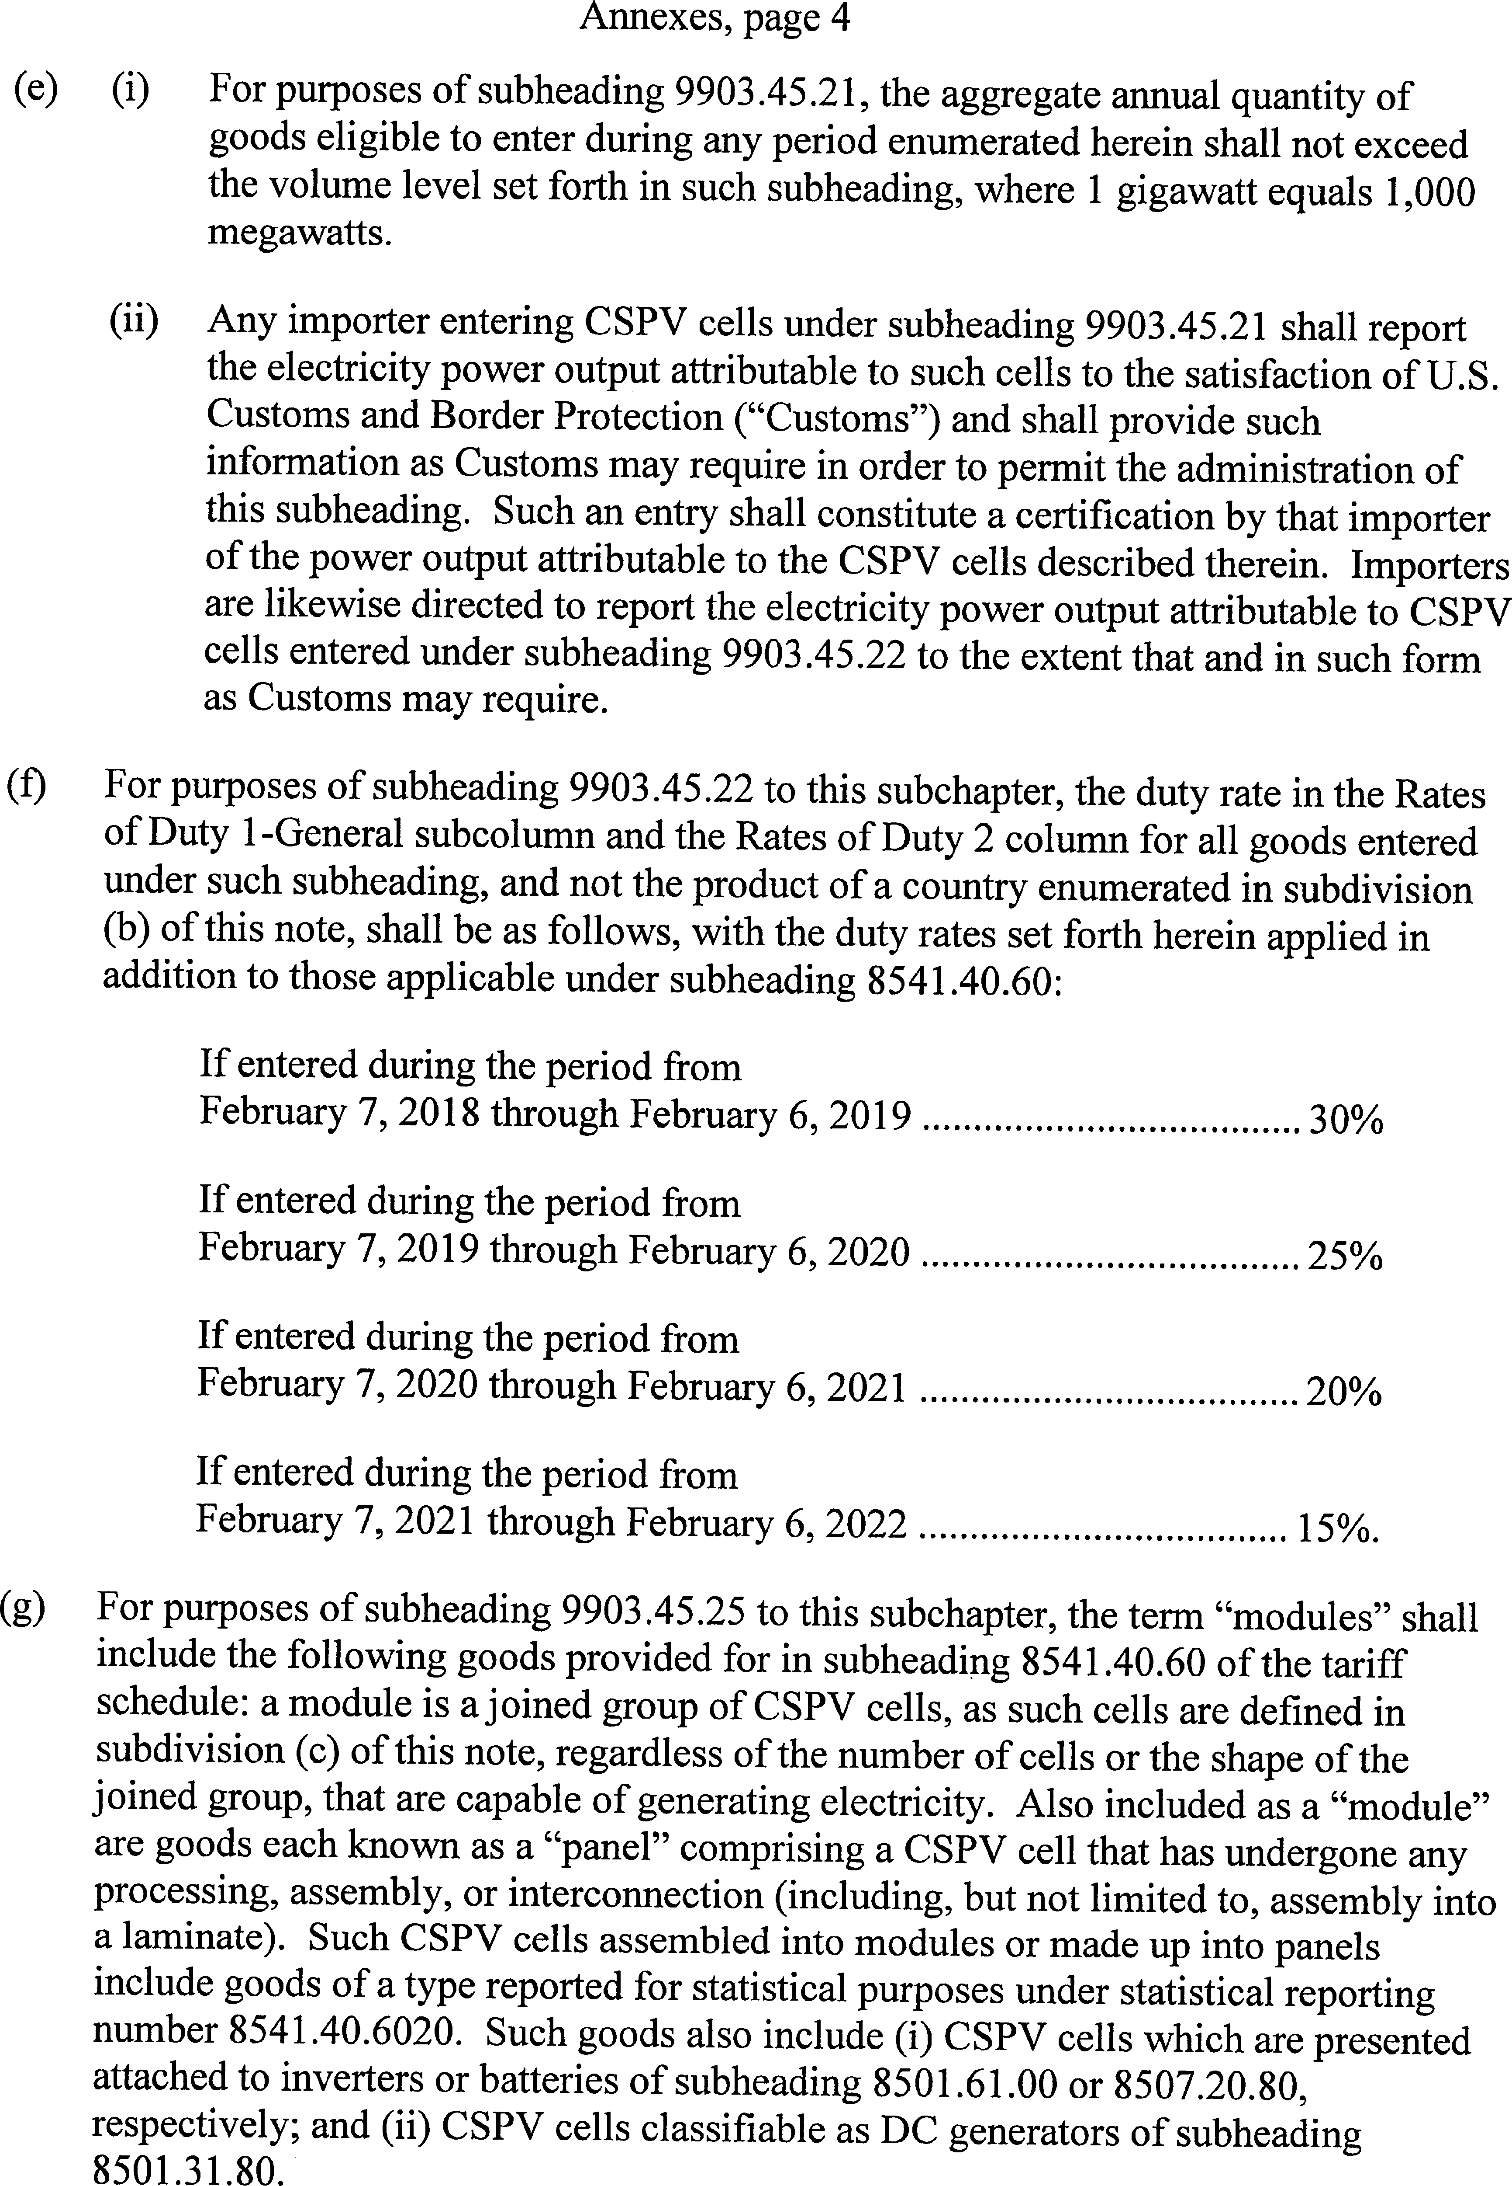

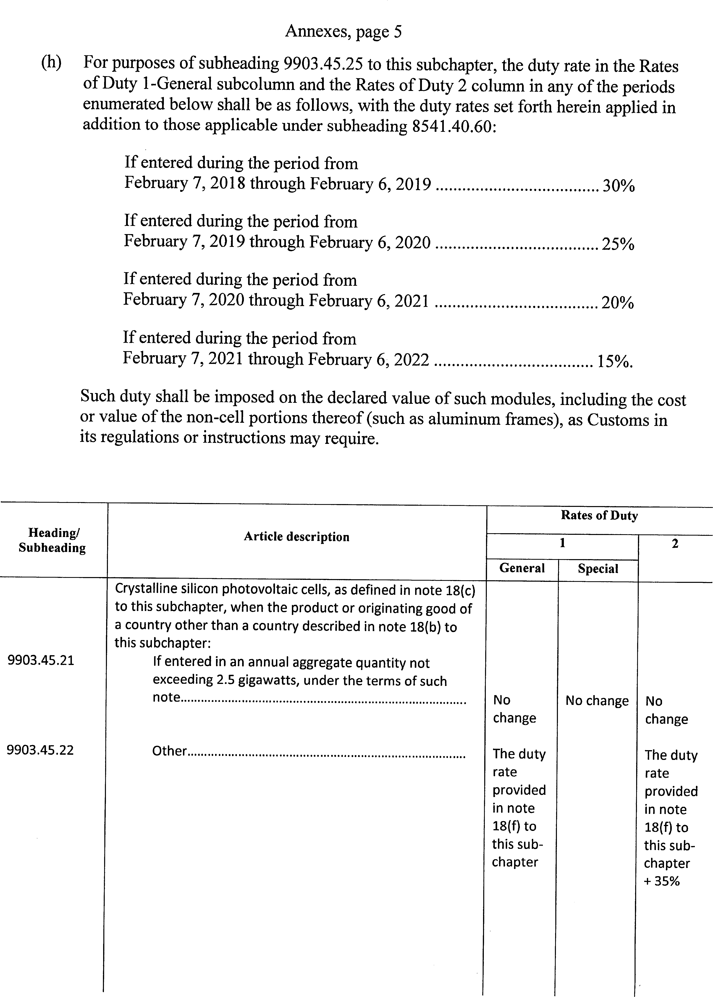

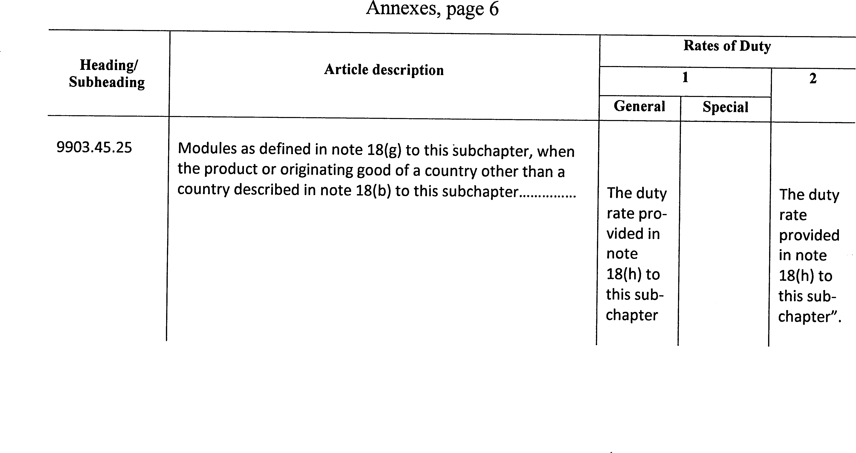

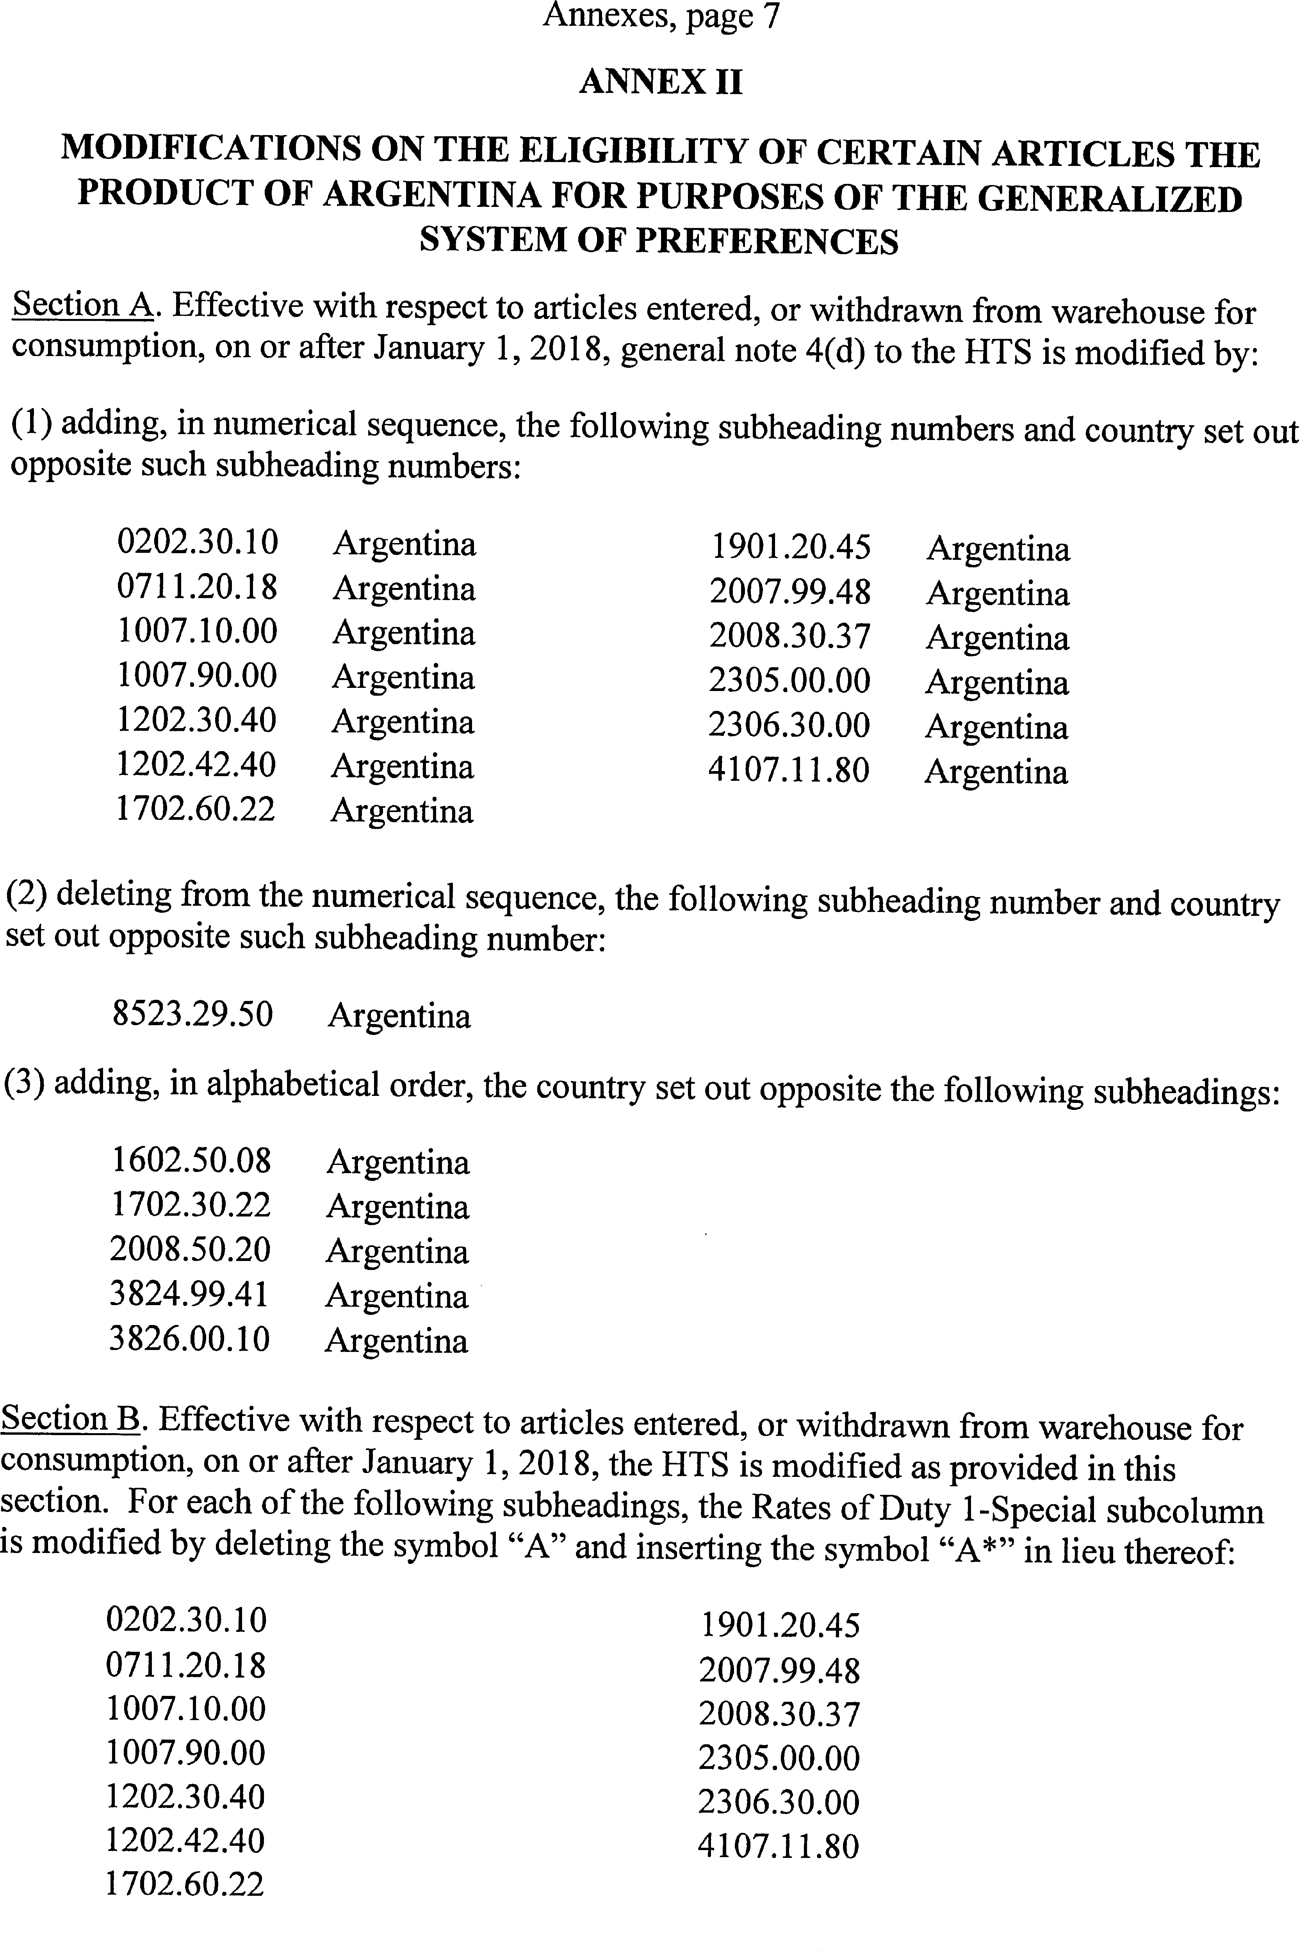

[FR Doc. 2018–01592
Filed 1–24–18; 2: pm] Billing code 7020–02–C

