HS Classification

COMPANY will use reasonable care in classifying its imports and exports and ensuring compliance with all classification requirements. Misclassifications can result in the overpayment and underpayment of duties, failure to satisfy import restrictions, and monetary penalties.
COMPANY uses HS classifications for both imports and exports for the U.S. as COMPANY does not currently have any products that require a Schedule B code to be used.

Background
The Harmonized Tariff Schedule of the United States (HTSUS) is based on the Harmonized Commodity Description and Coding System (HS), a single internationally recognized classification system shared by a majority of the major trading nations.
The HTSUS has 99 Chapters. Chapters 1-97 are arranged in 21 sections, generally grouped together by branches of industry and commerce, and progressing from raw materials to finished goods. These groupings are not absolute, but serve as an indication of the proper classification provisions relating to imported merchandise. The HTSUS also has additional sections with two additional chapters. Chapter 98 covers special classification provisions relating to articles exported and returned to the United States, as well as other special provisions, such as those classifications for articles returning to the United States after repair abroad. Chapter 99 is designed for the incorporation of temporary legislation, proclamations and administrative actions.
To ensure accurate classification of merchandise, careful consideration must be given to the General Rules of Interpretation, Section Notes, Chapter Notes, Explanatory Notes, published Customs rulings and CIT slip opinions.

Harmonized System Numbering
HTSUS classifications consist of ten (10) digits. Digits one through six represent the internationally standardized HS classifications. Digits seven and eight represent U.S. tariff subdivisions of the international system, and the last two digits represent statistical subdivisions.
The HTSUS is hierarchical in nature. This is done so that an article that is to be classified at an 8-digit subheading level must be classifiable at its 6-digit subheading level, and in order for the item to be classified at the 6-digit subheading level, it must be classifiable at its 4-digit heading level. Consequently, a given article must fall within its particular section and chapter before it can be classified in any one heading or subheading.
Preceding each section and chapter are legal notes. These notes define the precise scope and limits of sections, chapters, headings, and subheadings. They also contain rules intended to prevent the conflict of competing provisions. Through these particular rules, headings, chapters or sections may be given precedence over others.

General Rules of Interpretation
Classification is governed by the General Rules of Interpretation (GRI). The GRIs must be followed in numerical order. In other words, if proper classifications cannot be determined using GRI 1, one must proceed to GRI 2, and so on through each GRI, stopping at the GRI that finally determines the proper HTSUS classification.

GRI 1 The table of contents, alphabetical index, and titles of sections, chapter and subchapters are provided for each of reference only; for legal purposes, classification shall be determined according to the terms of the headings, and any relative sections or chapter notes and, provided such headings or notes do not otherwise require, according to the following provisions:
GRI 2(a) Any reference in a heading to an article shall be taken to include a reference to that article incomplete or unfinished provided that, as entered; the incomplete or unfinished article has the essential character of the complete or finished article. It shall also include a reference to that article complete or finished (or failing to be classified as complete or finished by virtue of this rule), entered unassembled or disassembled.
GRI 2(b) Any reference in a heading to a material or substance shall be taken to include a reference to mixtures or combinations of that material or substance with other materials or substances. Any reference to goods of a given material or substance shall be taken to include a reference to goods consisting wholly or partly of such material or substance. The classification of goods consisting of more than one material or substance shall be according to the principles of rule 3.
GRI 3 When, by application of rule 2(b) or for any other reason, goods are, prima facie, classifiable under two or more headings, classification shall be effected as follows:
GRI 3(a) The heading, which provides the most specific description, shall be preferred to headings providing a more general description. However, when two or more headings each refer to part only of the materials or substances contained in mixed or composite goods or to part only of the items in a set up for retail sale, those headings are to be regarded as equally specific in relation to those goods, even if one of them gives a more complete or precise description of the good.
GRI 3(b) Mixtures, composite goods consisting of different materials or made up of different components, and goods put up in sets for retail sate, which cannot be classified by references to GRI 3(a), shall be classified as if they consisted of the material or component which gives them their essential character, insofar as this criterion is applicable.
GRI 3(c) When goods cannot be classified by reference to 3(a) or 3(b), they shall be classified under the heading which occurs last in numerical order among those which equally merit consideration.
GRI 4 Goods that cannot be classified in accordance with the above rules shall be classified under the heading appropriate to the goods to which they are most akin.
GRI 5 In addition to the foregoing provisions, the following rules shall apply in respect of the goods referred to therein.
GRI 5(a) Camera cases, musical instrument cases, gun cases, drawing instrument cases, necklace cases and similar containers, specifically shaped or fitted to contain a specific article or set of articles suitable for long-term use and entered with the articles for which they are intended, shall be classified with such articles when of a kind normally sold therewith. This rule does not, however, apply to containers, which give the whole its essential character.

GRI 5(b) Subject to the provisions for rule 5(a) above, packing materials and packing containers entered with the goods therein shall be classified with the goods if they are of the kind normally used for packing such goods. However, this provision is not binding when such packing materials or packing containers are clearly suitable for repetitive use.
GRI 6 For legal purposes, the classification of goods in the subheadings of a heading shall be determined according to the terms of those headings and any related subheading notes and, mutatis mutandis, to the above rules, on the understanding that only subheadings at and subchapter notes also apply, unless the context otherwise requires.

Additional U.S. Rules of Interpretation
Rule 1 In the absence of special language or context which otherwise requires;
Rule 1(a) A tariff classification controlled by use (other than actual use) is to be determined in accordance with the use in the United States at, or immediately prior to, the date of importation, of goods of that class or kind to which the imported goods belong, and the controlling use is the principle use;
Rule 1(b) A tariff classification controlled by the actual use to which the imported goods are put in the United States is satisfied only if such use is intended at the time of importation, the goods are so used and proof thereof is furnished within three years after the date the goods are entered;
Rule 1(c) A provision for parts of an article covers products solely or principally used as a part of such articles, but a provision for parts or parts and accessories shall not prevail over a specific provision for such part or accessory;
Rule 1(d) The principles of section XI regarding mixtures of two or more textile materials shall apply to the classification of goods in any provision in which a textile material is named.

Responsible Party

Only members of the COMPANY Global Trade team or specific persons trained and authorized by COMPANY Global Trade can assign classifications for COMPANY. The system of record for classifications is SAP; the classifications are completed and updated in the Global Trade Management software, which updates SAP.

Classification Process

COMPANY creates hundreds of new product numbers every month, many of which may never be commercialized, imported, or exported. Because of this volume, new products are not automatically classified. Only products that are imported, exported, qualified for a Free Trade Agreement, or specifically requested for classification by a customer are sent to Global Trade to be classified.
Requests for classifications are received by Global Trade from customs brokers, freight forwarders, Business Units, Sourcing, customers, or other stakeholders. After receiving the request, Global Trade reviews the request to check for the COMPANY product number, which informs Global Trade if the item is an SAP product or non-SAP product.
For SAP products, Global Trade looks up the item in the GTM software and SAP. Global Trade reviews the BOM for the product, including the HTS classifications for the BOM components, and looks for any key ingredients that indicate a definite classification (such as Carbon Black for color products). The Global Trade Contact List includes the Sourcing Contact List, which shows the product categories for raw materials and is used to identify the raw materials in the BOM. Global Trade reviews any additional materials needed to complete the classification, including Section notes, Chapter notes, CROSS, and technical information. If necessary, Global Trade contacts the appropriate technical contact for the Business Unit to which the product belongs to request assistance with identifying characteristics or use (see the Global Trade Contact List file in Global Trade: Contact Lists folder). Global Trade documents the classification and backup information in the GTM software and responds to the classification request. The GTM software updates the classification in SAP and sends the updated classification to COMPANY’s authorized freight forwarders / customs brokers.
For non-SAP products, Global Trade requests additional information from the BU as necessary. The information required may include specific questions for determining the HTS code, or a BOM pulled from the ERP system used for that product line. When Global Trade has sufficient information to classify, the classification and backup information are documented in the GTM software and the classification request is completed.

HTSUS Example:

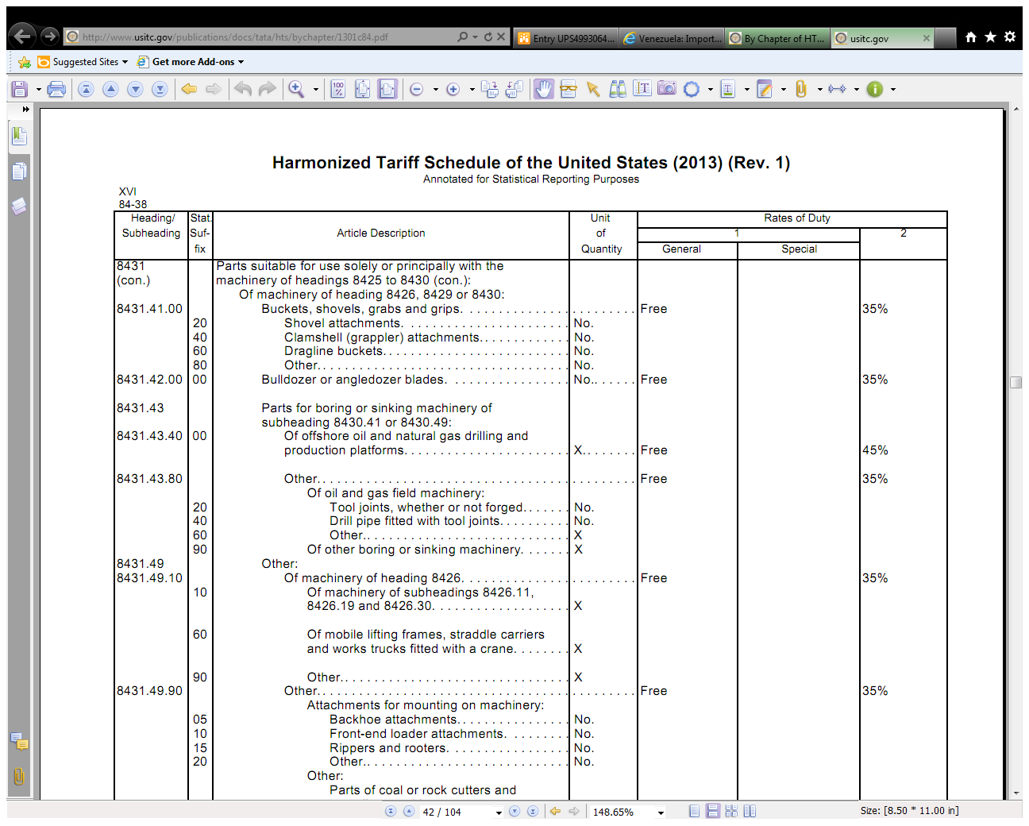
First four digits are the heading, the next two digits are the subheading. This portion is “harmonized” – used globally.
Notice the indent – the part being classified has to fall under the heading first, then subheading and so on. You cannot classify based on the statistical suffix description first, you must go in order.
Some goods are required to be reported in a specific quantity (kg or pieces or oz)
This is the General duty rate – the rate for most countries without any special treatment like Free Trade Agreements.
If a Free Trade Agreement applies, it will be noted here.
This duty rate is for embargoed countries, like North Korea.

