Getting the AR-007 as of 1/16/2018
Account Revenue (AR) Reports created and saved before 1/16/2018 will no longer provide up to date information. The new Statements Universe was created for the REV-101, 102, 103, 104 Reports that provide current data.
The AR-007 Quickview Report can still be accessed via the Statements Link under the Accounts Tab. This AR Report has current data. To still use the AR-007 Report in the Reports tool and to modify the data elements, you will need to save the Report from Statements to your Reports Tool Favorite folder.

1st Time Running:
- Log into the ACE Portal:
- Go to the Accounts Tab:
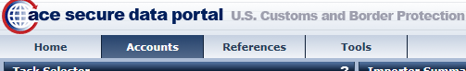
- Change to your correct View Type and click GO (Importer or Broker) *defaults to Broker:
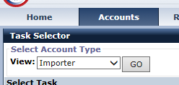
- Select your Company Identifier under the Account Selector List. You may have to click the “+” next to your Top Account:
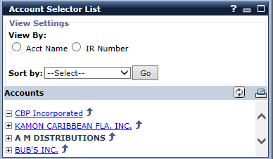
- Under the Task Selector Portlet, select the Statements Link:
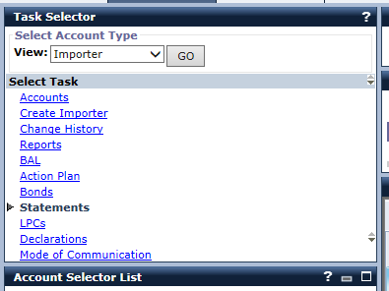
- To your right the Periodic Statement Quickview Portlet will begin to load:
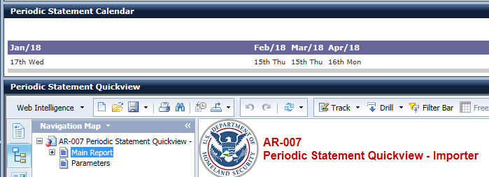
- Click the Save As button:
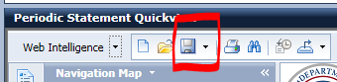
- The “Favorites Folder” should be the default. You can change the name if need be, but it is not required. Click the Save Button:
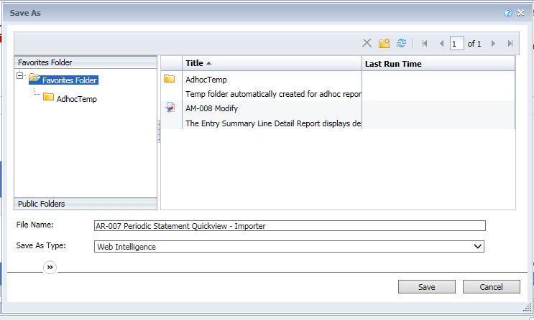

Running Saved AR-007 Report:
- Log into the ACE Portal:
- Go to the Accounts Tab:
- Change to your correct View Type and click GO (Importer or Broker) *defaults to Broker:
- Select your Company Identifier under the Account Selector List. You may have to click the “+” next to your Top Account:
- Under the Task Selector Portlet, select the Reports Link:
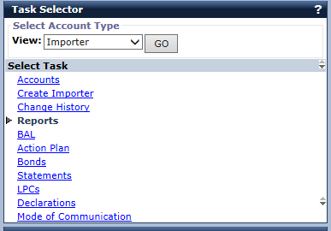
- Click the Launch Tool button as usual:
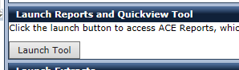
- At the top of the screen, click the Documents tab:
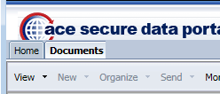
- You are defaulted to Folders Public Folders. Click the Tab “My Documents”:
  - 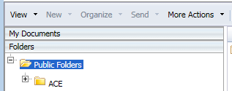
  - 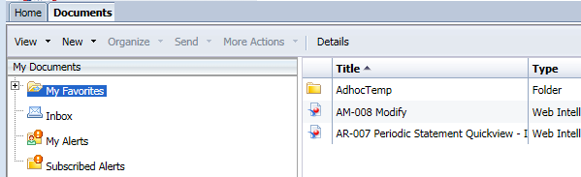
- Double Click the Saved “AR-007…” Report:
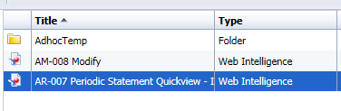
- You should be prompted to run the Report, you now have current data:
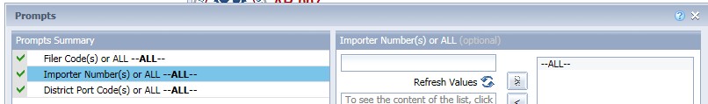
- If you instead were sent to the Report itself, click the “Refresh” Button to pull updated data:
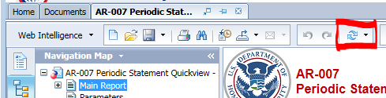
- You can now make any modifications to the Report such as adding or removing data elements.
- In the future you can come back to your Favorites Folder and run your AR-007 Report.

