DURLSTONE PRIMARY SCHOOL WATER PROJECT
The Durlstone Water project has the aim to provide flowing water to central water release points at the school area and teachers houses. This will increase the hygiene and allow the children to water their school gardens which has the purpose to teach them how to grow vegetables. These vegetables are prepared in the morning together with the porridge meal which is served at 10.00 am each school morning.
Till six months ago there was only one central water release point by means of a handpump placed on top of the present borehole.
We are fortunate and grateful to our “Friend and Family” sponsors, the “Wilde Ganzen” Foundation, ICPA, Rotary Dronten, The Netherlands and Rotary Msasa in Harare, Zimbabwe to get together the necessary funding and support.
The project consists out of three phases namely:
- Phase 1:
- To accommodate a solar cell energy driven pump to be placed in the existing borehole
- To place a 10.000-liter water storage tank.

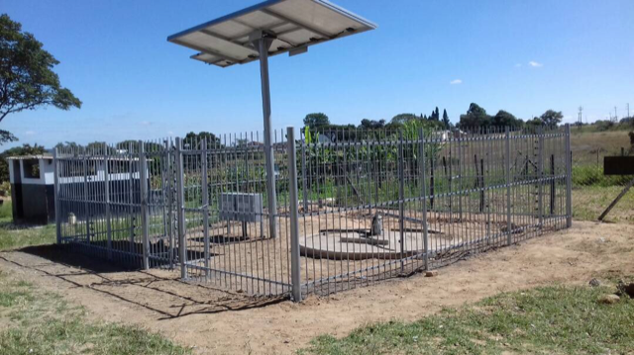
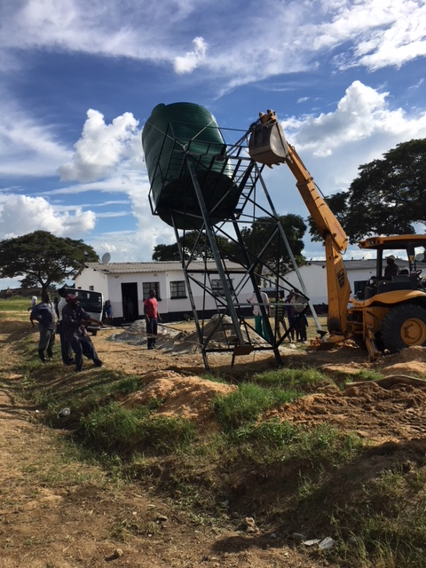
The solar energy pump and borehole The 10.000 liter water tank

Remark: This phase has been delivered in April 2018

- Phase 2:
- To install appr. 800 meter of underground pipeline with branches to the Bachelor washing facilities, Teacher houses, Outside kitchens and 7 open water release points
- To build kitchen- and bath water outlets and sewage pipes
- To build 3 septic tanks, 10 Soak Away’s and 7 Garden taps

- Phase 3:
- Installation of a Simple kitchen sideboard with a sink
- Installation of a flushing toilet
- Installation of a flexible shower head
Phase 2:
This document represents by the means of supporting pictures the execution of phase 2 of the project
A land survey and drawings of the school area, the locations of the building, the heights and its differences were required before we could execute phase 2.

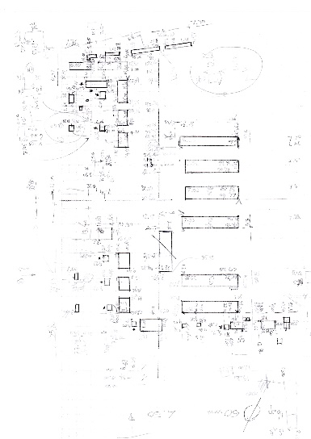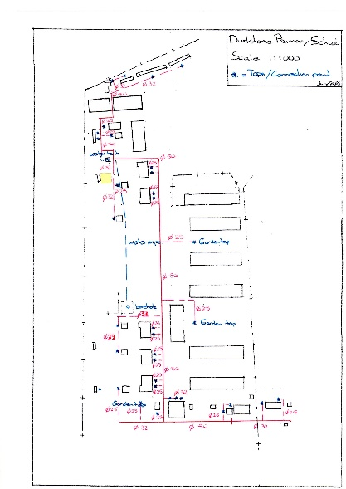
The initial land survey The proposed waterpipe
network and taps

Some figures:
Number of workers in the project: Project manager 1
Quality control 1
Plumbers 4 and 1 foreman
Masons 4 and 1 foreman
Diggers 8
Start to finish in working days: 15
Underground water pipes in meters: 807
Number of Garden taps installed: 7
Number of in-house taps installed: 23
Number of kitchen taps installed: 10
Number of Soak Away’s built 10
Total number of taps installed 40
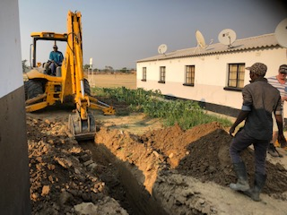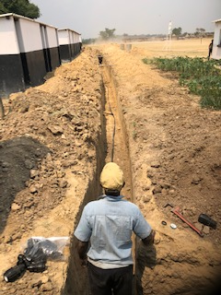
The excavating starting The first water pipes in the ground
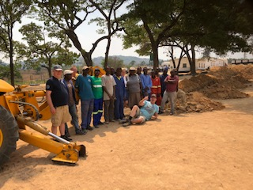
The team starting the project

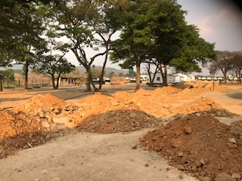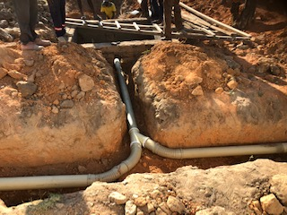
The school area during the excavation activity The last of the sewage junction made

Good to know:
Sections: The water network is divided in 4 sections which can be closed and opened independent from each other.
The network can run without pressure pump and use gravity instead with a lower pressure on each tap

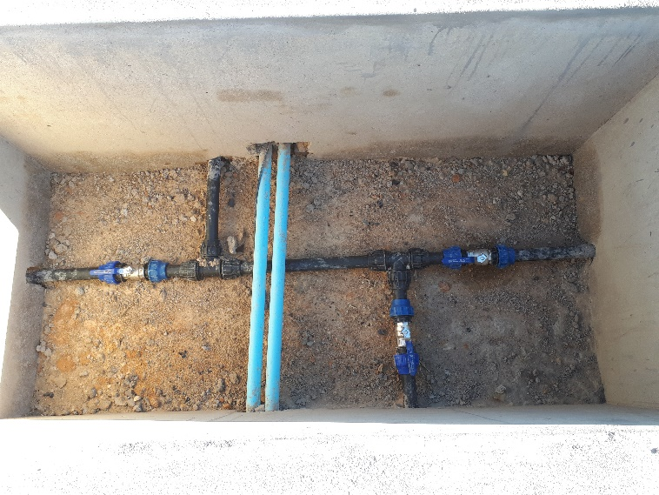
The water distribution pit

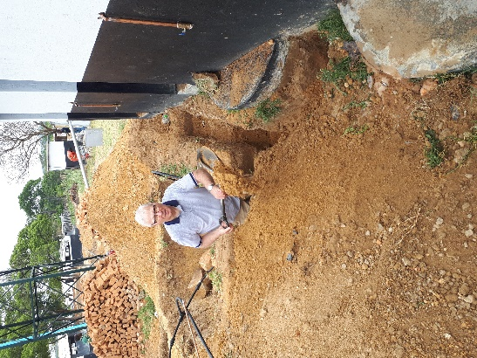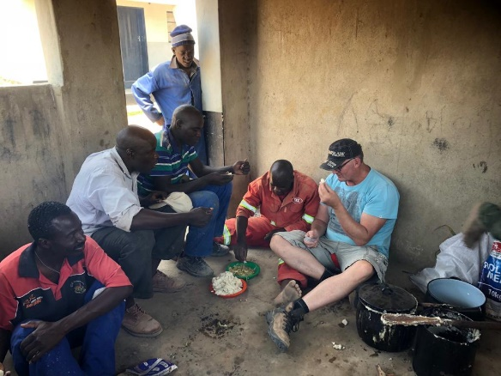
Inspection by Hans Lunch with project leader Jeroen

Heavy Equipment used in the project:
JCB: 3 days
Tractor with blade: 2 days
Tractor with dam-scope: 2 days
Tractor with trailer: 1 day

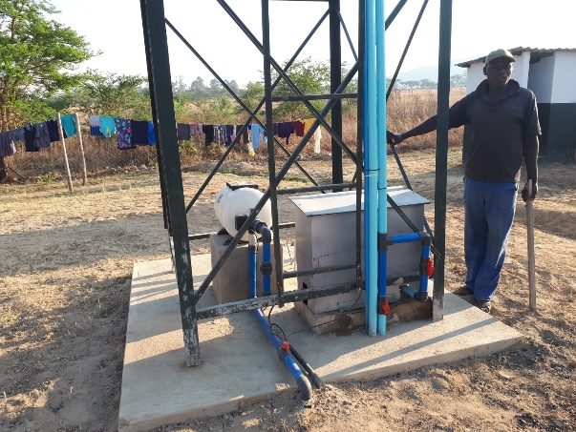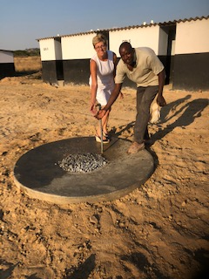
The pressure pump for equal pressure The first water comes out of one of the garden taps

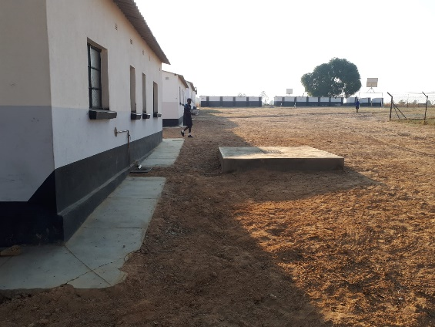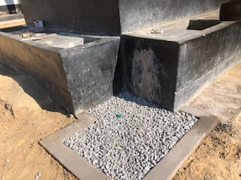
A newly built septic tank A Soak Away with outside tap

Challenges during the project:
Because of the economic situation and elections held during the startup phase the challenge was to have the materials and equipment prior to the start of the project. We succeeded and within budget
Another one was the installation and adjustment of the pressure pump and its power cell engines.
To keep strict attention to the planning, every day at 06.30 am progress meetings were held between parties involved.

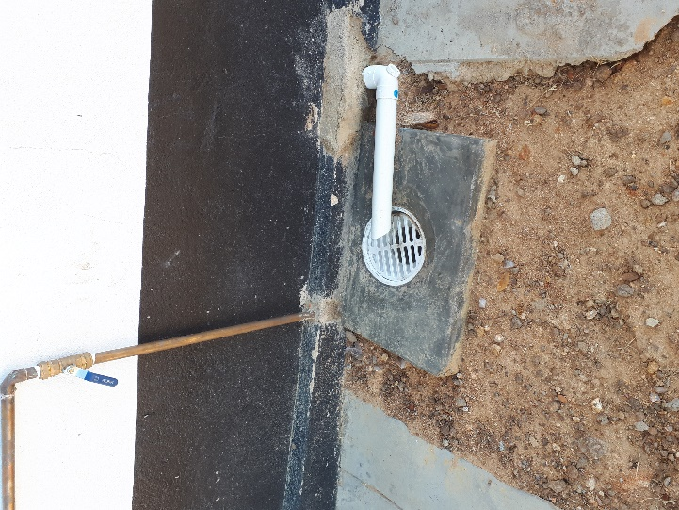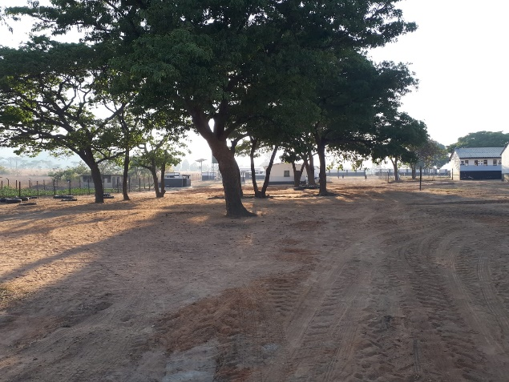
In and outlet The school area after the job done

This project could not have been realized without the sponsoring by our “Family and Friends”, the “Wilde Ganzen” Foundation, ICPA, Rotary Dronten, The Netherlands and Rotary Msasa in Harare, Zimbabwe.

Dronten and Msasa


We are grateful to have received specialized contribution and support from

Erwin Westerveld and Ivo Berning, Technical advise and support which removed all our doubts to fail from a technical perspective in the project.



Jeroen Westerhuis, On site Project management availability. Without his support and experience we were not able to have that quality and performance as scheduled.

On behalf of the children at Durlstone Primary School
Thank you all, so much appreciation

