Compliance Check List
- Screening
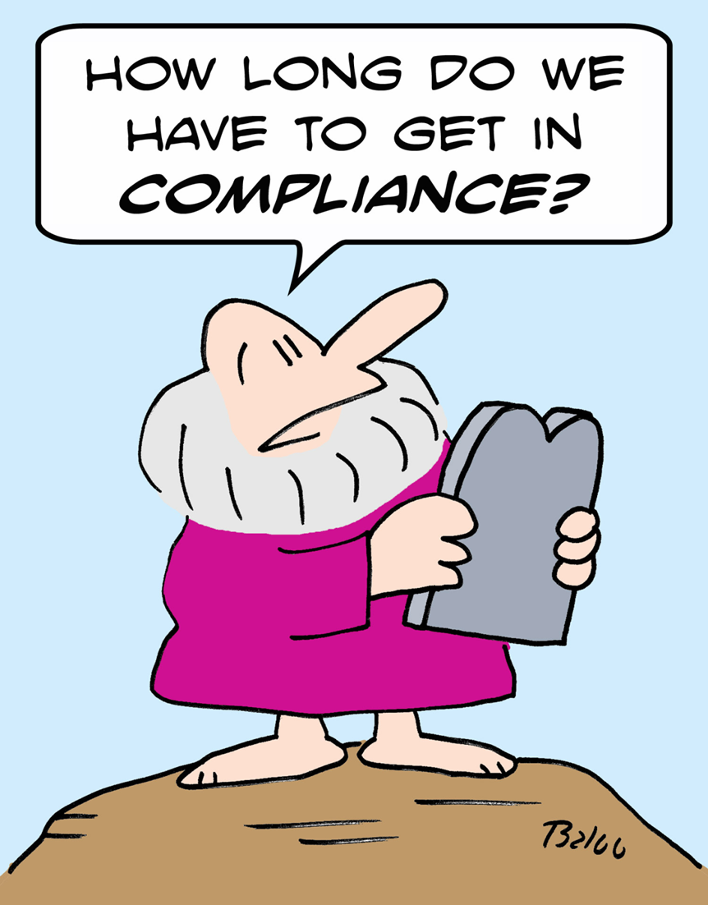
  - Customers, Companies, and Individuals
  - Interface with Company ERP
  - Transaction Screening
- Product Classification
  - Global HS library
  - Global Export Controls library
  - Single, automated global classification
- Export License determination
  - Transaction Screening
  - License determination
- Declarations and Documentation
  - Automatic declaration
  - Sharing of transaction data
  - Required Recordkeeping
- Country of Origin
  - Automated origin determination
  - Automated FTA Qualification
  - Full Trade Agreement Access
- Real Time Content
  - Restricted parties
  - Global HS and export controls library
  - Exceptions and error checking
  - Everything else

