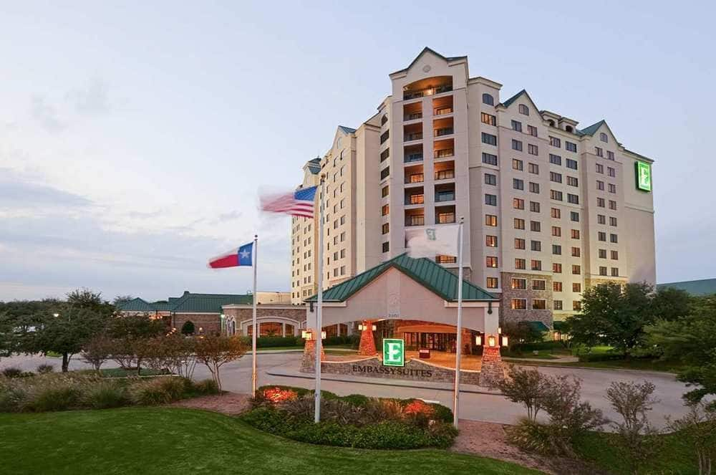
ICPA@Sea!
First annual Conference Cruise for ICPA!
When: Mon Sept. 4 – Sat Sept. 9
Where: Carnival Liberty, Galveston, Progreso, Cozumel

Registration: OPEN – https://www.regonline.com/ICPAATSEA
To book the cruise call Jennifer @ 305-814-1830 and tell her you are with ICPA cruise to get our discounted rate of about $398/person, double occupancy, inside cabin. Rates increase as the ship fills up. Friends and family also receive this rate and are encouraged! Kids daycare for ages 2 and up is included in kid’s cruise fee. All meals are included in cruise rate, too so no expensing dinner to the company is needed. What a great deal!
Don’t forget to make travel arrangements to Galveston! Most people fly into Houston then take a taxi/uber to Galveston. You will also get to see 2 large, working shipping ports on this adventure!
For more information contact Elisabeth Sherrell, ICPA Director of Member Relations - elisabethicpa@gmail.com

ICPA Fall Conference – Grapevine, Texas
Now offering a 1-day seminar with or without conference attendance with George Tuttle on Advanced Valuation! (For 5 more CCS points – pending)
When: Sun Oct. 22 - Tue Oct. 24
Valuation Seminar Wed Oct. 25
Where: Embassy Suites, Grapevine, Texas

Registration: Watch the website for details.
You will be able to register for the conference only, the conference and seminar, or the seminar only. PLEASE PAY ATTENTION TO THIS WHEN REGISTERING!
Make sure you book your hotel when you register for the conference.
For those of you who come regularly to the fall conference, yes, there will be a mechanical bull again and this year, KARAOKE!! We know how to party down here, y’all! So, dust off your boots and put you cowboy hats on straight; Grapevine in the fall is rich in cowboy culture!
For more information contact Elisabeth Sherrell, ICPA Director of Member Relations - elisabethicpa@gmail.com

We hope you enjoyed our annual conference in Miami. We want to make sure you get the first opportunity to join us in the fall at one of our smaller conferences. Each offers 10 CCS points (pending) and our ICPA family/fun atmosphere!
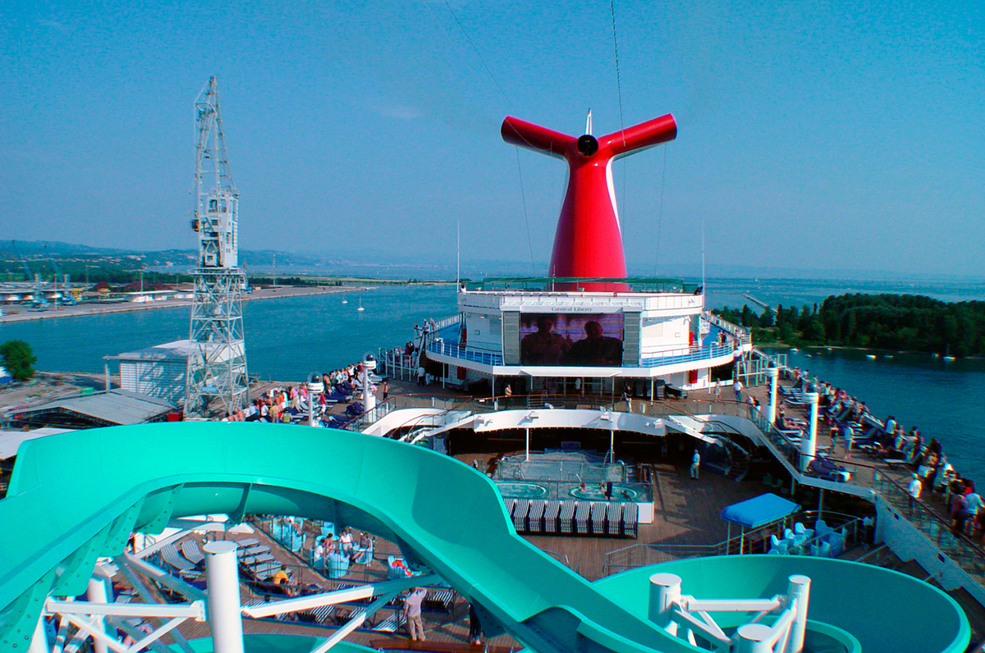
ICPA Fall Conference Options

