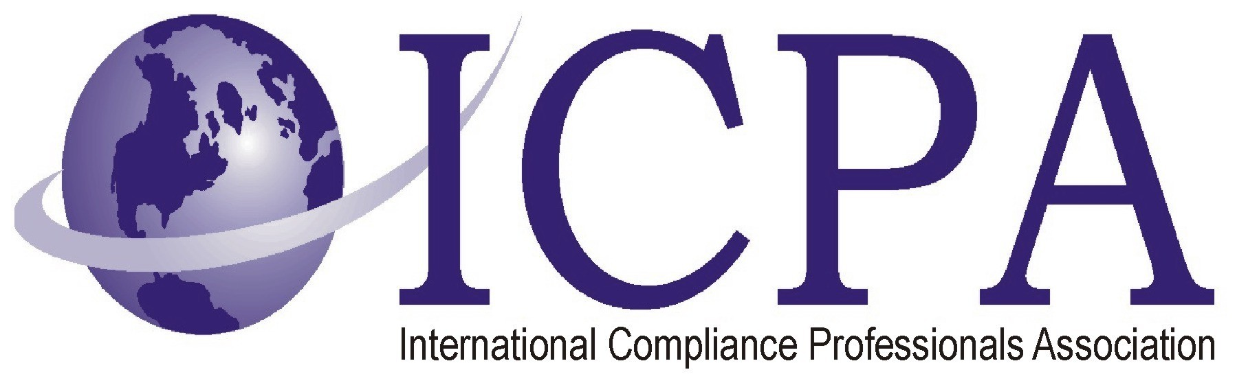

Job Opportunity

Company | The Babcock & Wilcox Company
Job Title | Global Director of International Trade Compliance
Location | Charlotte, NC
Salary Range | 150 Depending on Experience
Relocation Assistance | Yes

Job Description / Responsibilities / Requirements

The Babcock & Wilcox Company (NYSE: BWC) seeks a Global Director of International Trade Compliance. The position will be based out of the company’s Charlotte, NC headquarters and will manage the company’s programs for ensuring compliance with the laws and regulations governing the import and export of goods, services and information throughout the world. This position serves as the subject matter expert for US and international trade compliance regimes (EAR, ITAR, OFAC, CBP, NRC, EU sanctions/restrictive measures, etc.) and requires detailed knowledge of US trade compliance laws and regulations and the international trade compliance requirements affecting US multinationals. The position will ensure necessary trade compliance policies and procedures are in place and up-to-date and will work with other compliance professionals to ensure that the company’s trade compliance training is comprehensive, timely, accurate and properly documented. The position will ensure trade compliance awareness and communications initiatives are consistent and effective, and will work cross-functionally and collaboratively with business unit personnel to ensure rigorous implementation of the trade compliance program throughout all business units.
SPECIFIC RESPONSIBILITIES:
Monitor developments with the international trade compliance laws and best practices in trade compliance; efficiently and effectively incorporate developments and best practices into the company’s trade compliance programs
Ensure trade compliance (import and export-related) policies are in place, maintained and reflect evolving global requirements, local regulations, and corporate polices/standards
Ensure trade compliance policies are effectively implemented across the company
Develop a comprehensive trade compliance training program and ensure training occurs at all appropriate levels across the business
Develop and implement comprehensive trade compliance communications/awareness plans
Mitigate risks associated with import/export operations, identify opportunities for cost-savings and lead the company’s participation in various government initiatives and global trade programs
Manage relationships and agreements with trade compliance regulatory agencies and officials (CBP, OFAC, BIS, NRC, etc.)
Facilitate/manage trade compliance investigations and the successful resolution of regulatory challenges with U.S. and foreign regulatory agencies
Manage supply-chain security initiatives (e.g., C-TPAT and AEO)
Ensure restricted party screening processes are fully understood and rigorously applied across the company
Grow and improve the company’s network of field trade compliance professionals
Serve as a focal point and subject matter expert for trade compliance licensing activities
Requirements:
Candidates should have a four-year degree from an accredited university with at least eight years’ dedicated experience in building, managing and continuously improving a comprehensive international trade (both import and export) compliance program in the context of a multinational industrial and manufacturing enterprise.
Substantial trade compliance subject matter expertise is a must.
Related legal, compliance or program management experience is a plus, and experience investigating possible trade compliance violations is highly desirable.
Experience with an energy, government contracting or nuclear-related business is a strong plus. DOE security clearance is preferred.
The successful candidate should be analytical, organized, self-motivated and have strong communications and project management skills.
Must be able to work well under pressure, meet deadlines and prioritize and work independently on multiple tasks.
Must have experience with trade compliance software solutions (Visual Compliance, D-Trade, etc.) and possess strong computer skills with particular proficiency in Excel and PowerPoint.
Must be a team player and able to work well with others (employees at all levels as well as the company’s suppliers, customers and third party intermediaries).
Must be able to travel up to 25% domestically and internationally.
B&W is a leading international provider of clean energy products and services with more than 10,000 employees around the world. We’re known for our technology and record of innovation, for our history in solving complex problems, and for our expertise in both the commercial and government sectors.
To be considered for this position, go to www.babcock.com, click on “Careers,” then “Get Started.” Look for International Trade Compliance Director (#1399) and apply for the position.
B&W’s strength comes from its people, and we’re committed to recruiting, rewarding and retaining the best minds in the business.
The Babcock & Wilcox Company (B&W) embraces diversity of thought, values individuality, encourages new perspectives and provides equal opportunity in employment for all qualified employees and applicants without regard to race, color, religion, gender, sexual orientation, age, national origin, disability, veteran status, genetic information, or any other category protected by federal, state, and/or local law.

Contact Information to Apply

