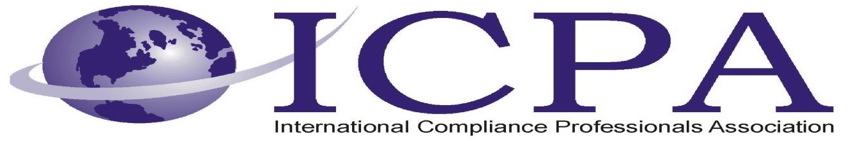

Job Opportunity

Company | Kiva Systems
Job Title | Trade Compliance Program Manager
Location | North Reading, Massachusetts
Salary Range | TBD
Relocation Assistance | Yes

Job Description / Responsibilities / Requirements

Kiva Systems is a wholly owned subsidiary of Amazon.com and we are experiencing high growth. Kiva Systems LLC uses game-changing automation technology for distribution centers that helps companies simplify operations and reduce costs while increasing strategic flexibility. Using hundreds of autonomous mobile robots and sophisticated control software, the Kiva Mobile-robotic Fulfillment System enables extremely fast cycle times with reduced labor requirements, from receiving to picking to shipping
We are looking for an energetic and talented Trade Compliance (TC) Program Manager to lead import and export compliance matters for Kiva Systems, an Amazon subsidiary. Kiva Systems is an industry leader for the production and development of automated warehouse material handling systems. Other teams that this person will be working with include: Amazon’s Corporate Trade Compliance Team, Kiva Operations, Kiva Product Engineers, Legal, Transportation and other internal businesses and external vendors. This person will help drive import and export compliance across the entire supply chain.
Principal duties: Serve as the primary point of contact for Trade Compliance at Kiva
- Work with Amazon’s Global Trade Compliance team to execute strategy, seek automation opportunities and leverage technologies
- Manage the customs brokerage relationship at Kiva
- Serve as the initial point of contact for Customs and other trade regulator inquiries
- Process Implementation: work with the TC team to implement and enforce corporate policies at Kiva
- Develop and provide targeted training on specific trade compliance topics
- Report metrics on local trade compliance program
- Provide import and export classifications of products for internal business units and external service providers in order to ensure compliance with the US and other regional trade regulations
- Escalate any trade compliance matters to Amazon TC as necessary
Basic Qualifications
- Bachelor’s Degree from an accredited university
- Experience classifying products according to US Customs (HTS), US Commerce (EAR) and US State (ITAR)
- 3-5 years of experience with import and export compliance, preferably also with experience in global logistics
- Knowledge of Customs laws and regulations relative to classifications, valuation and markings
- Self-motivated and possesses ability to handle multiple tasks
- Ability to clearly communicate logic and justification for classifications and compliance decisions
- Outstanding organizational and follow-up skills and must be able to work independently
- Strong written and oral communication skills
- Strong analytical and strategic skills
- Ability to demonstrate sound judgment even in ambiguous situations
- Ability to turn complex compliance requirements into scalable processes
- Common sense, great judgment, and a good sense of humor
Preferred Qualifications
- Experience leveraging technology to drive process improvements
- Master’s Degree is a plus, but not required
- US Customs Brokerage License a plus, but not required
- Experience with Lean Six Sigma and other process improvement tools
- Experience in Electrical or Software Engineering and/ or High-tech products

Contact Information to Apply

Please send qualified resumes to Engineeringjobs@kivasystems.com and put your name and the job title on the subject line.

