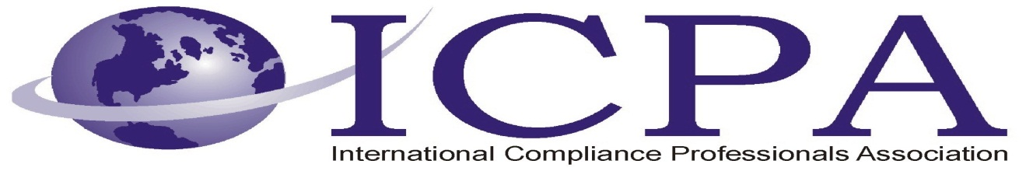

Job Opportunity

Company | E. & J. Gallo Winery
Job Title | Trade Compliance – Analyst 3 (job ID# 8417)
Location | Modesto, CA, USA
Salary Range | Negotiable
Relocation Assistance | Negotiable

Job Description / Responsibilities / Requirements

SUMMARY
Serves as a subject matter expert providing sound analysis and expertise ensuring that the winery is informed of import/export control regulations in markets where the winery conducts business. Also is responsible for analyzing and evaluating the organization's regulatory programs and activities; ensuring compliance.

ESSENTIAL FUNCTIONS
- Maintains awareness of all regulations associated with import and export of our products and raw materials.
- Advises the company on any upcoming or proposed import/export regulations that could impact the company; develops plans for the company to engage and maintain compliance with the new regulations.
- Functions as the winery’s primary point of contact regarding interaction with Customs, Customs Broker(s), Freight Forwarder(s), and third party logistics providers.
- Educates and trains Global Sourcing and the International Business Unit personnel on items that impact import and export compliance.
- Takes the lead role in addressing and solving customs-related import/export incidents that occur.
- Oversees the C-TPAT program and coordinates C-TPAT audits where required.
- Develops and maintains the database to track all current imports and exports for the winery.
- Supports comprehensive product classification and development of country of origin databases for imports and exports.
- Determines proper tariff classifications, valuation, and country of origin/marking of imported merchandise.
- Evaluates the tariff preference program and free trade status for imported merchandise under NAFTA and other free trade agreements. Conducts periodic import and export self-assessments (compliance audits) to ensure that import and export documentation is completed properly on a consistent basis.
- Reviews and advises the company on FDA requirements with respect to food imports to wine, spirits, and ingredients imports.
- Reviews and advises the company on TTB requirements with respect to wine and spirits imports and exports. Reviews and advises the company on TTB requirements with respect to wine and spirits imports.
- Leads, coordinates, and supports management in the resolution of non-compliance situations.
- Performs trade-related research and drafts comments and papers in support of industry positions in governmental and non-governmental organization (NGO) proceedings.
- Maintains satisfactory attendance, to include timeliness.
- Responsible for understanding and complying with applicable quality, environmental and safety regulatory considerations. If accountable for the work of others, responsible for ensuring their understanding and compliance.
- This job description reflects management's assignment of essential functions; it does not prescribe or restrict the tasks that may be assigned.

Contact Information to Apply

Job ID # 8417
http://hrsjobs.gallo.com/psp/ert/EJGAPP/PSFT_HR/c/HRS_HRAM.HRS_CE.GBL?Page=HRS_CE_JOB_DTL&Action=A&JobOpeningId=8417&SiteId=1&PostingSeq=1

