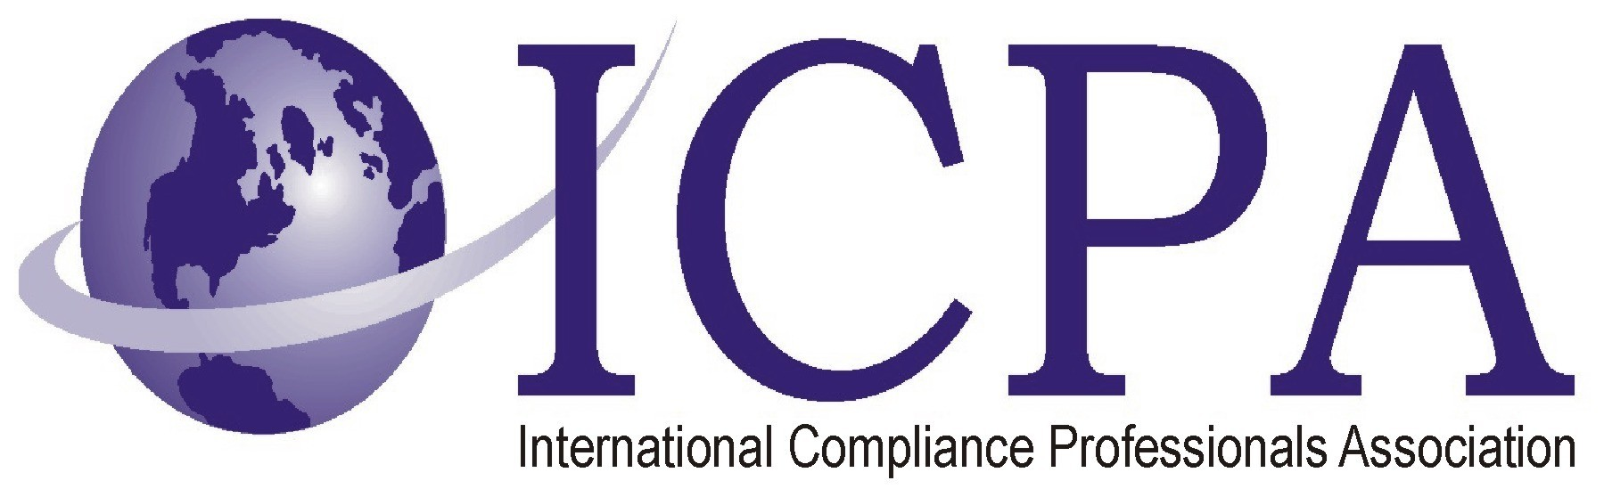

Job Opportunity

Company | Mobis Parts America, LLC
Job Title | Brand Protection Sr. Analyst
Location | Fountain Valley, CA
Salary Range | TBD
Relocation Assistance | N/A

Job Description / Responsibilities / Requirements
1. SUMMARY: Mobis Parts America brand protection expert on all product lines throughout the entire product lifecycle and achieve MPA targets by support protection of Hyundai and Kia Parts and Accessories in North America. SME for brand protection at MPA, KMA and HMA as the point of contact with the National Intellectual Property Rights, a government agency, Mark Monitor and other OEMs Assist with joint project development to stop the flow of counterfeit parts and accessories with other OEMs.

- MAJOR RESPONSIBILITY

Priority | Major Responsibility | %
1st | Identification of North American companies dealing with illegal Hyundai or Kia parts. Identification of grey parts traders | 25%
2nd | - Investigate specific market situation based on MPA, HMA and KMA field teams reports on market activities  - Liaise closely with MOBIS HQ market surveillance team  - Pro-actively investigate all possible sources to identify illegal activities affecting our brands  - Obtain evidence and propose crack down activities | 40%
3rd | - Monthly Reporting and presentation to management of results of activities  - Conduct detailed review of assigned cases and in-depth analysis  - Obtain approval of crack down activities in close cooperation with legal advisors | 15%
4th | SME for MPA with Mark Monitor and online trade mark protection | 10%

- PERSONALLY PERFORMED DUTIES
Become the SME on Brand protection and grey parts investigation for MPA, HMA and KMA investigating North American companies dealing with illegal Hyundai or Kia parts.
Tasks:
- Identification of grey parts traders
- Follows all cases submitted by PBDMs
- Investigate specific market situation; liaise closely with MPA and HMA/KMA
- Liaise closely with MOBIS HQ market surveillance team
- Pro-actively investigate all possible sources to identify illegal activities affecting our brands
- Support the dealers to identify suspicious goods and suppliers
- Meet local staff onsite and support/lead local activities
- Identify suspicious suppliers or traders
- Identify suspicious goods and conduct primary investigation to identify sources
- Obtain evidence and propose crack down activities
- Reporting and presentation to management
- Conduct detailed review of assigned cases and in-depth analysis
- Obtain approval of crack down activities in close cooperation with legal advisors
- If necessary supervise crack down actions supporting local authorities

4. JOB REQUIREMENTS

Education
- It is requested that applicant has a four-year degree from an accredited college or university or equivalent experience and demonstrated skills.
Overall Related Experience
- Candidate would have importation and trademark experience with identification of counterfeit and gray market products. Preferred automotive or automotive related business experience.

5. SKILLS
- Ability to analysis labeling and trademark identification
- Excellent verbal and written communications skills to allow effective interaction with all levels of the organization.
- Knowledge of Microsoft Office including Word, Excel, Access, PowerPoint and Internet.
- Internet web site skills considered a plus.

6. PROBLEM SOLVING/DECISION MAKING
- Ability to analyze report data to understand needs / trends with shipments.
- Strong organization and follow-up skills.
7. TRAVEL
- May be required, but not expected on a regular basis.

To apply for the position, click on the link below:

https://home.eease.adp.com/recruit/?id=9633661

