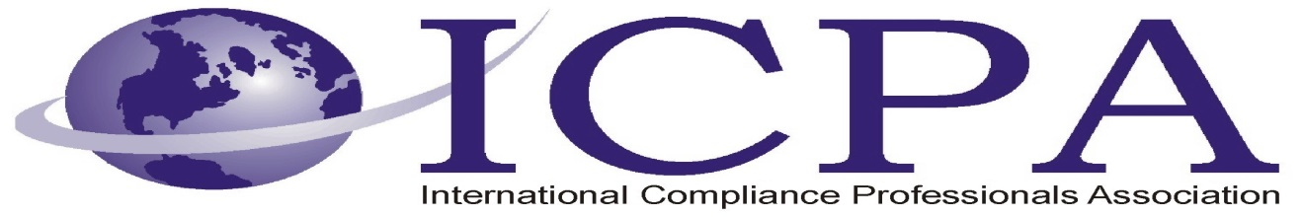

Job Opportunity

Company | Mondelēz Global LLC
Job Title | Customs Specialist
Location | Wilkes Barre, PA
Salary Range
Relocation Assistance | Not available

Job Description / Responsibilities / Requirements

Job scope:
The primary responsibility of this position is to support North American customs cross-border efficiency in a secure supply chain environment, yielding quick entry, minimal delays, reduced customs duty and storage spend, and an outstanding reputation with government agencies, our peers and customers.
The Customs Specialist will proactively develop and implement compliance measures to meet the highest standards of regulatory compliance. They will act as a backup point of contact between Mondelēz and its customs brokers, ensuring all data submitted to US Customs & Border Protection (CBP), US Food and Drug Administration and Canada Border Services Agency (CBSA) is accurate and complete.
The Customs Specialist will support and act as backup to the Customs Analysts as well as actively supporting the Global Services Associate Director.
Key responsibilities:
- Support the Mondelēz NA import compliance program to ensure it meets the requirements defined by the relevant government agencies. Work to integrate Mondelēz Corporate Compliance Policy (Customs and Trade Laws) and Finance Policy (Intercompany Transfer Pricing) requirements into Mondelēz business.
- Review brokerage invoices for accuracy and completeness, maintain tracking log and pre-authorize invoice payment in support of Customs Manager’s review/approval.
- Audit customs documentation for transactional and program compliance.
- Prepare and provide to Customs Analyst the data required to determine eligibility of products for free trade agreements (FTA)
- Prepare and provide the data required to set up new SKU’s for import into the US and Canada
- Act as backup to the Customs Analysts to manage and maintain FDA hold and release procedures and provide guidance to receiving facilities as necessary.
- Establish a basic knowledge of CBP/CBSA and other government agencies, (e.g. FDA, FSIA, USDA, etc.) and the regulations relevant to importing into North America.

Contact Information to Apply

Go to http://mdlz.jobs/jobs/ and locate the requisition in any of the following ways:

- Go directly to http://mdlz.jobs/wilkes-barre-pa/customs-specialist/45272365/job/
- Search requisition #1403064
- Keyword search Customs Specialist

