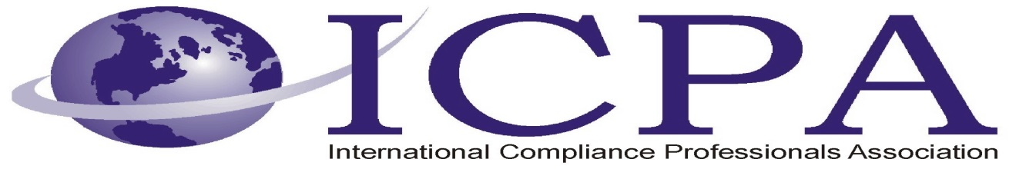

Job Opportunity

Company | Lucas Group
Job Title | Global Trade Compliance Manager
Location | Atlanta, GA
Salary Range | Depends on Experience, excellent compensation package
Relocation Assistance | Some relocation provided

Job Description / Responsibilities / Requirements

The Global Trade Compliance Manager creates, manages and implements processes and procedures to ensure import and export transactions comply with customs laws and regulations for the United States and Canada.

Requirements:
- Licensed Customs Broker
- 5+ years of relevant customs compliance experience
- Experience and extensive knowledge of NAFTA, C-TPAT, and CBP
- Bachelor Degree
- Must be eligible to work for any US Employer
Job Summary:
- Manage Global Customs Compliance programs and ensure adherence to US Customs Regulations.
- Will manage and implement initiatives in relation to all import/exports to include: US Customs and Border Protection, NAFTA Certificates of Origin, Audits, First Sale, etc.
- Work with Customs Brokers to Audit and Monitor all import and export transactions
- Perform risk analysis on imports to the US and Canada, Mexico, Latin America report results and present solutions and risk
- Work with acquisition team to ensure compliance

Contact Information to Apply

Lucas Group
Glenna Collins, CPC
Executive Supply Chain/Manufacturing Recruiter
Apply online at:
http://www.maxhire.net/cp/?E55569361D43717B7A521D653A53176E07283348
or send resumes to:
gcollins@lucasgroup.com

