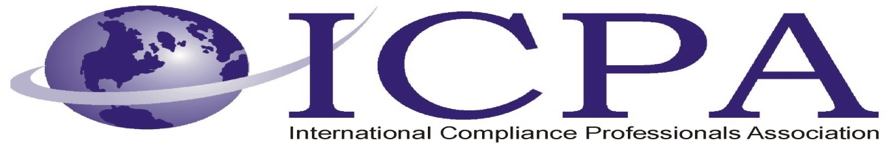

Job Opportunity

Company | Aeroflex/Metelics
Job Title | Compliance Manager
Location | Londonderry, NH
Salary Range | TBD, commensurate with experience
Relocation Assistance | For the right candidate

Job Description / Responsibilities / Requirements

Compliance Manager Job Description and Profile
The Compliance Manager will be ensure that all employees comply with required company, local, state and federal regulations in regard to export controls and environmental health and safety.

Duties and Responsibilities

Export Compliance (50%):
- Supervising and implementing the day-to-day operations of the Aeroflex Ex/Im Policy

- Documenting relevant procedures required to ensure compliance with all export control laws as
well as all requirements established in the Aeroflex Ex/Im Policy

- Completing or delegating responsibility for all export compliance requirements for each proposed
export and re-export transaction

- Monitoring all export orders to ensure completion of all required documentation and proper usage
of export licenses and/or exemptions where applicable

- Arranging export compliance training at the facility level and providing an Ex/Im Policy for
applicable employees

- Monitoring and advising Aeroflex employees of revisions/changes to export control laws and
regulations; and the Ex/Im Policy

- Responding to inquiries from Aeroflex employees regarding compliance issues, in consultation
with the Corporate Export Compliance Officer (“CECO”) or the Manager, Global Trade
Compliance (“ECM”) as necessary

- Preparing, processing, tracking and maintaining export license applications and requests for other
types of export approvals filed with government agencies on behalf of Aeroflex

- Developing a recordkeeping system to ensure compliance with Appendix 5 of the Ex/Im Policy

- Assisting the CECO or ECM with changes to the Company’s export compliance procedures, as
required

- Serving as Aeroflex’s point of contact for the receipt, use and secure storage of any controlled
technology or technical data

- Ensuring that Technical Data is not released to any Foreign Person, whether an Aeroflex
employee or otherwise, unless access is authorized
- Assisting the CECO or ECM with the annual audits of their facility’s compliance with the Aeroflex Ex/Im Policy or more frequently as necessary. (Note: the CECO or ECM may direct the
ECO to carry out the onsite audit and submit the results to the CECO or ECM for final review)

- Attending periodic training provided by Aeroflex, government agencies or private firms as
required

- Reviewing and documenting products/services jurisdiction and classifications in assistance with
the CECO or ECM

- Coordinating information requests pertaining to FCPA matters at the direction of the ECM

- Gathering information, at the direction of CECO or ECM, related to Conflict Minerals compliance

Environmental Health & Safety (50%):

- Proactively manage EH&S program

- Develop, implement and coach Emergency Response Team

- Develop and conduct employee training in emergency response and hazardous material handling

- Maintain all training and program records

- Oversee Hazardous Waste Management Program including collection, packaging, storage, transporting and disposal of hazardous and non hazardous materials and waste

- Develop and manage Respiratory Protection Program

- Conduct periodic walkthroughs and inspections to ensure compliance with regulations for all department

- Maintain all MSDS forms for onsite chemicals

- Maintain Lock Out / Tag Out Program

- Maintain liaison with appropriate regulatory agencies for applicable permits

- Develop and manage industrial hygiene and safety programs

- Maintain inventory of safety equipment

- Assist with response to first aid indicents

- Conduct internal audits

- All other duties as requested by manager

Skills and Specifications
- Bachelor’s degree in safety engineering, industrial engineering or related field or equivalent experience

- Five or more years as a safety professional

- Working knowledge of local, state and federal workplace safety regulations

- Experience in industrial safety, preferably in the semiconductor industry

- Able to work in a clean room environment

- Comfortable working with and around hazardous chemicals

- Excellent written and oral communication skills

- Must be able to work independently and as part of a team

- Ability to effective organize and prioritize multiple projects

- Experience with managing programs and interacting with all levels of personnel

- Experience with export compliance heavily preferred (willing to train the right candidate)

- Ability to effectively utilize MS Office (Excel, Word)

- Keen and consistent attention to detail and follow through required

- Understanding of the provisions and requirements of the various export control regulations and the

criminal and administrative penalties as well as civil liability for violating such statutes or regulation

- Must be a U.S. person

Contact Information to Apply

Please visit the link below to apply online:

https://home.eease.adp.com/recruit2/?id=7842391&t=1

