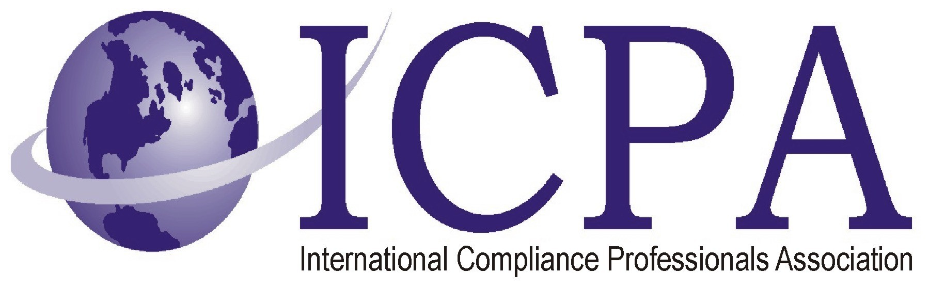

Job Opportunity

Company | OSRAM Sylvania
Job Title | Export Control and Customs Specialist
Location | Westfield, IN
Salary Range | Highly Competitive Salary
Relocation Assistance

Job Description / Responsibilities / Requirements

OSRAM SYLVANIA is the #1 lighting manufacturer in North America and a worldwide leader in lighting solutions. Our products feature innovative design and energy saving technology. We sell products for homes, businesses and vehicles primarily under the SYLVANIA brand name in the U.S. and operate under the OSRAM brand in Europe, China and beyond. Around 60 percent of sales come from energy-efficient products.
Our Westfield, IN (an Indianapolis suburb) location has an opening for an Export Control and Customs Compliance Specialist.

Job Description
Summary: Experienced (5-10 years) trade compliance professional to support the development, monitoring and execution of the OSRAM Trade Compliance Program. Works closely with the Corporate Export Control and Customs (ECC) Compliance Manager to ensure that the company complies with U.S. trade regulations, laws and security programs. The Export Control and Customs Compliance Specialist is responsible for:
• Supporting the ECC department to ensure the continuous improvement and the implementation of the trade compliance program on import/export awareness for all OSRAM NAFTA personnel, focusing on product issues and customs and export control regulations around products and technologies including, but not limited to EAR, OFAC, Customs, and FTR.
• Supporting with the definition, development and implementation of policy and procedure that support the Trade Compliance Program for ensuring OSRAM’s compliance with U.S. governmental, regulatory agency and corporate policies. Examples include but are not limited to U.S. Customs, U.S. Commerce Department, Department of Transportation, Census, and the U.S. Treasury Department, etc.
• Completing HTS/ECCN/USML classifications and associated recordkeeping for OSRAM products, fixed assets, supplies and technologies.
• Conducting and monitoring internal and external audits, self-assessments and internal reviews as required.
• Supporting the monitoring, maintenance and development of the following programs: C-TPAT, Free Trade Agreements (i.e. NAFTA, GSP), Customs Valuation, Duty Drawback, Reconciliation, and Chapter 99/98 Provisions.
• Interface with OSRAM forwarders, brokers, personnel and plants.
• Projects and tasks as assigned to support ECC department and the OSRAM Trade Compliance Program.

Qualifications:
• Bachelor’s degree required. M.B.A. preferred
• Minimum 5-10 years direct experience with the development and implementation of a trade compliance program preferred
• Strong technical background in the U.S. Export Control and U.S. Customs Regulations required with emphasis on EAR, FTR and OFAC compliance as well as U.S. Customs Regulations
• Customs Broker License required
• Direct experience in classification (HTS and ECCN) of products, software and technology required
• Experience and knowledge of the ABI, ACE and AES systems preferred
• Proficiency and experience with the implementation of Free Trade Agreement Programs preferred
Along with a highly competitive salary, OSI offers full medical benefits, matching 401K, extensive wellness programs and tuition reimbursement. Our location offers a business casual environment, free parking, an on-site cafeteria, on-site fitness center with classes and a great working environment. If you are thinking about an exciting change and challenge this is the place to be!

OSRAM SYLVANIA wishes to deal directly with our best and brightest candidates.
We do not work with third party recruiters.
We are an Equal Opportunity Employer and encourage all candidates to apply directly to our site.

Contact Information to Apply

Please apply at: https://osram.taleo.net/careersection/2/jobdetail.ftl?job=10108

