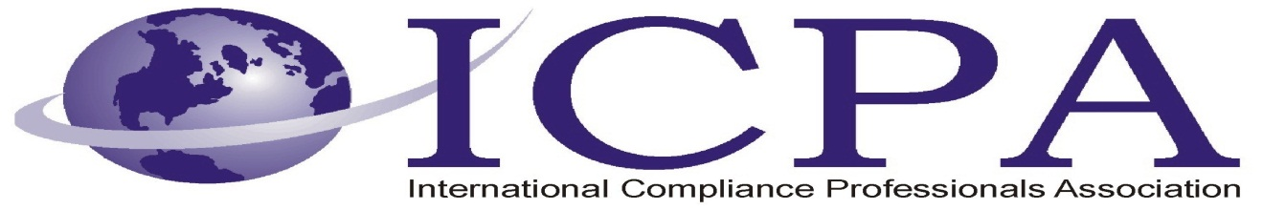

Job Opportunity

Company | Volkswagen Group of America, Inc.
Job Title | Senior Customs Specialist
Location | Herndon, VA
Salary Range | N/A
Relocation Assistance | No

Job Description / Responsibilities / Requirements

Description
Role Summary
- Oversees numerous ongoing Customs reporting programs, such as duty drawback, APA reconciliation filing, and Importer Self-Assessment (ISA).
- Responsible for collecting/analyzing all applicable data to support reporting protocols.
- Works with internal and external business partners to collect all required data and to prepare/file timely reports, both with Customs and VWGoA Management.
- Acts as a support function for Customs compliance functions when/where applicable.
Role Responsibilities
- Daily Parts operations processing
  - Ensure smooth flow of daily operations for all VW and Audi brand parts shipments
  - Receive/file copies of shipping documents
  - Distribute parts information to Customs brokers
  - Check daily “HALT” report and resolve outstanding issues
  - Communicate with external classification resource for parts classification issues
  - Work with Customs brokers on exception management
- Manual vehicle operations processing
  - Ensure smooth flow of daily operations for manual vehicle entries, to include Bentley, Lamborghini, and Bugatti brands
  - Receive/process shipping/invoice documents (air/ocean bills of lading, commercial invoices, etc.)
  - Create vehicle information records in VWGoA import processing system
  - Communicate with Customs broker to receive/record pertinent Customs entry data
  - Log entry information into VWGoA import processing system
  - Create/manage document retention files for all Customs entries
- Customs entry verification processing
  - Receive/organize hard-copy Customs entry documents from Customs brokers
  - Validate information against data in VWGoA import processing system
  - Compare entered values, etc.
  - Report/log issues and work with Customs broker for corrective action and final resolution

Qualifications
- Bachelor's Degree in Business, Political Science, or related field
- 5+ years of experience
- Understanding of automotive-related Customs regulations
- Knowledge of duty drawback principles
- Familiarity with writing Customs rulings and responding to Customs requests for information
- Working knowledge of U.S. Customs procedures & trade practices & ability to interpret regulations
- Working knowledge of federal & international Customs laws & familiarity with various sources of Customs information
- Working knowledge of Harmonized Tariff Schedule classification rules
- Technical expertise in valuation, country of origin marking, duties, protests, anti-dumping, & other government agencies
- Demonstrated ability to analyze data, select audit samples & write result reports
- Working knowledge of Excel, Access
- Ability to independently undertake the development, implementation, & on-going management of Customs processes & procedures
- Ability to integrate existing & new Customs procedures into the Corporation through cooperative work with other processes
- Ability to work independently
- Analytical skills & ability to recognize areas that create Customs concerns & adjustments
- Ability to locate varied sources of information & apply information obtained
- Ability to train others on Customs procedures
- Plus working knowledge of the following:
- Importer Self Assessment (ISA) program
- North American Free Trade Agreement (NAFTA)
- US Customs Duty Drawback program
- ACS Reconciliation prototype
Desired Qualifications
- Licensed US Customs Broker
- Key performance indicator development and management
Work Flexibility
- Less than 10% travel required

Contact Information to Apply

Apply here: https://vwgoa.taleo.net/careersection/jobdetail.ftl?job=CUS000017&lang=en&sns_id=#.UouuZ6pGkOM.mailto

