

Job Opportunity

Company | StandardAero
Job Title | Trade Compliance Specialist
Location | San Antonio, San Antonio, Houston, Los Angeles, Augusta, Springfield (IL), or Tempe.
Salary Range | Commensurate with Experience
Relocation Assistance | No

Job Description / Responsibilities / Requirements
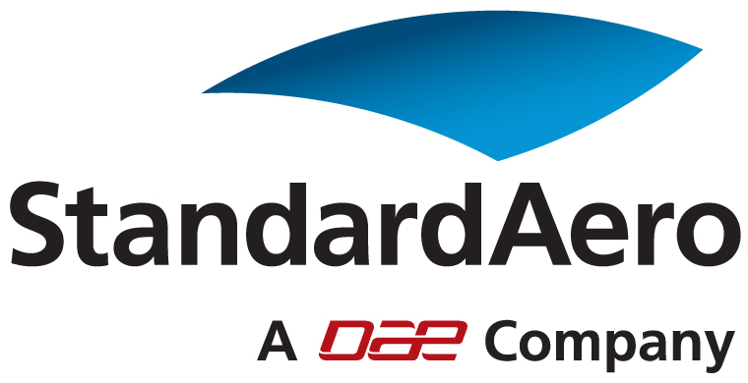

Trade Compliance Specialist

StandardAero a Dubai Aerospace Enterprise (DAE), specializes in engine maintenance, repair and overhaul services for business and general aviation, air transport, and military aircraft.

Summary

As a Trade Compliance Specialist, you will be responsible for compliance with trade compliance laws and regulations as established by the United States, Canada, and other countries’, as applicable. You will also ensure the compliance of import and export of products and technical information and other trade compliance matters.

If you have 3 – 5years of experience in the Import / Export industry, work well within a team environment with a flare to work independently then please read on.

Specific Accountabilities

- Supports the Global Trade Director in advocating trade compliance as a business tool through education and continuous improvement.
- Ensures compliance with import and export regulations and requirements for StandardAero & AAC.
- Maintains good working relationships and actively cooperates with, internal and external customers, business partners, and applicable government agencies, to execute import and export best practices.
- Maintains the policies and procedures contained in the respective Import & Export Compliance Manuals and other internal compliance publications.
- Supports the Global Trade Director in providing useful trade metrics.
- Provides support, regulatory interpretation and guidance in the following areas, to include but not limited to,: Product Classification, Export Licensing, Technical Data, Import/Export Documentation, Customs Clearance, Tariff/Schedule B Classification, Denial Party Lists, Broker Management, Incoterms, etc
- Assists the Global Trade Director with external audits (i.e., government agencies and external 3rd parties).
- Performs periodic internal import/export audits to ensure compliance with regulatory requirements.
- Assists/leads investigations in areas of non-compliance and executes on root causes and corrective actions to ensure compliance.
- Develops and delivers compliance training as required to various groups within the company, to include senior leadership. Initiates efforts to continuously improve the import/export knowledge of our internal customers at all levels.
- Ensures export and import recordkeeping and reporting requirements are met.
- Acts as a liaison with the respective trade compliance regulatory agencies, as applicable.
- Represents SA in trade community (seminars, conventions, etc).

Minimum Educational/Academic Requirements

- The typical minimum level of education to perform this job competently is equivalent to completion of a university (bachelor) program in a specialized field of study and work.
- Licensed customs broker or equivalent, preferred.

Required Skills/Experience

- Minimum 3-5 years experience in an import/export environment, required
- EAR and/or ITAR experience required
- Knowledge of U.S., Canadian and/or international custom requirements and regulations required.
- Demonstrated ability to read, interpret, analyze, and assimilate regulations and technical documents.
- Ability to maintain professional relationships and makes prudent decisions.
- Demonstrated ability to champion ideas, influence the organization, and facilitate change to ensure ideas are executed
- Ability to effectively present information and respond to questions from all levels within the organization
- Knowledge of international and domestic freight systems and requirements.
- Demonstrated decisions making skills
- Strong oral and written communication skills
- Ability to multi-task in a fast pace and high-demanding environment.

Location

This role is open is to the following locations: San Antonio, Houston, Los Angeles, Augusta, Springfield (IL), or Tempe.

We employ the highest quality professional in locations worldwide and we are dedicated to enhancing the ownership and operating experience for every customer, then StandardAero is the place to be.

Contact Information to Apply

For more information about this and other exciting opportunities within our organization or to apply, please go to career web site www.standardaero.com/aboutus/careers.aspx and search job id #1712 or contact Larry Blanchard, National Recruitment Manager at larry.blanchard@standardaero.com

