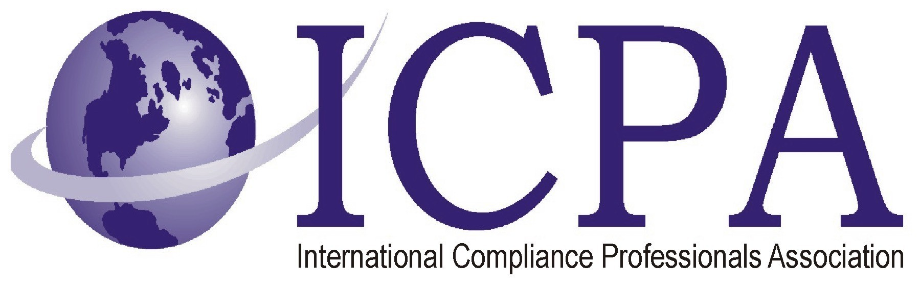

Job Opportunity

Company | Perrigo Company
Job Title | Trade Compliance Analyst
Location | Allegan, MI
Salary Range
Relocation Assistance

Job Description / Responsibilities / Requirements

Seeking Trade Compliance Analyst

About Perrigo
At Perrigo our mission is clear: we seek to provide quality affordable healthcare products. With nearly $3 billion in sales and close to 9,000 people working around the world, Perrigo Company is a leading global healthcare supplier. We develop, manufacture, package and distribute over-the-counter and prescription pharmaceuticals, nutritional products, active pharmaceutical ingredients and consumer products. We are the world’s largest manufacturer of store brand OTC pharmaceutical products and infant formulas. Perrigo’s locations are in the United States, Israel, Mexico, the United Kingdom, India, China and Australia

At Perrigo, your job will mean more. You will join a team that is as driven and excited as you are about making healthcare products more affordable around the globe. Our products improve our consumer’s quality of life – let Perrigo improve the quality of your career.

Description
Reporting to the Global Trade Compliance Manager, this position provides expert counsel and direction to Perrigo personnel, suppliers and customers regarding import and export requirements.

Duties include:
- Determine Customs, FDA, USDA, etc. (“other government agency”) requirements for imported products for all Perrigo U.S. entities, including Harmonized Tariff Classifications, FDA product codes, and country of origin
- Determine export requirements for export shipments from all Perrigo U.S. entities and ensure all export shipments adhere to Export Administration Regulations
- Perform thorough and documented compliance reviews of export shipments, denied parties screening, product classifications, import shipments, etc. to ensure compliance with all relevant regulations and internal procedures
- Manage Perrigo’s international logistics program
- Manage North American Free Trade Agreement (NAFTA) program for imports and exports for all Perrigo U.S. entities
- Manage Perrigo’s Foreign Trade Zone (FTZ), ensuring all activities are executed in compliance with Customs & FDA regulations and internal procedure
- Communicate directly with U.S. Customs, FDA, USDA and other government agencies as required to trouble-shoot or facilitate release of import shipments
- Participate in announced and unannounced U.S. Customs and other government agency audits
- Monitor vendor, forwarder and broker compliance with regulations and internal procedures and issue detailed quarterly performance reports
Qualifications
- Bachelor’s degree required and licensed Customs Broker strongly preferred.
- 3-5 years experience in imports/exports and/or international logistics and C-TPAT a plus.
- Experience with imports and/or working with U.S. Customs and other relevant government agencies preferred
- Effective decision-making and analytical skills required
- Initiative and the ability to work with minimal supervision (self-directed) required
- Attention to detail, accuracy and the ability to prioritize required
- Excellent written and verbal communication and strong interpersonal skills required
- Ability to effectively interact with government agencies and company personnel at all levels required
- Previous experience with SAP preferred
- Some travel required (15% maximum)

Contact Information to Apply

Please apply on-line at: http://bit.ly/18vvOTK

