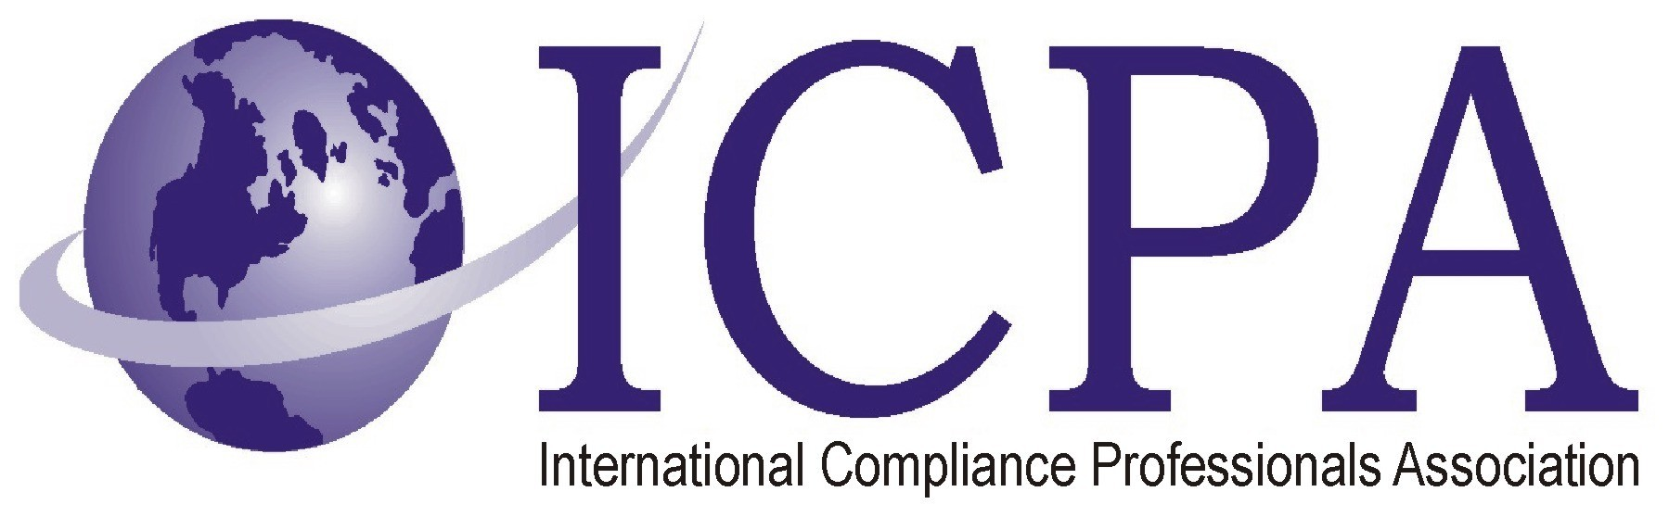

Job Opportunity

Company | Ormco Corporation
Job Title | Customs and BIS Compliance Assoc (NAFTA and Export Specialist)
Location | San Dims C
Salary Range
Relocation Assistance | No

Job Description / Responsibilities / Requirements

Position Summary: The Customs & BIS Compliance Associate (NAFTA & Export Specialist) is responsible for providing regulatory services, guidance and information pertaining to all NAFTA and Export issues. Promotes compliance with Customs and Border Protection (CBP), Bureau of Industry and Security (BIS), Food and Drug Administration (FDA) and other government agencies. Expedites international shipments while minimizing total shipping costs. Serves as a liaison between company facilities, custom brokers and freight forwarders to minimize the company’s risk of monetary penalties and CBP/BIS audits.

Responsibilities: Interprets regulations from Customs & Border Protection (CBP), Immigration & Customs Enforcement (ICE), Bureau of Industry & Security (BIS), US State Department, US Treasury Department or any other governmental agencies as they pertain to NAFTA regulations and the exportation of commercial goods and information for Ormco Corporation and Axis/SybronEndo.

Leads in the development of Standard Operating Procedures (SOP’s) based on applicable governmental regulations as they pertain to NAFTA and the exportation of commercial goods & information.

Provides specific, applicable information concerning governmental regulations regarding NAFTA and the exportation of commercial goods & information as required by management, so that management can make informed decisions regarding the implementation of NAFTA policies and procedures and the exportation of commercial goods and information.

Acts as primary company contact with 3rd party brokerage companies
providing required information for customs clearance pertaining to
exports.

Works with Distribution Associates to ensure compliance with CBP regulations concerning Electronic Export Information (EEI) and Automated Export System (AES) filing.

Reviews documentation submitted to CBP and BIS for accuracy and comprehensiveness. Makes corrections as necessary and notifies appropriate individuals.

Determines & provides tariff classifications, country of origin, and duty rates on goods to be processed internationally to all appropriate parties, internal & external, while minimizing rates and duties to be paid.

Identifies opportunities to secure duty refunds and takes advantage of duty saving programs.

Assists international shippers with documentation and issues that may surface involving compliance.

Provides training and assistance, as directed, to departments, inter-companies, maquiladoras and vendors that process material and information internationally.

Issues General Use Certificates upon request from the Distribution Associates.

Maintains NAFTA and export-related documents in accordance with government regulations.

Evaluates Ormco and Axis/SybronEndo parts manufactured in the USA
for NAFTA COO eligibility.

Provides NAFTA COO certificates for export when requested by the
customer and only when the NAFTA COO claim can be supported with
the proper documentation in accordance with NAFTA regulations.

Develops NAFTA and Export manuals and functional desk top procedures.

Provides required Hazardous Material training and ensures that Hazmat Certifications are up to date.

Assists Purchasing Department in gathering NAFTA certificates of origin for all purchased merchandise. Maintains current NAFTA certificates of origin for all purchased items and ensures that Sybron Specialty Platform has the proper documentation to support NAFTA claims.

Works with R&D, Procurement, Manufacturing, and Regulatory departments on COO & HTS determinations, as well as providing guidance on applicable trade agreements that the company could utilize in its sourcing of material.

Identifies and recommends opportunities for continuously improving NAFTA and Export processes.

Provides backup and support as necessary to Customs & BIS Compliance Associate II (Import & Compliance) in the following areas:

Contacting 3rd party brokerage companies, providing required information for customs clearance.
Auditing custom entries to ensure completeness and accuracy. Filing corrections as required.

Education/Training: Four-year Business Degree required, preferred major in International Business or Supply Chain Management or equivalent experience with a Customs Broker, Freight Forwarder, or in a compliance department of a company that Imports and Exports.

Certificate/License: Customs broker license or IMEX MBB preferred.

Experience: Five to seven years of import/export experience with a customs broker, freight forwarder or importer/exporter.

Experience with NAFTA regulations, application and role with maquiladoras as well as the function of a maquiladora.

Skills: Must have excellent communication skills (verbal and written). Must be able to communicate professionally and effectively with employees at all levels of the organization as well as individuals outside the corporation.

Ability to think critically, troubleshoot, and problem-solve.

Must have strong planning and organizational skills.

Fluent in the use and application of Microsoft Office Applications, Word, Access, Excel, Outlook, and PowerPoint.

Able to interpret & analyze import and export regulations.

Able to work independently and in a team environment with little supervision.

Able to effectively handle multiple projects simultaneously.

Bilingual English/Spanish (verbal and written) is a plus, but not required.

Contact Information to Apply

Apply online at Ormco’s Website

www.ormco.com

Enter Job Number ORM000243 in the Careers portal

